1400W PFC full load turn on and MOS breakdown

Description:

When the PFC circuit turns on at full load (1400W) with Vin at 100Vac,

the MOS(IQ1~IQ4) and driver IC break down。

This situation does not happen every time at turn-on, it is random

Do you have solutions to solve it?

Test Conditions:

Vin:100Vac

Vout:390Vdc

Iout:3.589A

PFC operation frequency:100KHz

Circuit :

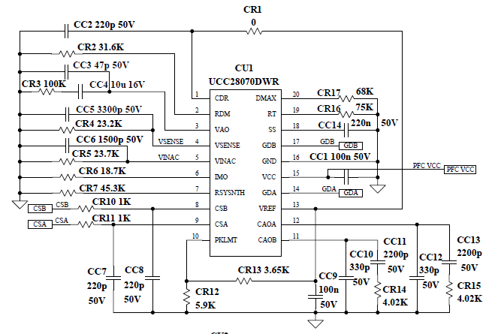

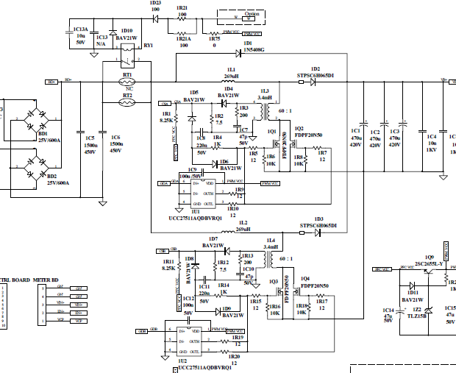

Waveform 1:

The following waveform1 is PFC turn-on at full load and MOS, driver IC do not breakdown

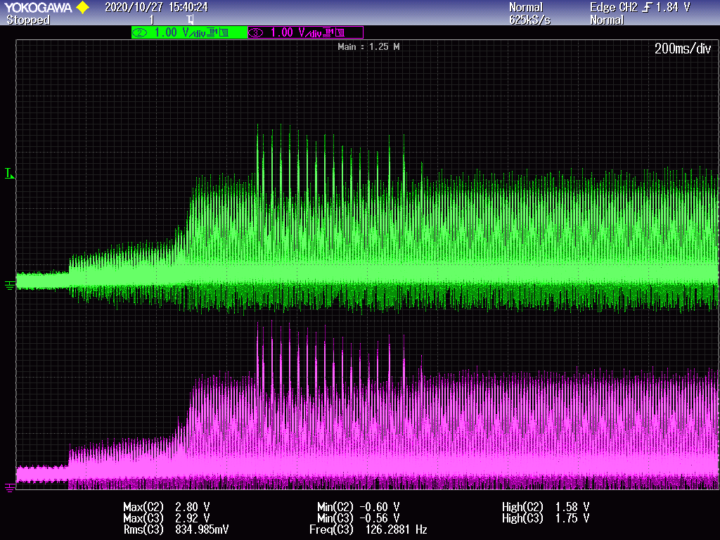

Green :CSA(Voltage across IR2)

Pinky: CSB(Voltage across IR12)

Waveform 2:

The following waveform2 is PFC turn-on at full load and MOS, driver IC break down

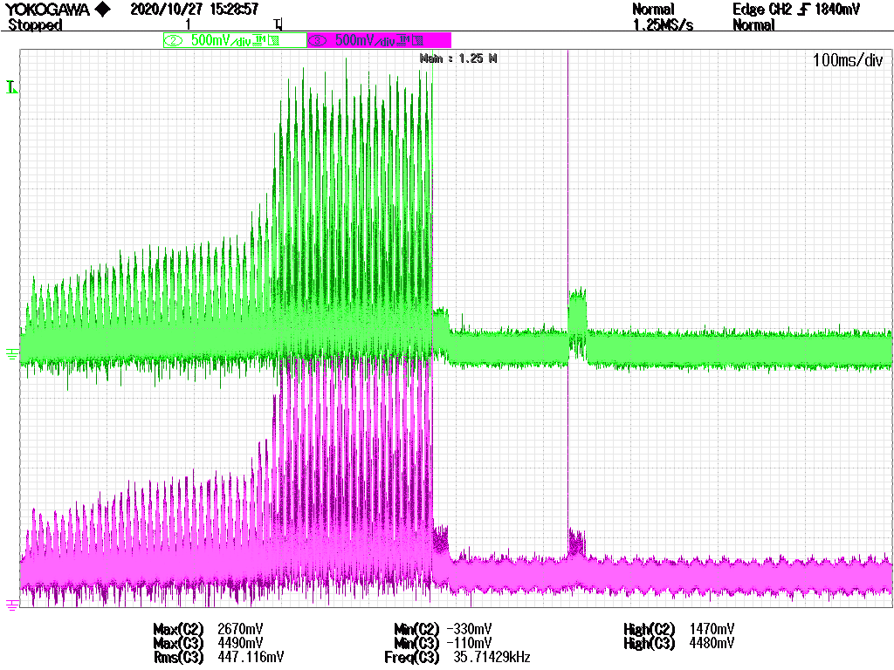

Green :CSA(Voltage across IR2)

Pinky: CSB(Voltage across IR12)