Design Requirements
- Input 230Vac @ 50/60Hz and output 48Vdc/10A continuous.

Mains Input Requirements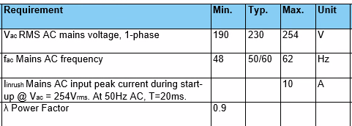

Output Requirements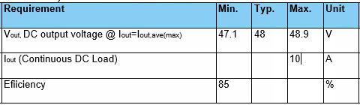

Line and Load Requirements
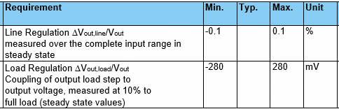

High Load Step Response Requirements
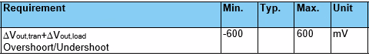

Output Noise & Ripple Requirements
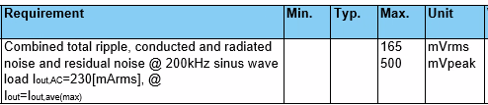

Ambient Temperature Range
- Operating range: +10C ~ +55C
- Storage range: -25C ~ +70C

EMC Requirements
- Conducted emissions: EN61000-6-4
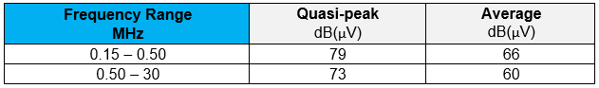
- Radiated emissions: EN61000-6-4
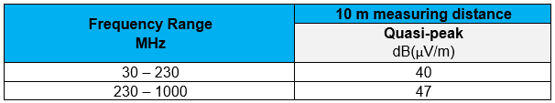
- Conducted immunity: EN61000-6-2
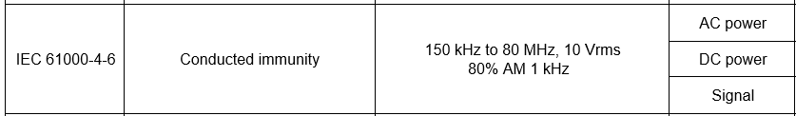
- Radiated immunity: EN61000-6-2
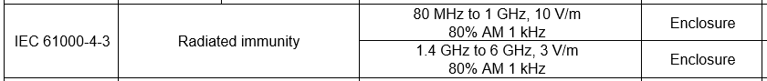
- ESD immunity: EN61000-6-2
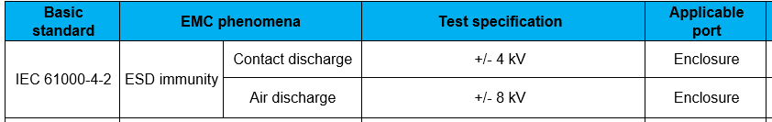
- Fast transient immunity: EN61000-6-2
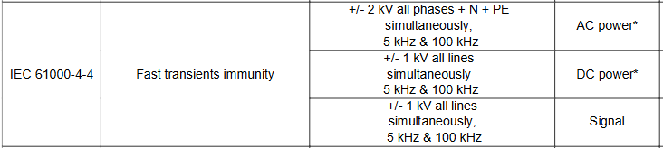
- Surges immunity: EN 61000-6-2
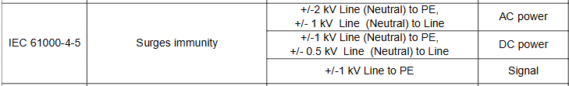
- Power frequency magnetic field immunity: EN61000-6-2

Additional Environmental Requirements
- Voltage sag immunity: SEMI F47

