Contents

Summary of Issue: 1

TI Reference Design: 1

Schematic: 2

PCB Layout: 2

BOM: 2

Deviations from Reference Design: 3

Modifications: 3

Observations and Screen Captures After Modifications: 3

B1 Oscope Captures: 4

B2 Oscope Captures: 5

B3 Oscope Captures: 6

Next Steps: 6

Changes for Rev: 6

# 

# Summary of Issue:

Non-systematic Issues to include:

1. Avg Vout 3V3, but noise is 800 – 1000mv
2. Vout varies with varying load current (outside of 10% of designed Vout)
3. One board has a Vout of 3V8 until under load, at which point Vout settles to 3V3 as desired
   1. Issue seen only one case. Other cases Vout is ~3V3 and falls ~50mV when load switches on
4. Vout regulation is ~2V70, not the designed 3V3
5. Spontaneous “Square Wave” in which regulation falls from 3V3 to ~2V5 in a random square wave like pattern
6. Some boards had regulator circuits fail completely causing a short-circuit
7. Sometimes regulator works very well and seems to be grumpy only the next day

# TI Reference Design:

<https://webench.ti.com/appinfo/webench/scripts/SDP.cgi?ID=40C1E499DED81B82>

# Schematic:

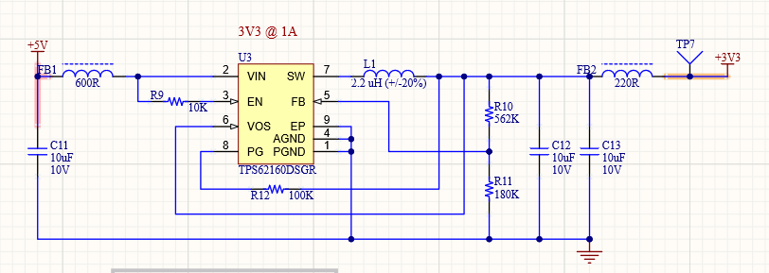

# PCB Layout:

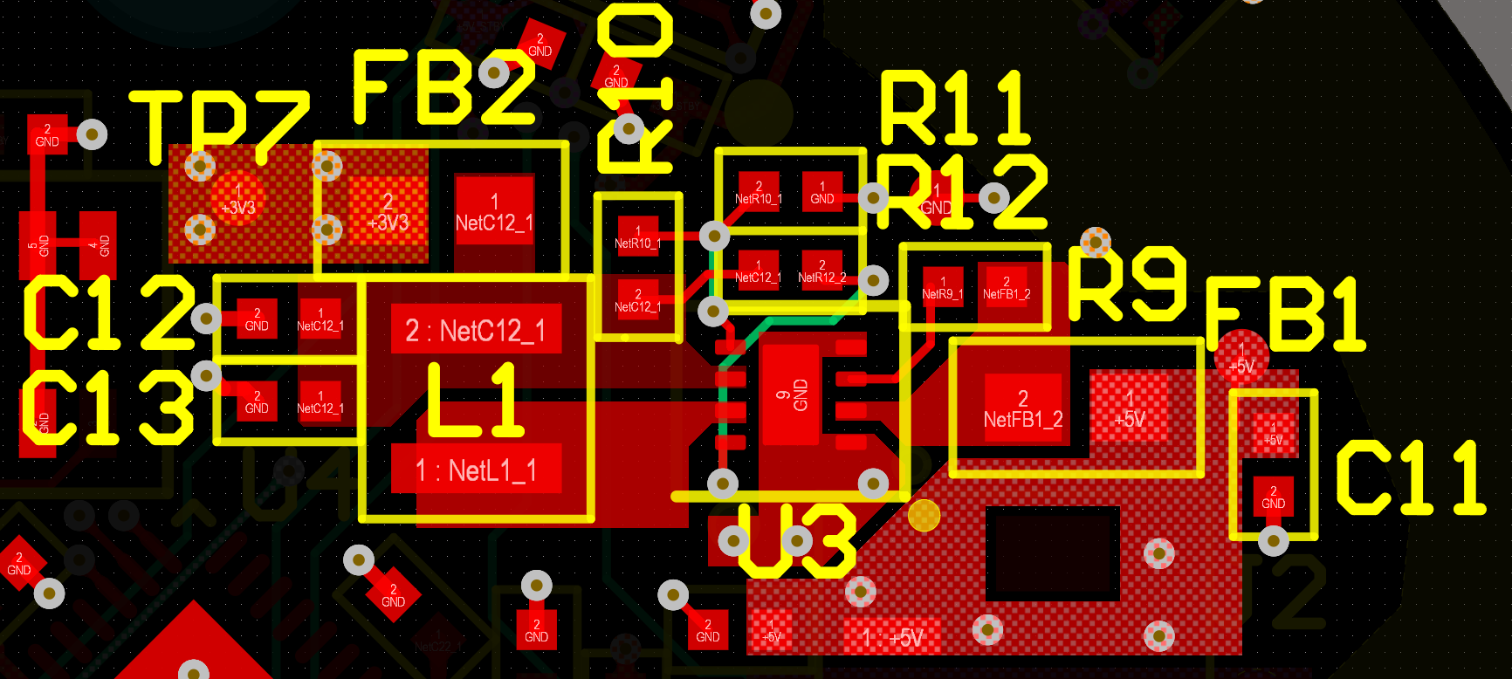

# BOM:

|  |  |  |  |
| --- | --- | --- | --- |
| Designator | Description | Manufacturer | Manufacturer Part Number |
| C11, C12, C13 | MLCC 10 µF, 10 V, 0402 [1005 Metric], ± 20%, X5R, CL Series | Samsung | CL05A106MP5NUNC |
| FB1 | 600 Ohms @ 100MHz 1 Ferrite Bead 0603 (1608 Metric) 500mA 380mOhm | Murata | BLM18AG601SN1D |
| FB2 | Ind Chip Bead 220Ohm 25% 100MHz Ferrite 2A 0603 Paper T/R | Murata | BLM18EG221SN1D |
| L1 | SMD Power Inductor, 2.2 uH, +/- 20%, 3 x 3 x 1.5 mm, -25 to 120 degC | Taiyo Yuden | NR3015T2R2M |
| R9 | RES SMD 10K OHM 1% 1/16W 0402 | Bourns | CR0402-FX-1002GLF |
| R10 | Thick Film Resistors - SMD 562K OHM 1% | Bourns | CR0402-FX-5623GLF |
| R11 | 0402 180K Ohm 1% 1/16W | Bourns | CR0402-FX-1803GLF |
| R12 | 0402 [1005 Metric], 100 kohm, CR Series, 50 V, Thick Film, 62.5 mW | Bourns | CR0402-FX-1003GLF |
| U3 | DC/DC Buck | Texas Instruments | TPS62160DSGR |

# Deviations from Reference Design:

1. Use of 0402 input and output caps
2. Use of Ferrite Beads at Input/Output

# Modifications:

1. 0402 caps > 0805 caps to deal with DC Voltage Bias
2. 20uF > 30uF @ output
3. 2.2uH Inductor > 3.3uH Inductor

# Observations and Screen Captures After Modifications:

## B1 Oscope Captures:

## 

Figure : B1 Power Up

## 

Figure : B1 Power Down

## B2 Oscope Captures:

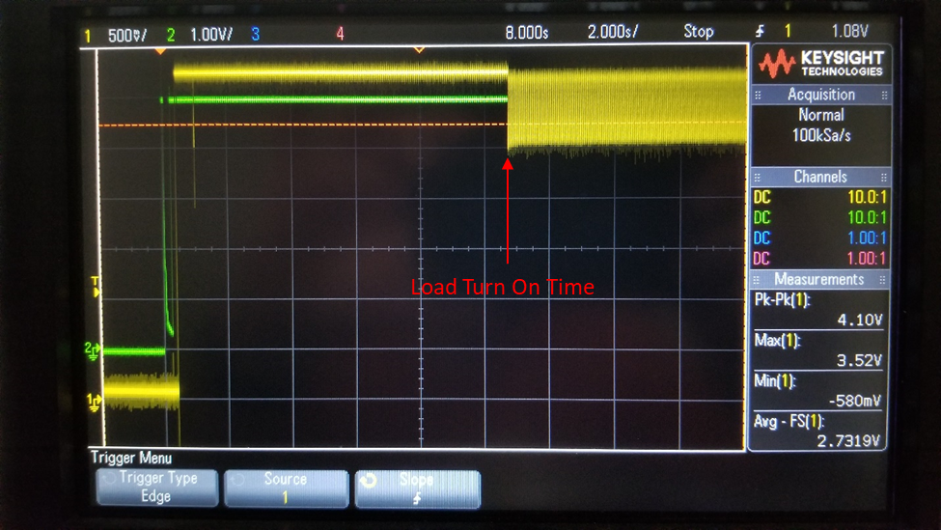

Figure : B2 Power Up (Note: ~1000mV noise starts when LED load turns on, ~80mA draw)

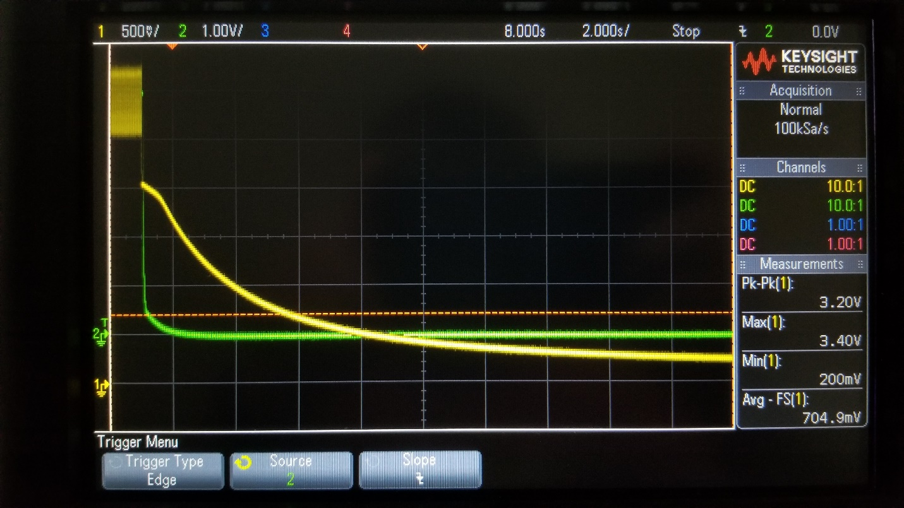

Figure : Power Down

## B3 Oscope Captures:

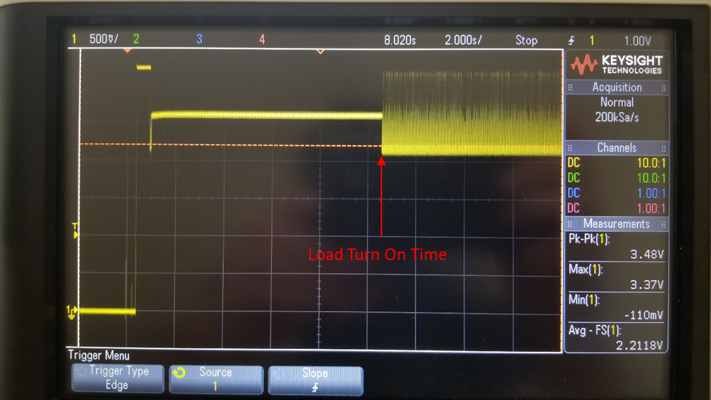

Figure : B3 Power Up (Note: Starts at 3V3 > 2V5 > high noise @ LED load, ~ 80mA, turn on)

# Next Steps:

1. AGND? See DS layout guidelines
2. Swap 3V3 rail with 5V_STBY (Reverse TXS0102 Ports to handle VCCA <= VCCB). Ensure to isolate DC-DC Regulator!
3. Characterize the TPS62160EVM
4. Hack TPS62160 into system and characterize performance

# Changes for Rev:

1. Add Load/Discharge Resistor to Vout (DNP)
2. Swap positions of R12 and R11 to reduce number of vias needed for routing. Also implement Power and Analog Ground layout per datasheet recommended layout.