Activated synchronous-rectifier
5[ms/div] 5[us/div]
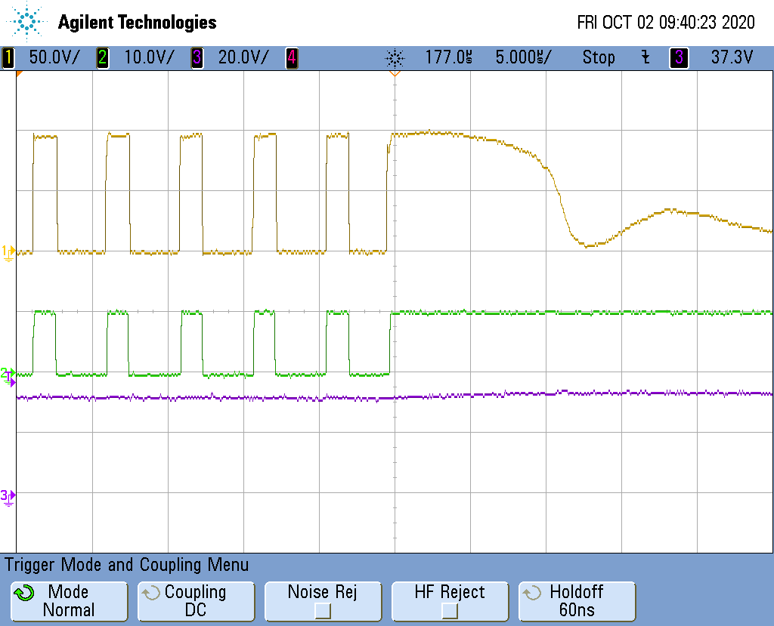
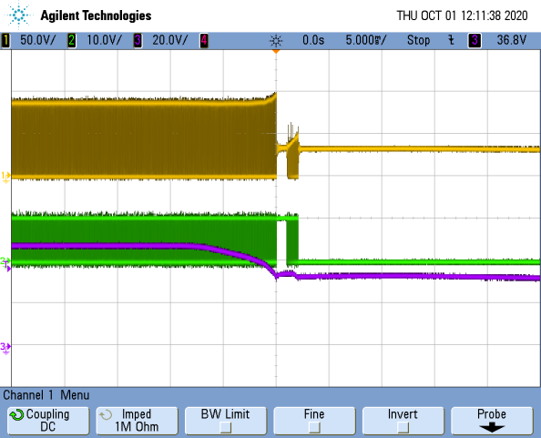

SW-node
50[V/div]
Clamp-SW control
10[V/div]
Vin

Disabled synchronous-rectifier
5[ms/div] 5[us/div]
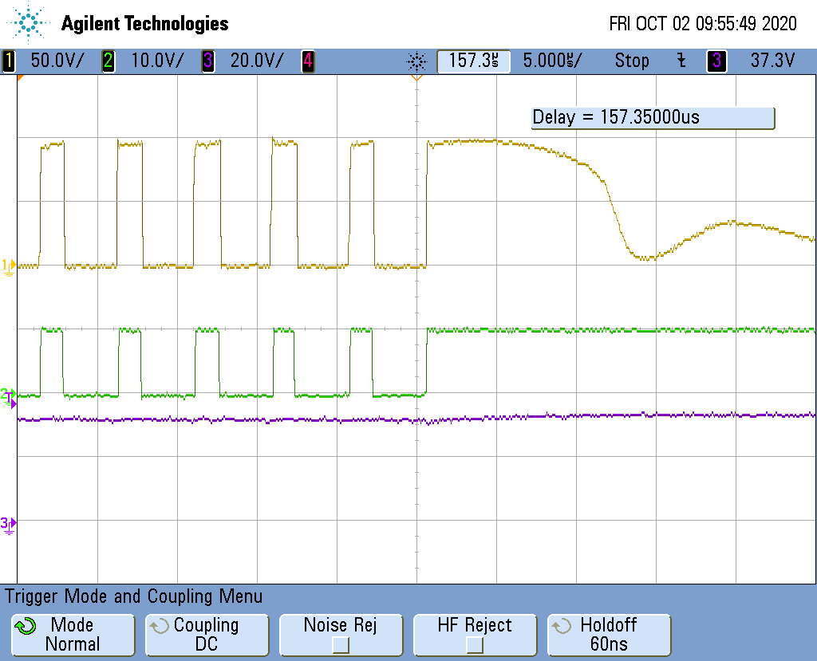
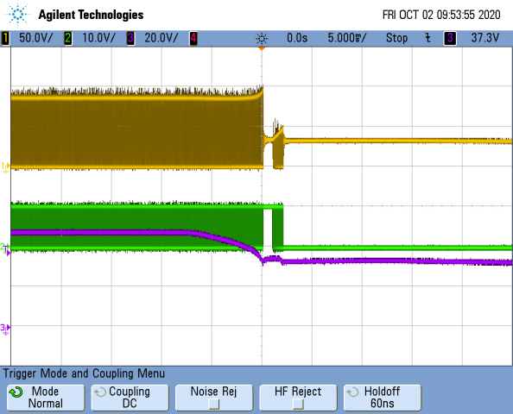

SW-node
50[V/div]
Clamp-SW control
10[V/div]
Vin

