Reference spec page 2 :
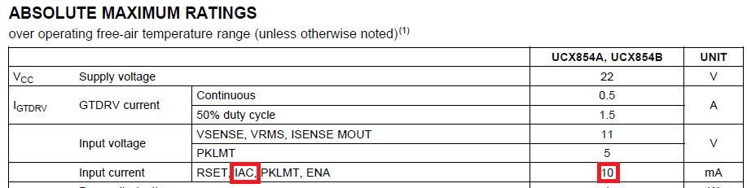
And spec page 8 :
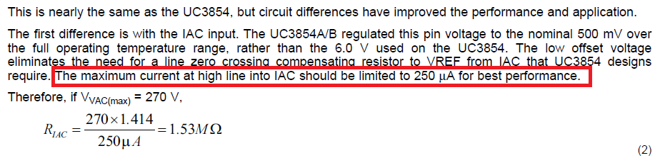
Q: Why setting 250uA Limit for AC high line ?
If over 250uA can influence which function ?
Which tolerance for this 250uA test plan in TI mass product testing ?
Reference [DN-44 UC3854A and UC3854B slua177a (250W)] : R8 1M Ohm, and this setting already over 250uA , How to meet IAC maximum 10mA ?
reference page 5 and page 1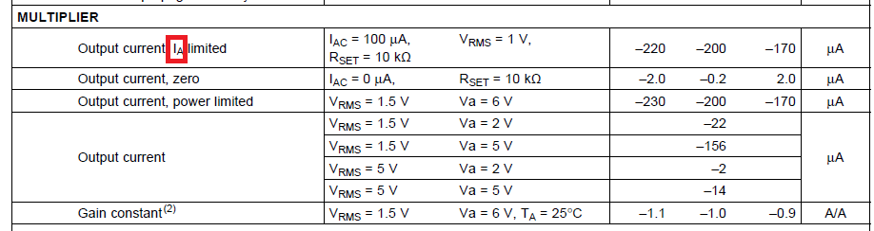
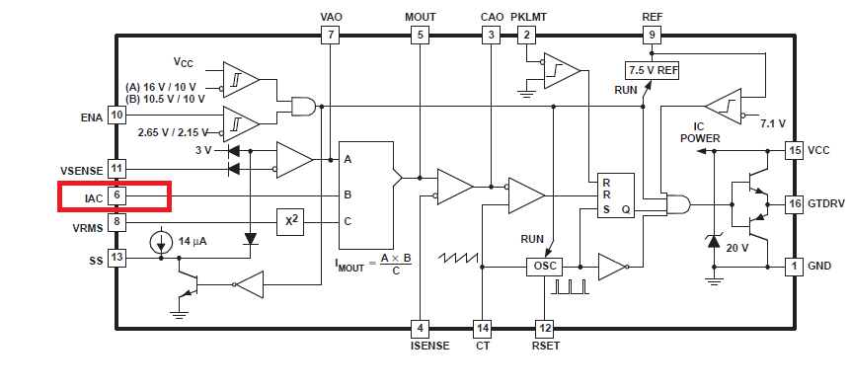
Q: IA is IAC pin input current ? or other ?
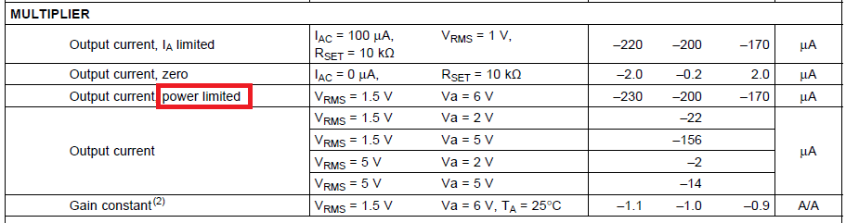
Q: Power limited is Multiplier output current limited or power limited ?
IA limited and power limited minimum value different reason ?
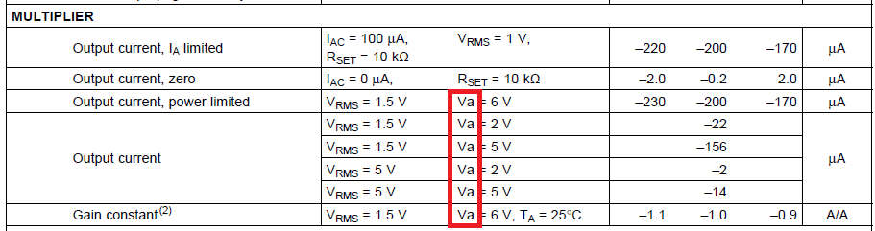
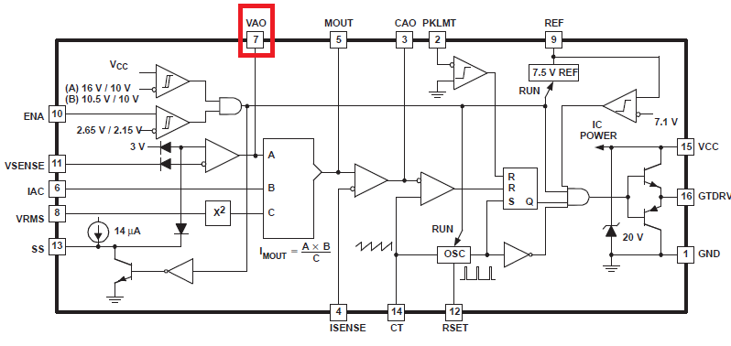
Q: Va is mean pin 7 VAO voltage right ?

