TPS55340 – Switch node ringing -> Vout high frequency oscillations

# Design parameters:

* 6V < Vin < 9V
* 16Vout
* 300mA out

# Design schematics:

Very close to Webench recommendations

Customer schematic:

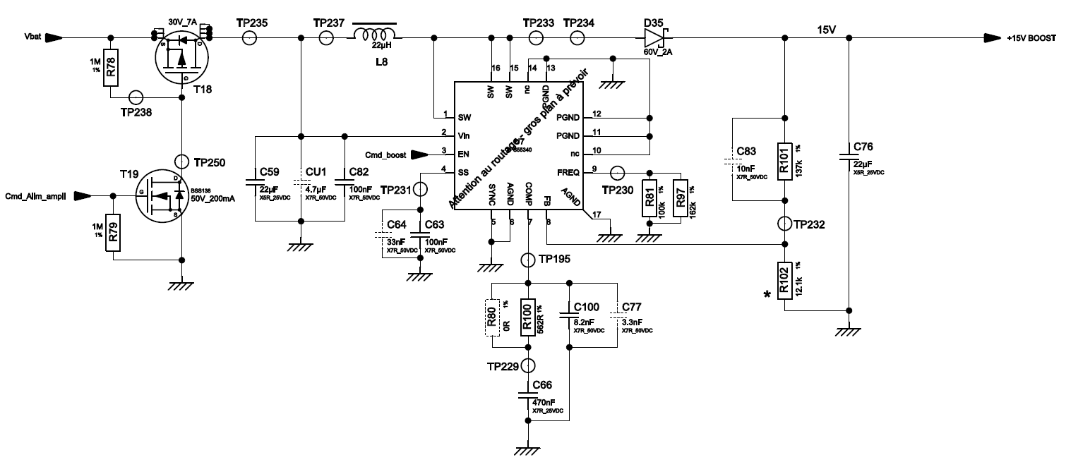

Webench:

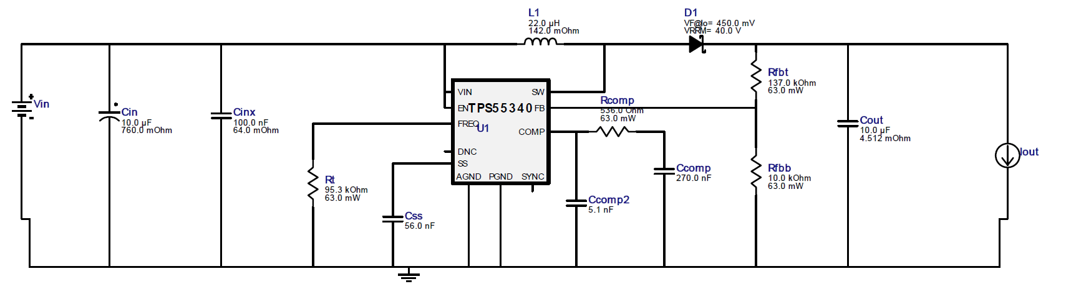

# Design layout:





# Observations:

* Yellow: Vout / AC coupling
* Green: switch node
* We observe a 1V pk-pk voltage @ Vout.

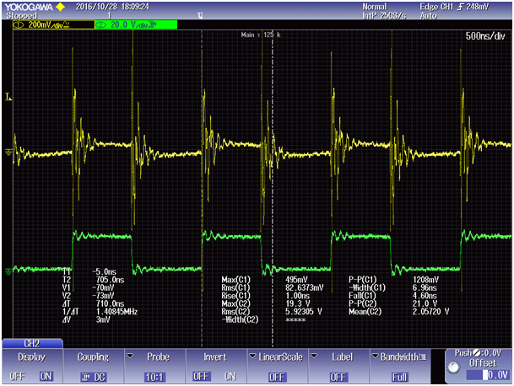

# Questions:

* Do you think this is a normal behavior?
* How could we improve that ?