2018.04.19 BQ24650 Rev A

Switching Node Ringing Problem

* 1. Stock config, PH node, w/ Iout

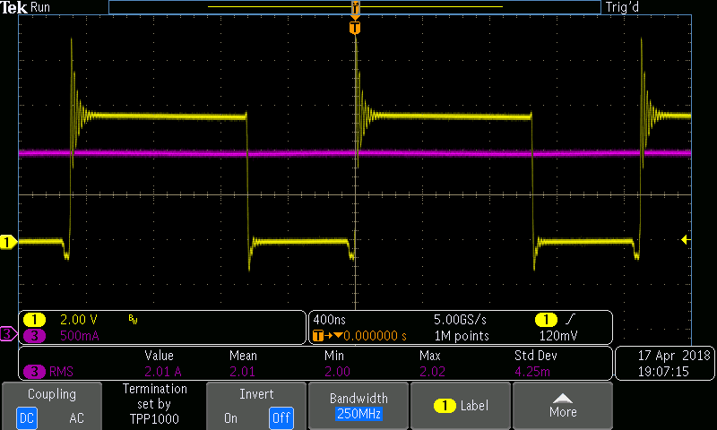

New Config (3.6 ohm on high side gate):

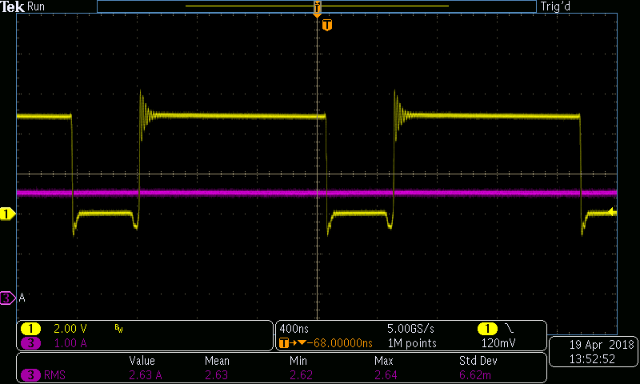

Close-up on ringing (2.6A charge I to LiIon):

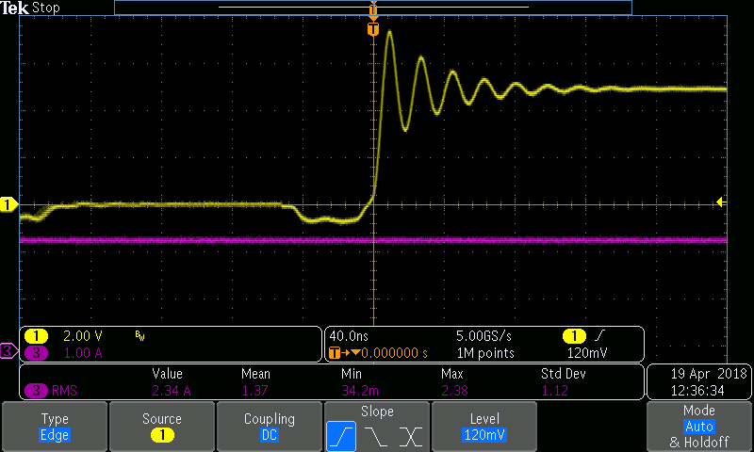

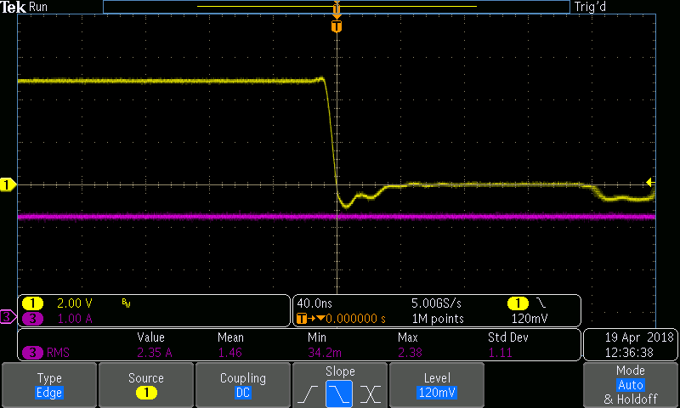

Try a 10 ohm series gate resistor on high side FET (2.6A Charge I to LiFePo4):

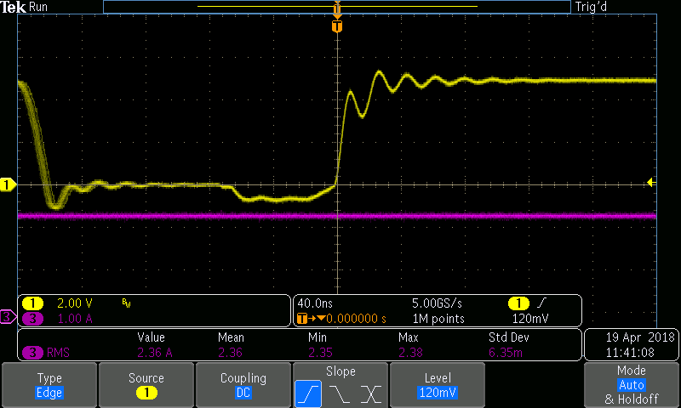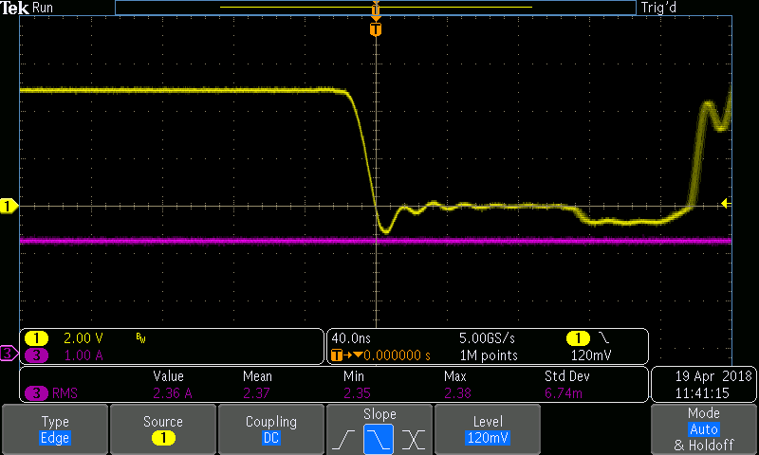

Try a 3.6 ohm series gate resistor on high side FET (2.6A Charge I to LiFePo4):

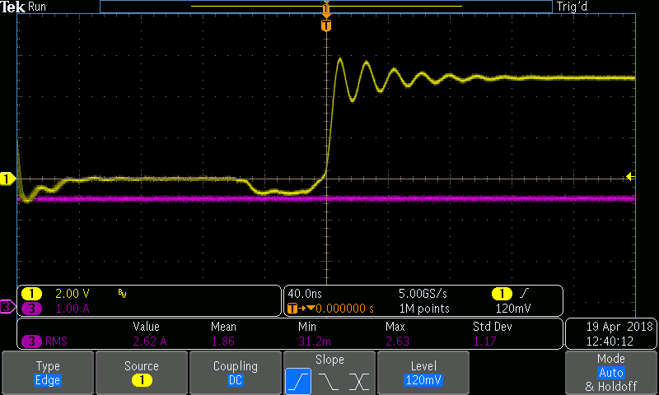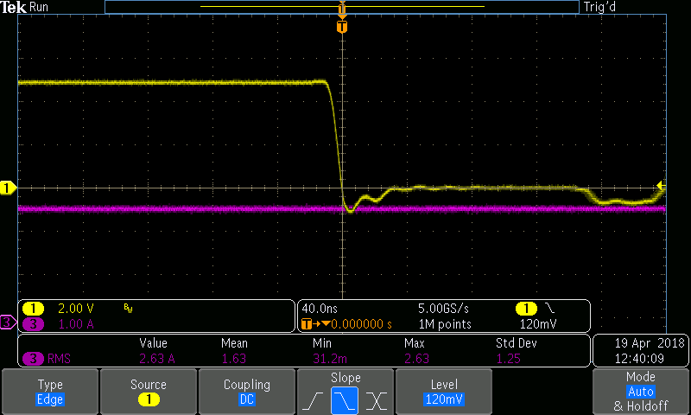

Try a 100pF 2ohm snubber (2A Charge I to LiIon):

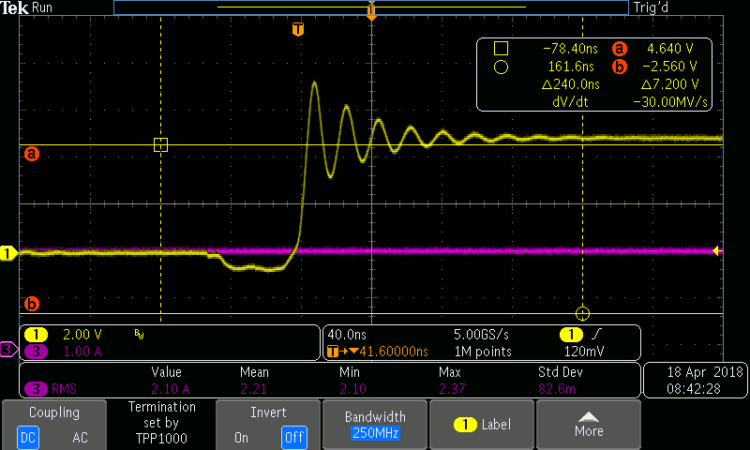

Try a 1000pF, 1 ohm snubber – not worth the 0.5W loss (2A charge I to LiIon):

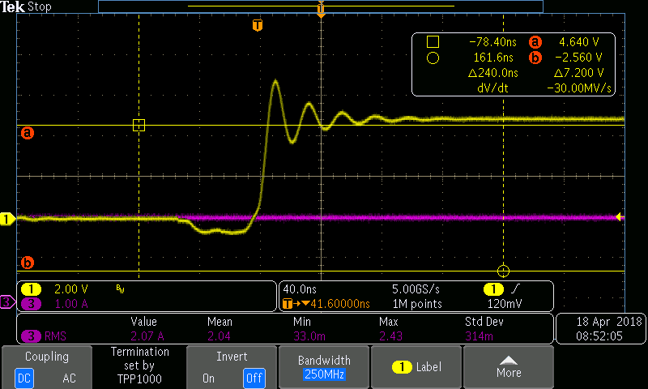

Try BSZ025N04LSATMA1 MOSFET (2A charge I to LiIon):

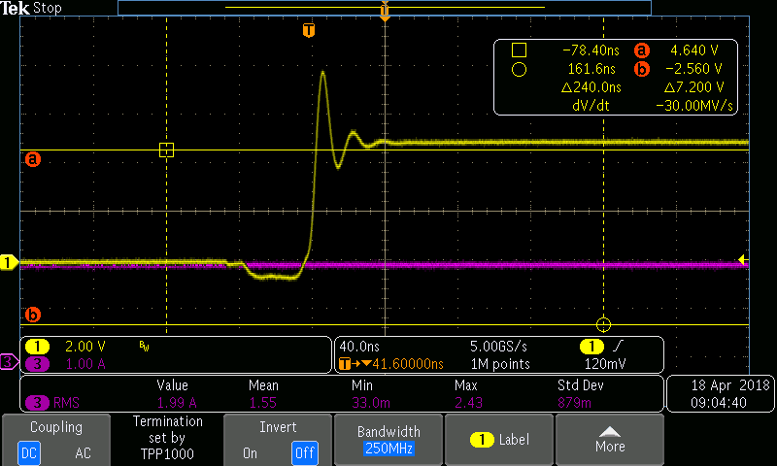

Add a 3.6 ohm series R at the low side gate (2.6A Charge I to LiFePo4):

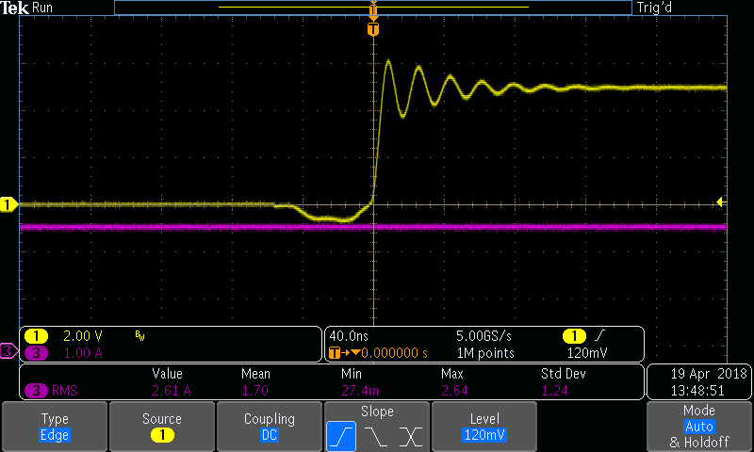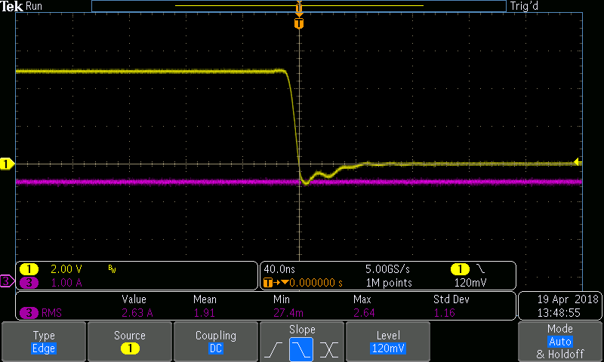

**Other Waveforms Old Vs. New:**

1. PH node, w/ Iout



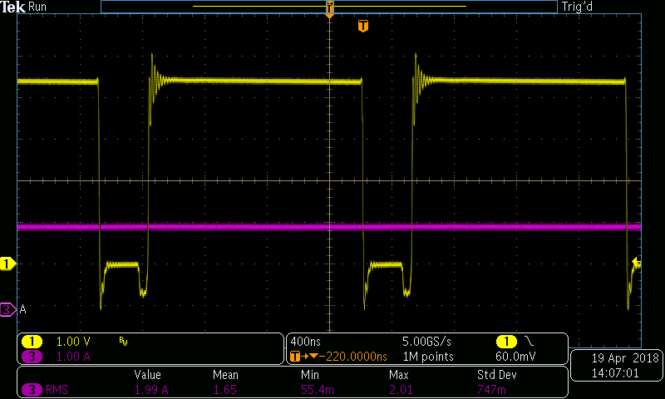

1. Q1 Gate, w/ Iout

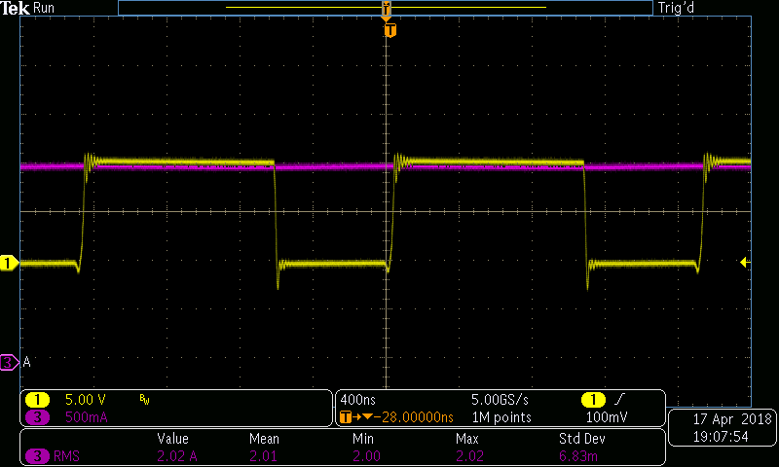

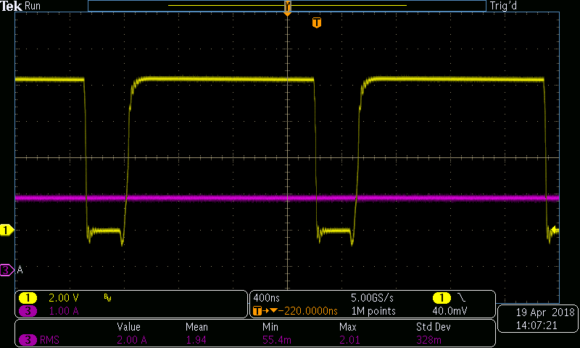

1. Q2 Gate, w/ Iout

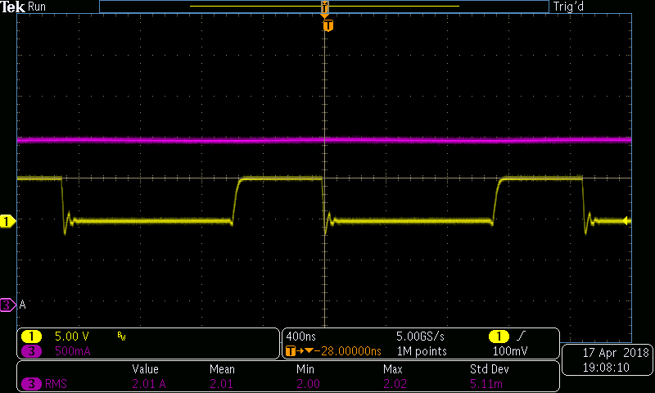

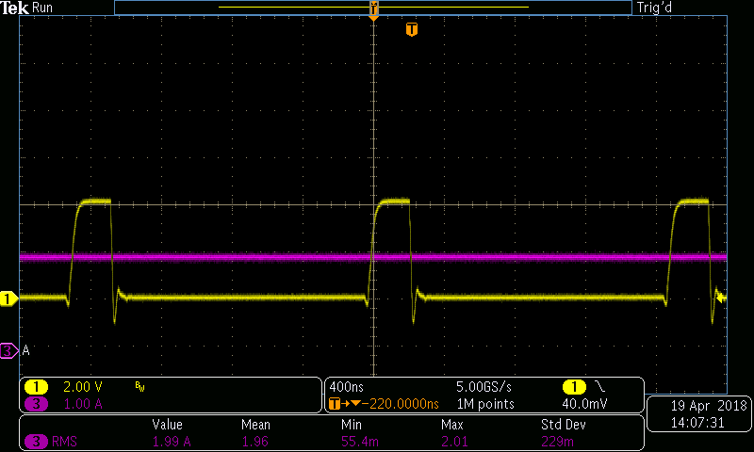

1. BTST node, w/ Iout

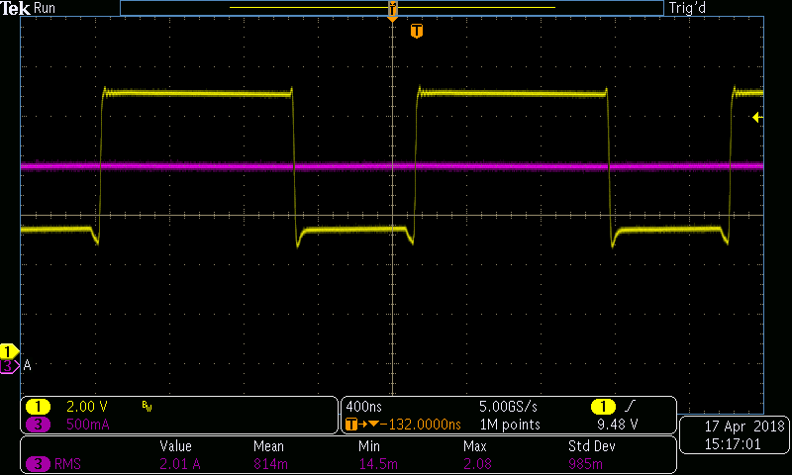

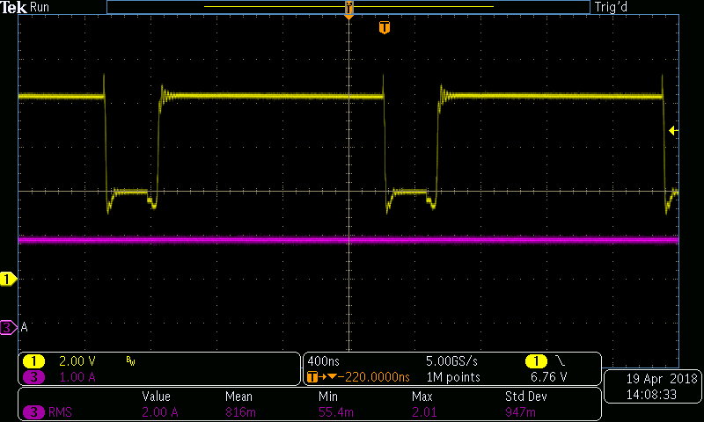

1. SRP, SRN (A/C coupled), w/ Iout

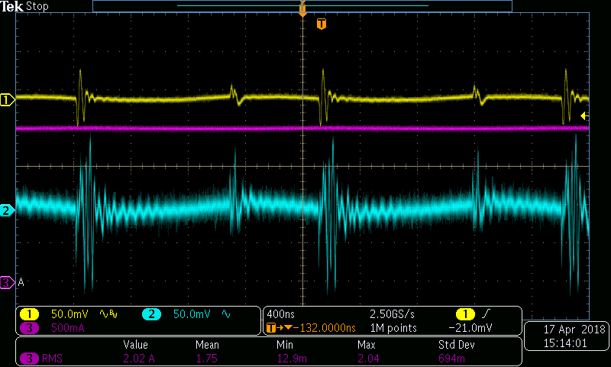

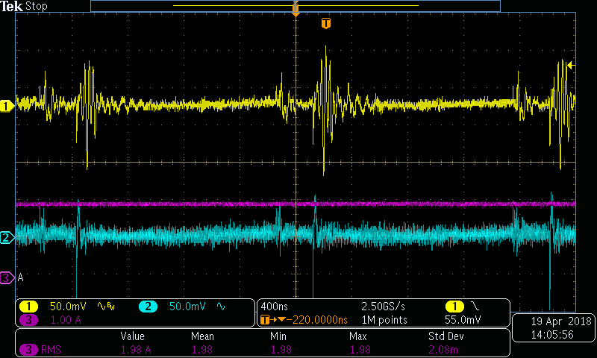

1. REGN pin on U1, w/ Iout

