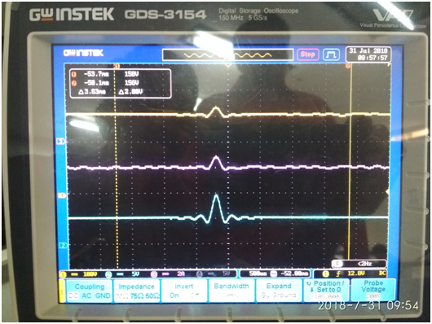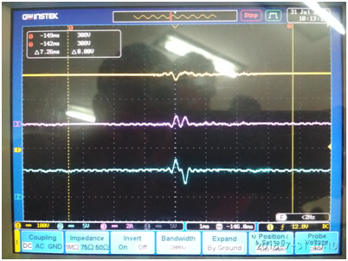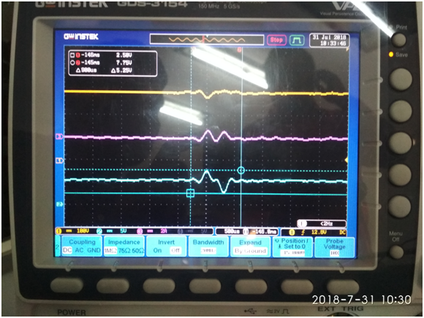
Fig:1: first time:When switch OFF (SW1) of FAN
Yellow line : Vin: 320VDC (100V/ div)
Pink Line: Iin: 0.03A DC (2A/ Div)
Blue Line: Vout: 5V DC (5V/ Div)

Fig:2: Second time: When switch OFF (SW1) of FAN

Fig:3: Expansion of fig2

