**24V 3A DC-DC CONVERTER SCHEMATIC, SWITCHING WAVEFORMS, LINE & LOAD REGULATION, EFFICIENCY.**

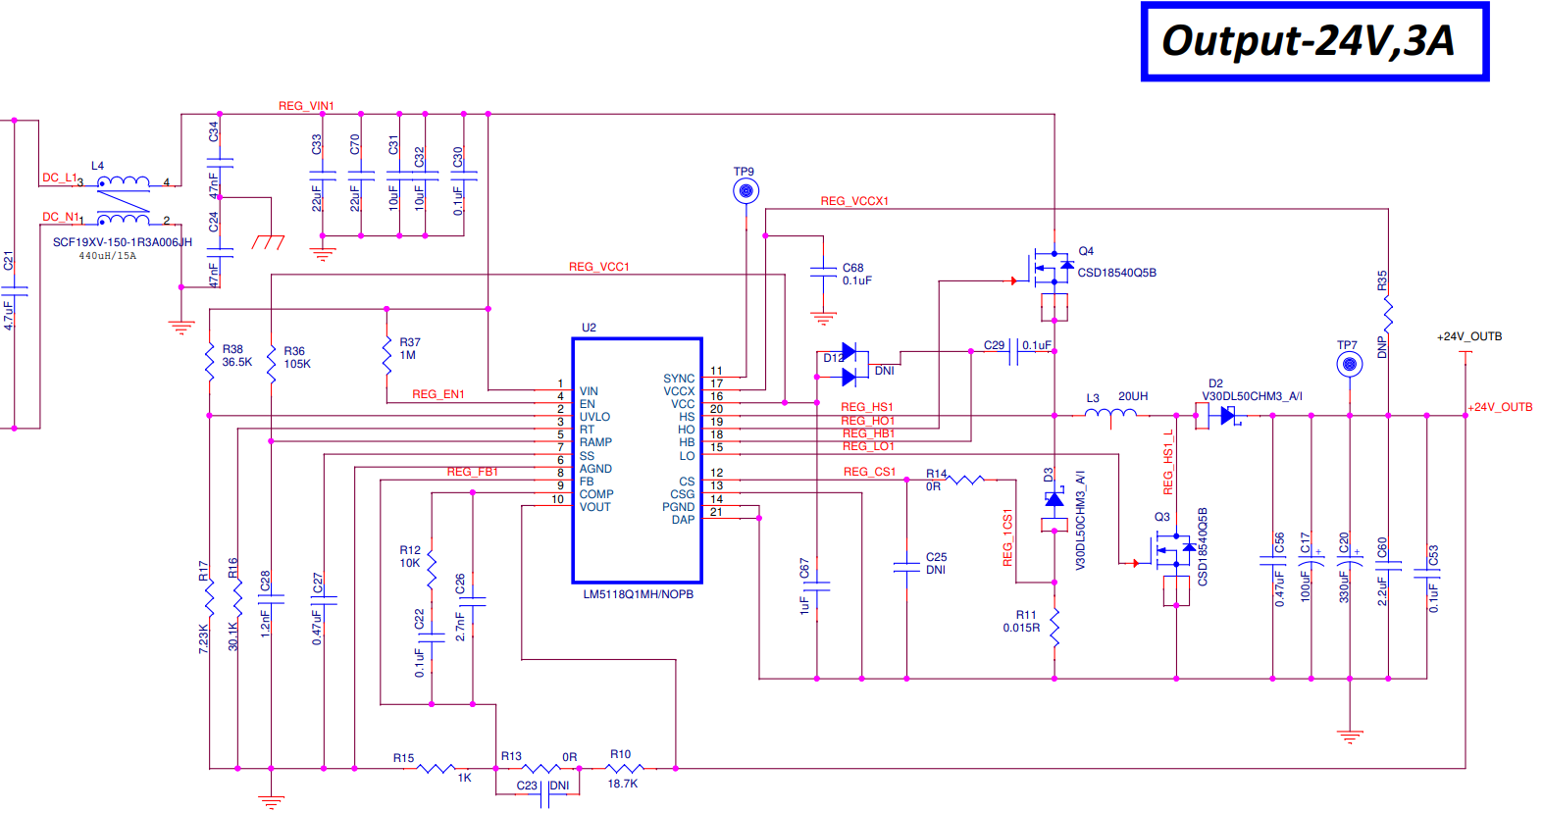

1. Steady state No load waveform of Q3 with input 12V & output 24V

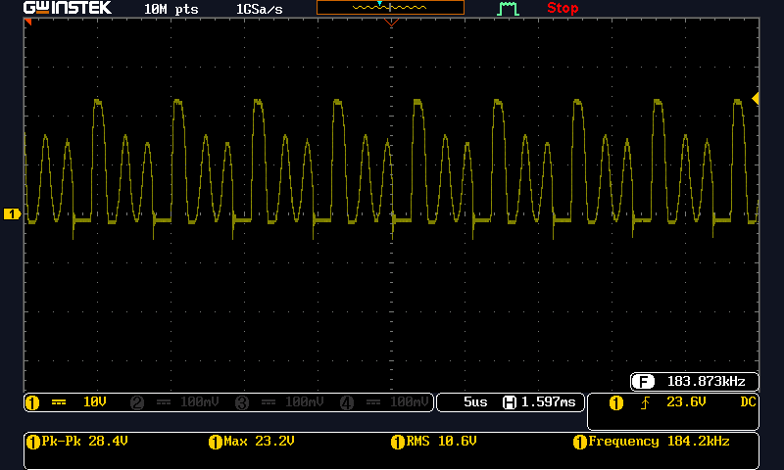

1. Steady state No load waveform of Q3 with input 36V & output 24V

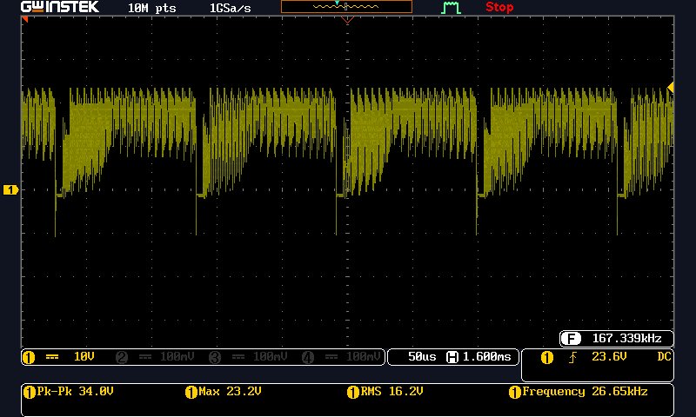

1. Start-up No load waveform of Q3 with input 12V & output 24V

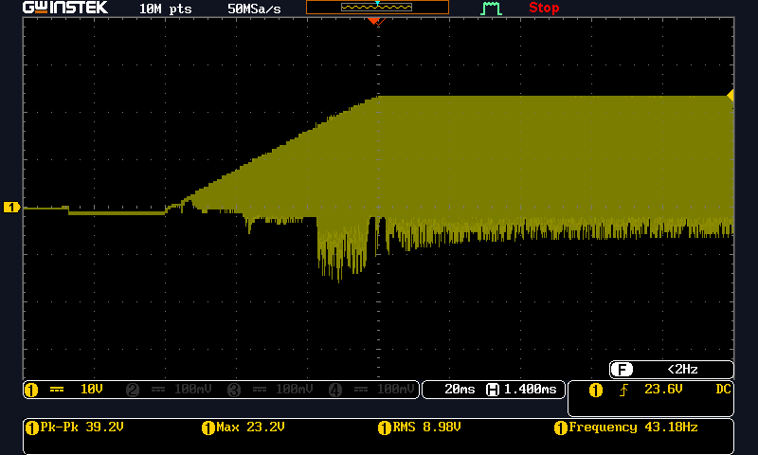

1. Start-up No load waveform of Q3 with input 36V & output 24V

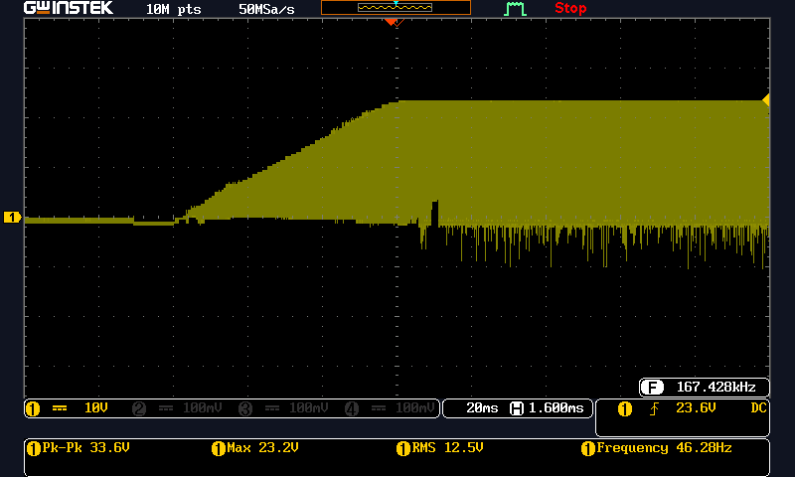

1. Steady state full load waveform of Q3 with input 12V & output 24V 3A

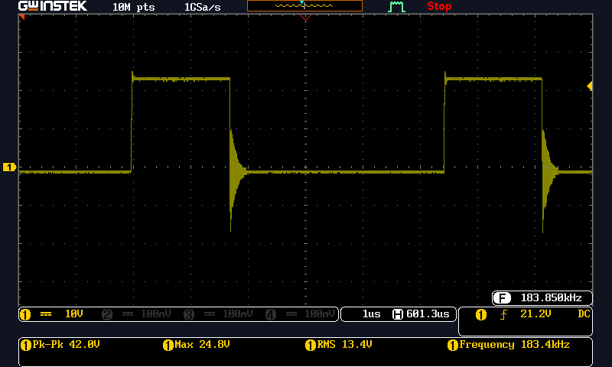

1. Steady state full load waveform of Q3 with input 36V & output 24V 3A

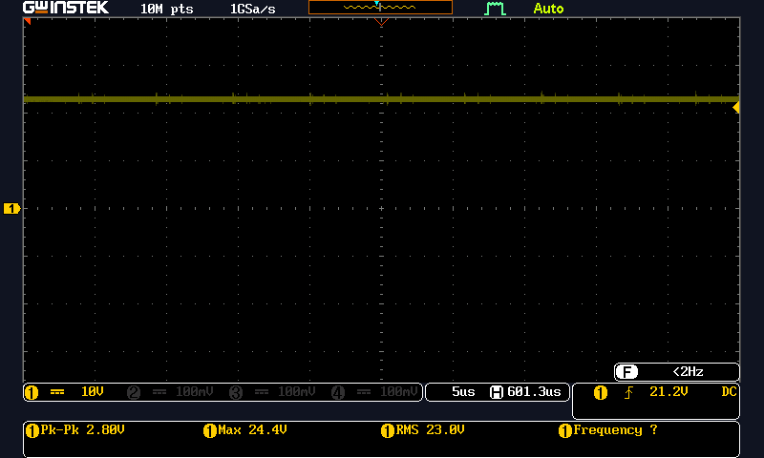

1. Start-up full load waveform of Q3 with input 12V & output 24V 3A

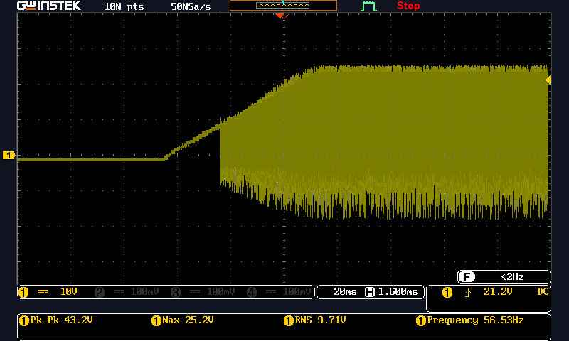

1. Start-up full load waveform of Q3 with input 36V & output 24V 3A

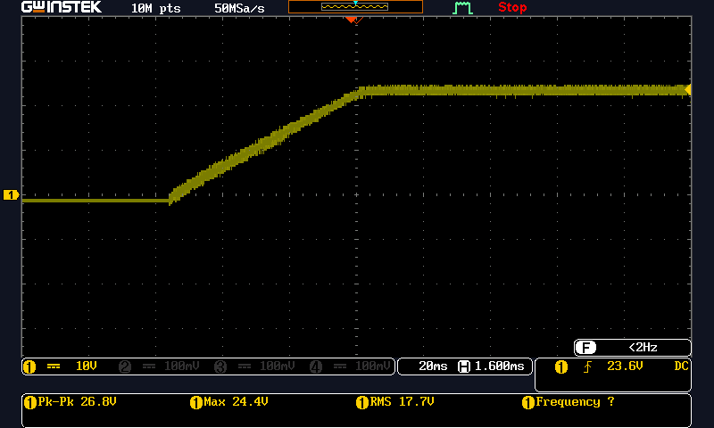

1. Steady state No load waveform of Q4 with input 12V & output 24V

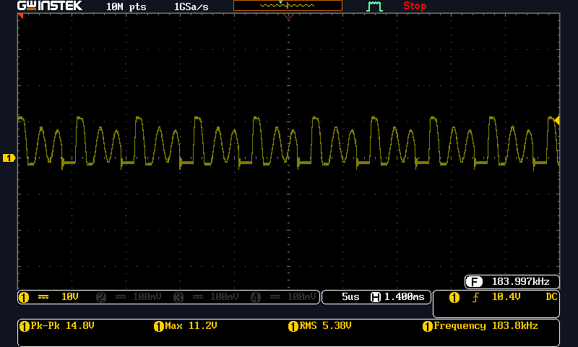

1. Steady state No load waveform of Q4 with input 36V & output 24V

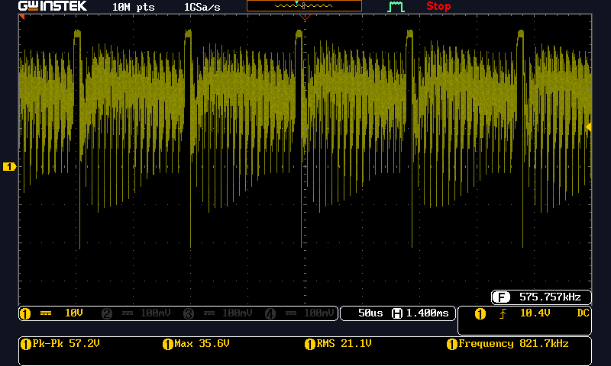

1. Start-up No load waveform of Q4 with input 12V & output 24V

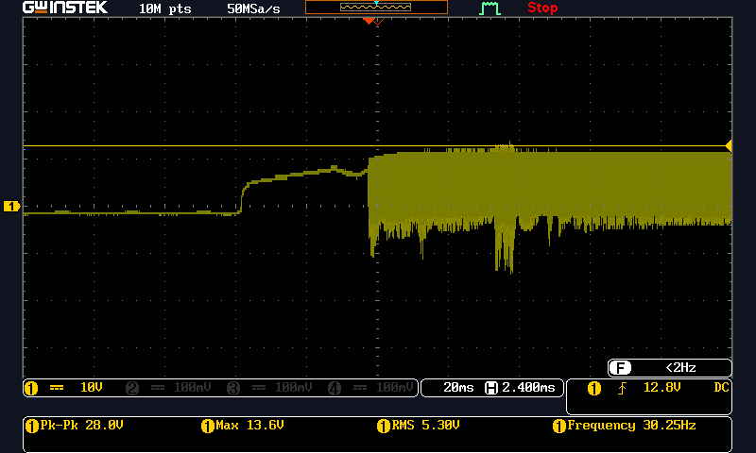

1. Start-up No load waveform of Q4 with input 36V & output 24V

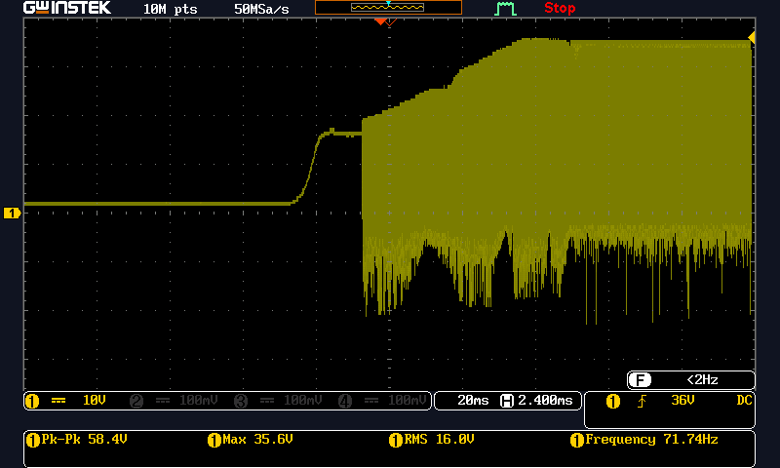

1. Steady state full load waveform of Q4 with input 12V & output 24V 3A

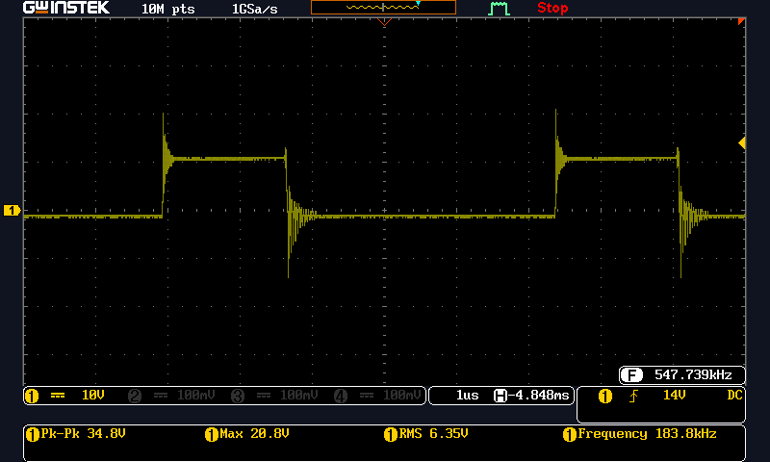

1. Steady state full load waveform of Q4 with input 36V & output 24V 3A

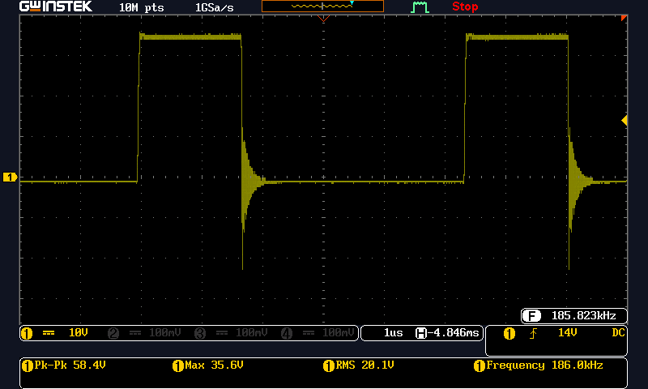

1. Start-up full load waveform of Q4 with input 12V & output 24V 3A

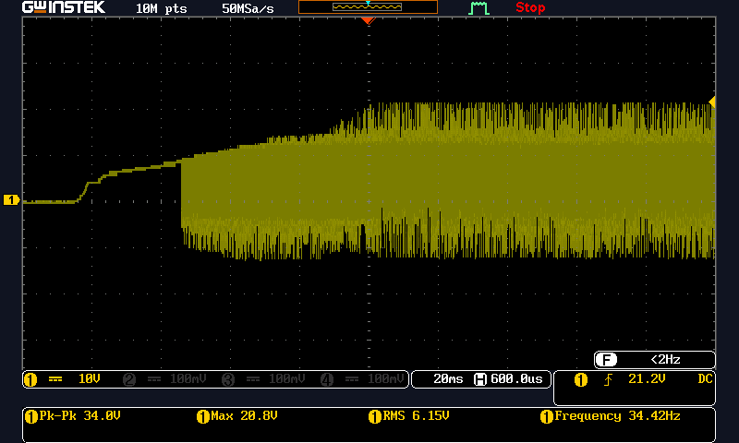

1. Start-up full load waveform of Q4 with input 36V & output 24V 3A

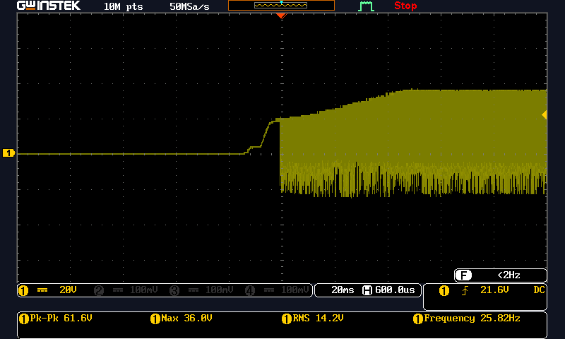

1. Steady state No load waveform of D2 with input 12V & output 24V

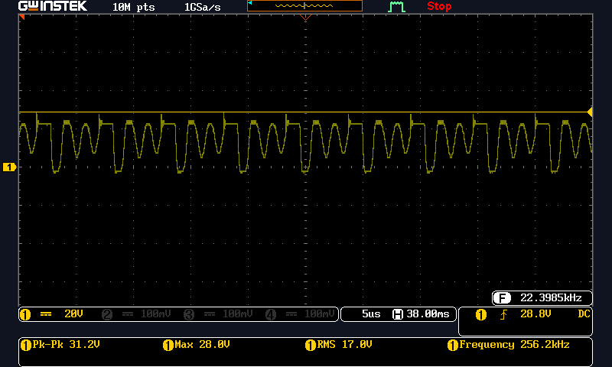

1. Steady state No load waveform of D2 with input 36V & output 24V

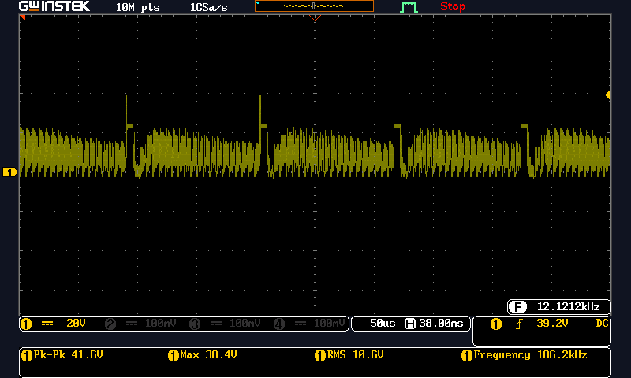

1. Start-up No load waveform of D2 with input 12V & output 24V

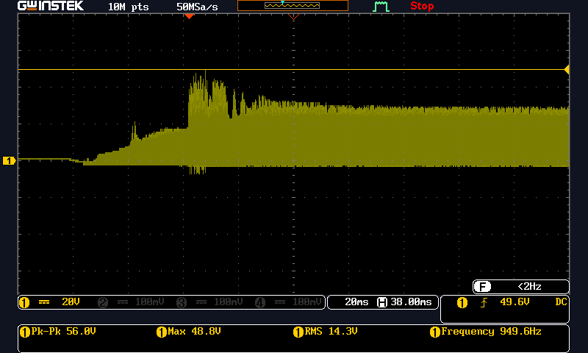

1. Start-up No load waveform of D2 with input 36V & output 24V

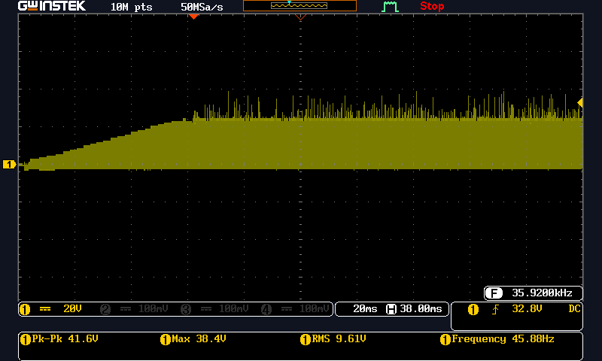

1. Steady state full load waveform of D2 with input 12V & output 24V 3A

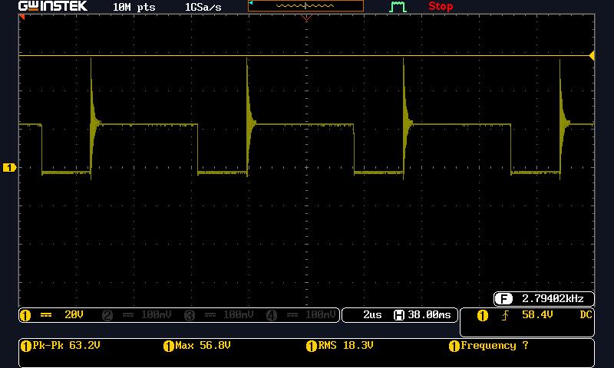

1. Steady state full load waveform of D2 with input 36V & output 24V 3A

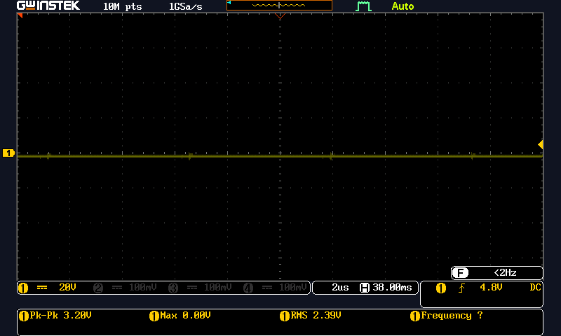

1. Start-up full load waveform of D2 with input 12V & output 24V 3A

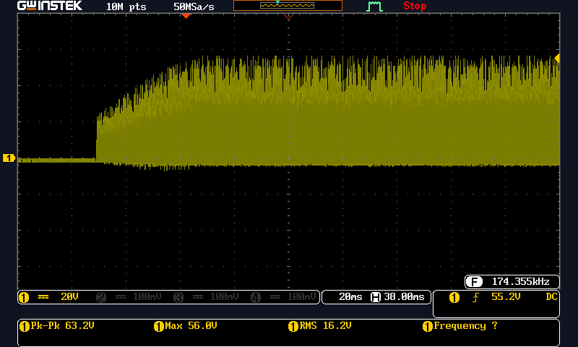

1. Start-up full load waveform of D2 with input 36V & output 24V 3A

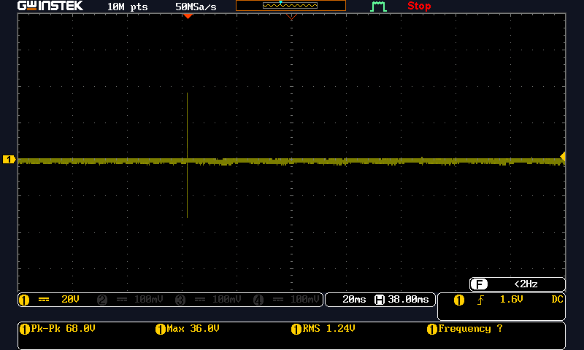

1. Steady state No load waveform of D3 with input 12V & output 24V

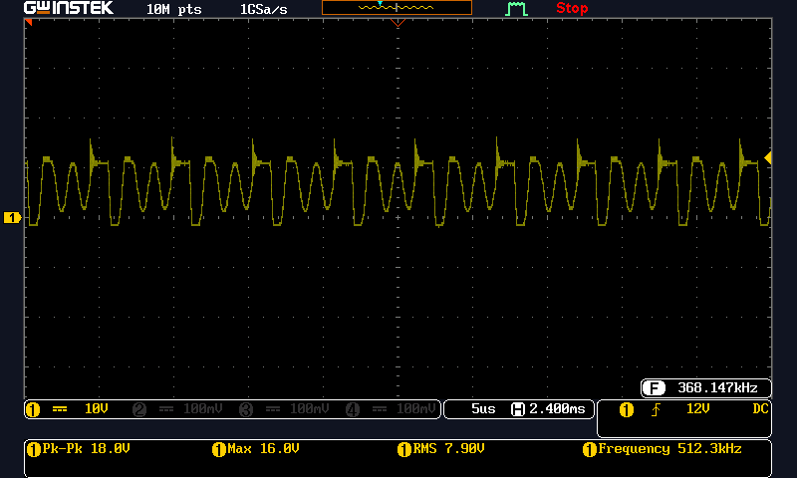

1. Steady state No load waveform of D3 with input 36V & output 24V

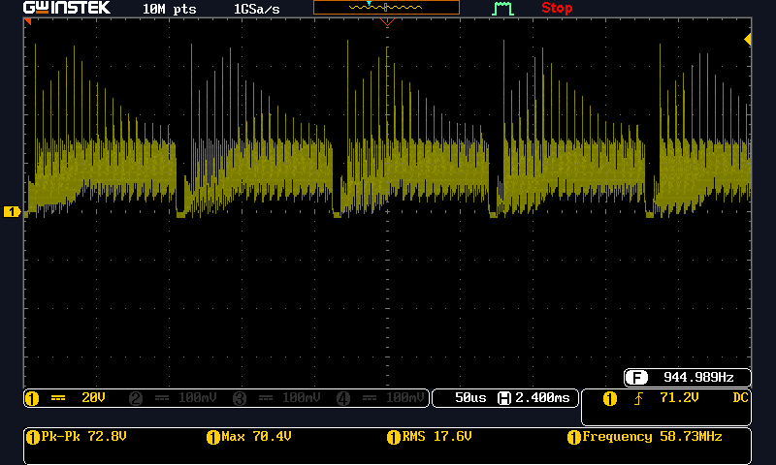

1. Start-up No load waveform of D3 with input 12V & output 24V

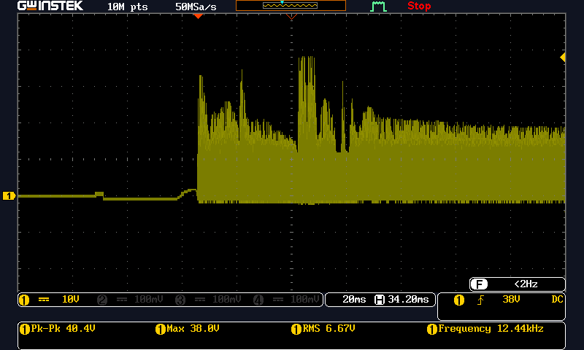

1. Start-up No load waveform of D3 with input 36V & output 24V

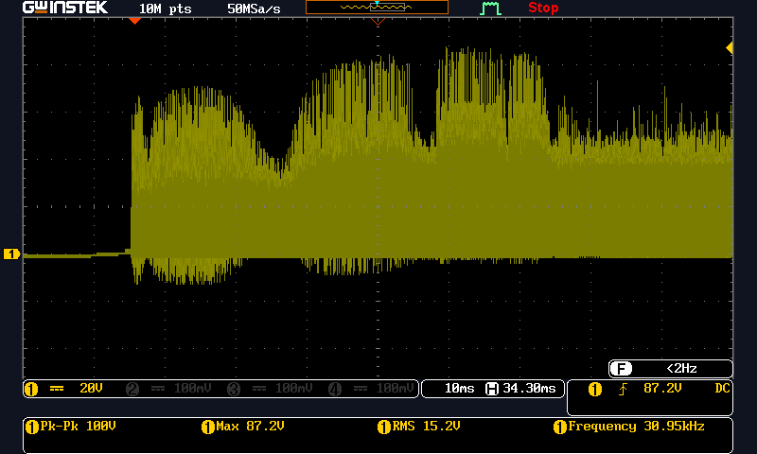

1. Steady state full load waveform of D3 with input 12V & output 24V 3A

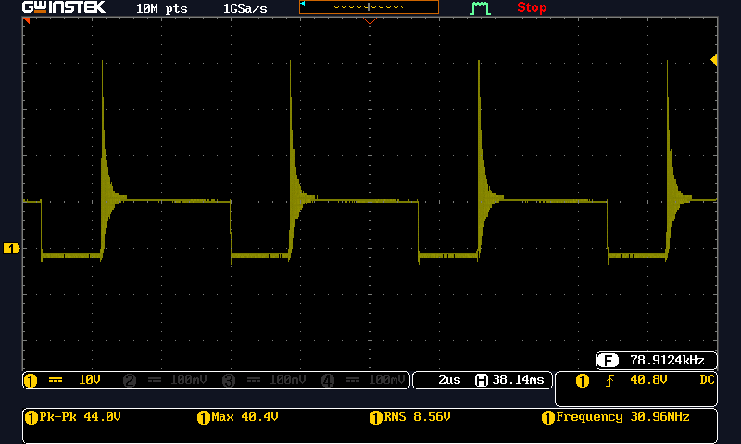

1. Steady state full load waveform of D3 with input 36V & output 24V 3A

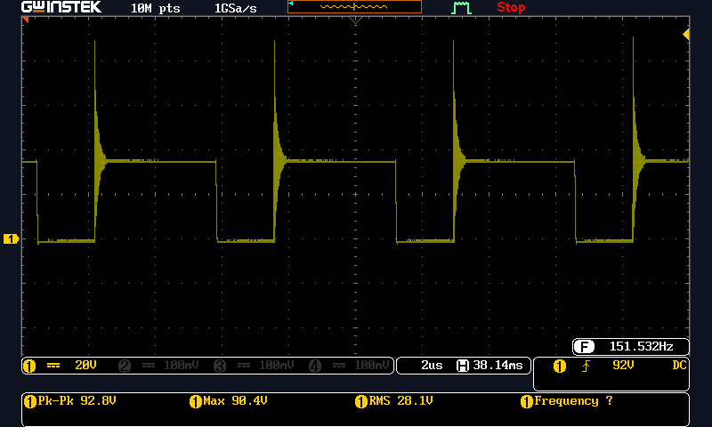

1. Start-up full load waveform of D3 with input 12V & output 24V 3A

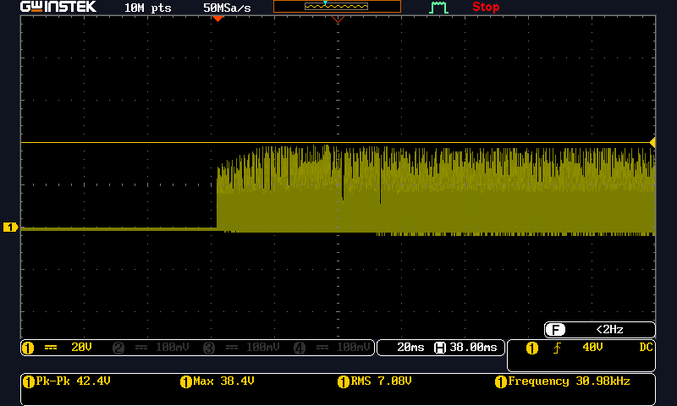

1. Start-up full load waveform of D3 with input 36V & output 24V 3A

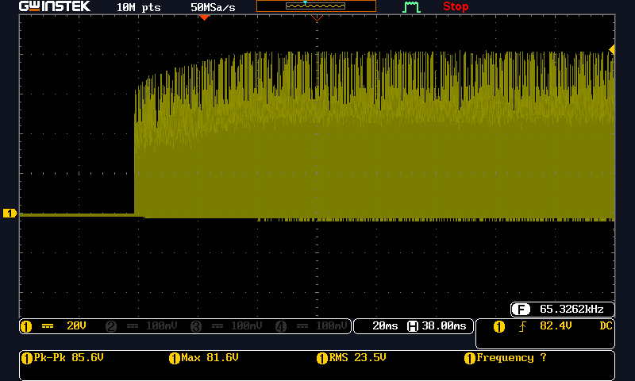

**RIPPLE VOLTAGE**

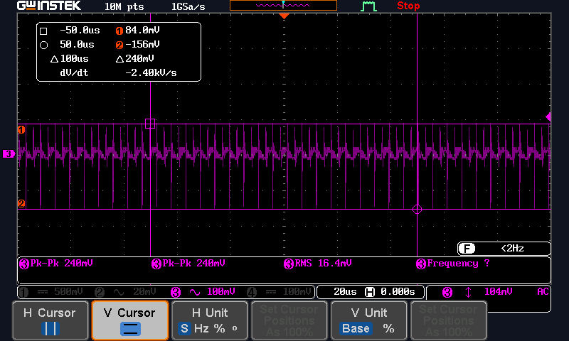

|  |  |  |  |  |  |  |
| --- | --- | --- | --- | --- | --- | --- |
| **Load:1500mA** | | | | | | |
| **Vin(v)** | **Iin(A)** | **Pin(w)** | **Vout(v)** | **Iout(A)** | **Pout(w)** | **Efficiency(%)** |
| 12v | 3.44 | 41.28 | 24.06 | 1.538 | 37.00 | 89.63 |
| 15v | 2.75 | 41.25 | 24.07 | 1.538 | 37.01 | 89.72 |
| 20v | 2.07 | 41.4 | 24.04 | 1.537 | 36.94 | 89.27 |
| 25v | 1.66 | 41.5 | 24.05 | 1.536 | 36.94 | 89.01 |
| 30v | 1.33 | 39.9 | 24.07 | 1.537 | 36.99 | 92.70 |
| 36v | 1.08 | 39.2 | 24.07 | 1.537 | 36.99 | 94.36 |

|  |  |  |  |  |  |  |
| --- | --- | --- | --- | --- | --- | --- |
| **Load:2000mA** | | | | | | |
| **Vin(v)** | **Iin(A)** | **Pin(w)** | **Vout(v)** | **Iout(A)** | **Pout(w)** | **Efficiency(%)** |
| 12v | 4.55 | 54.6 | 24.01 | 2.011 | 48.28 | 88.42 |
| 15v | 3.591 | 53.86 | 24.00 | 2.012 | 48.28 | 89.36 |
| 20v | 2.68 | 53.6 | 24.01 | 2.012 | 48.30 | 90.11 |
| 25v | 2.15 | 53.75 | 24.01 | 2.012 | 48.30 | 89.86 |
| 30v | 1.74 | 52.2 | 24.01 | 2.012 | 48.30 | 92.52 |
| 36v | 1.42 | 51.45 | 24.01 | 2.012 | 48.30 | 93.87 |

**LOAD, LINE REGULATION AND EFFICIENCY**

|  |  |  |  |  |  |  |
| --- | --- | --- | --- | --- | --- | --- |
| **Load:3000mA** | | | | | | |
| **Vin(v)** | **Iin(A)** | **Pin(w)** | **Vout(v)** | **Iout(mA)** | **Pout(w)** | **Efficiency(%)** |
| 12v | 7.00 | 84 | 23.90 | 3.007 | 71.86 | 85.54 |
| 15v | 5.42 | 81.3 | 23.89 | 3.008 | 71.86 | 88.38 |
| 20v | 4.00 | 80 | 23.90 | 3.007 | 71.86 | 89.82 |
| 25v | 3.20 | 80 | 23.90 | 3.004 | 71.79 | 89.73 |
| 30v | 2.58 | 77.4 | 23.90 | 3.006 | 71.84 | 92.81 |
| 36v | 2.12 | 76.42 | 23.90 | 3.006 | 71.84 | 94.00 |