Thank you for receiving my help request,

Chip: BQ27510

Target Programmer: EVA2300 HPA002

Software : bqEVSW 00.09.71 ?

The Software readme indicates the best contact is Shirish Kavoor [s-kavoor@ti.com](mailto:s-kavoor@ti.com)

The desired goal is to program the units on our production line with the following settings.

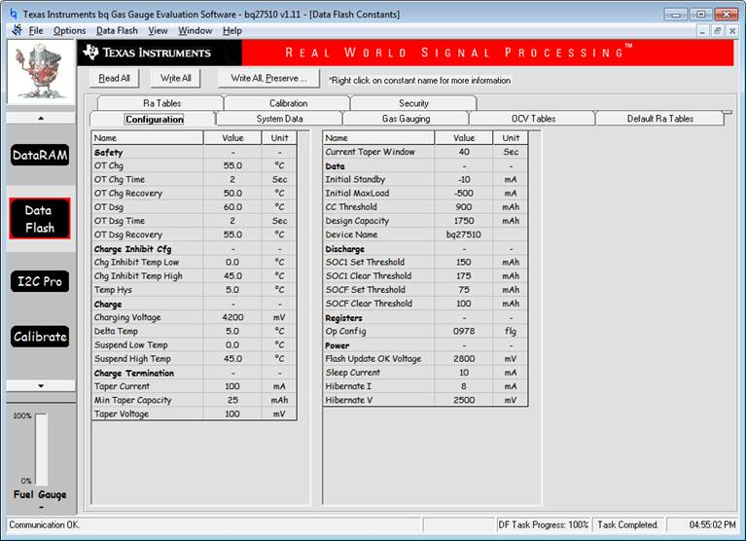

Neuronetrix suffered a data loss that resulted in the loss of the Manufacturing Build Procedures which included the programming methods and requirements for this chip.

Looking back at a development notebook from about 5 years ago and working from memory, I believe these should be the steps, although as they don’t seem to be working, it’s quite possible that one of them is incorrectly.

Startup Splash Screen

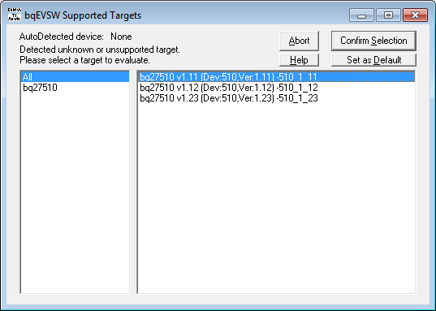  We Select ver. 1.11

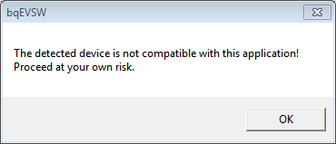First error message

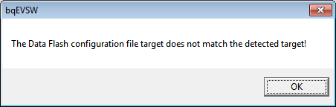second error message

Select dataflash:

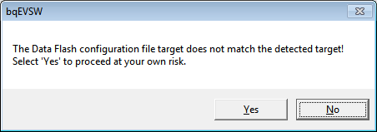3rd error message

Select “Read All” cid:image011.png@01D1126E.3550B800

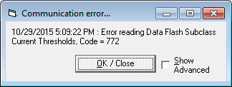

Select “Read All” cid:image011.png@01D1126E.3550B800

Operation works and all registers populate with their respective data.

Select “Write All” cid:image012.png@01D1126E.3550B800

Operation successful

Swap golden unit out with newly manufactured board to program the new board

Select “write All” cid:image012.png@01D1126E.3550B800

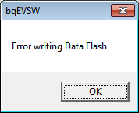

Then the program commences a “read all” automatically and populates all the registers with data from the non-gold unit.

Troubleshooting

Attempts to create dfi files or load configuration via bqEASY has been unsuccessful

Attempt to create \*.senc file has been unsuccessful  (772 error)

Attempting to use V1.12 or V1.23 have been unsuccessful