**800W @ 28VDC IN**

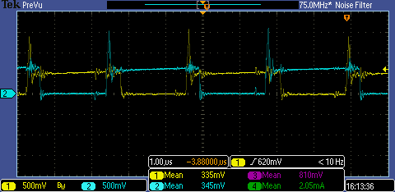

**800W @ 25VDC IN**

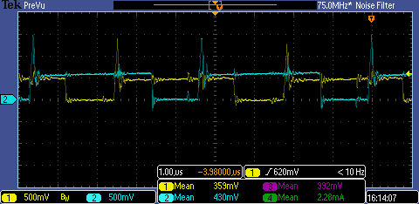

**800W @ 24VDC IN**

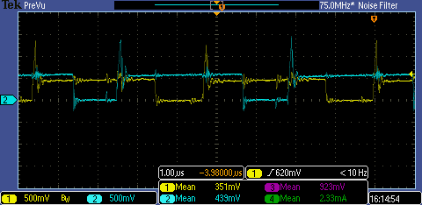

**1200W @ 28VDC IN**

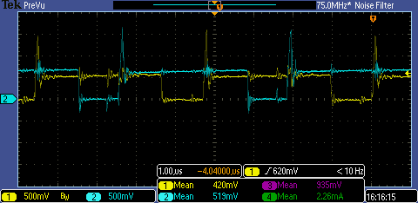

**1200W @ 25VDC IN**

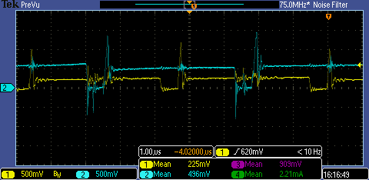

**1200W @ 24VDC IN**

