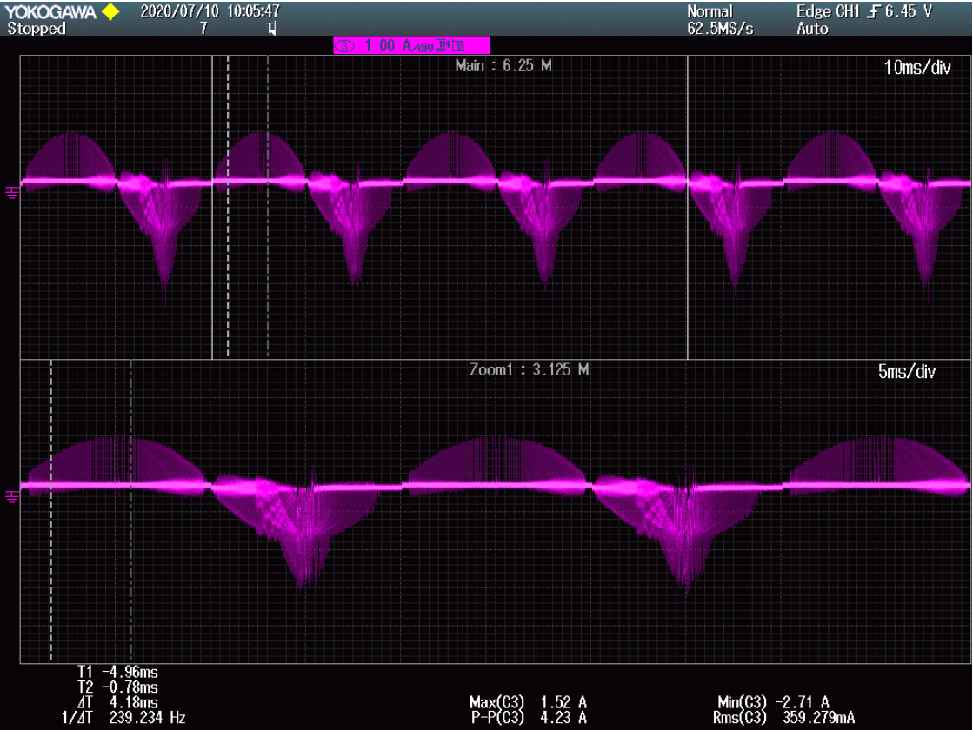

Ch3： input current；

I doubt Vin is too high， then obtain the below pic；

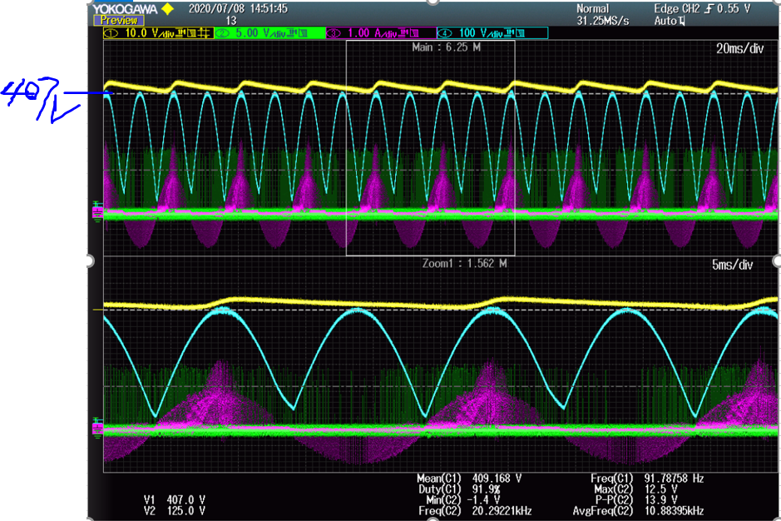

Ch1：PFCVout； ch2 DRB；ch3 input current ；ch4 input voltage；

We can find Vout > Vin all the time , it explain it is not the root cause ; then we doubt output power is too low, and then we obtain the below wave;

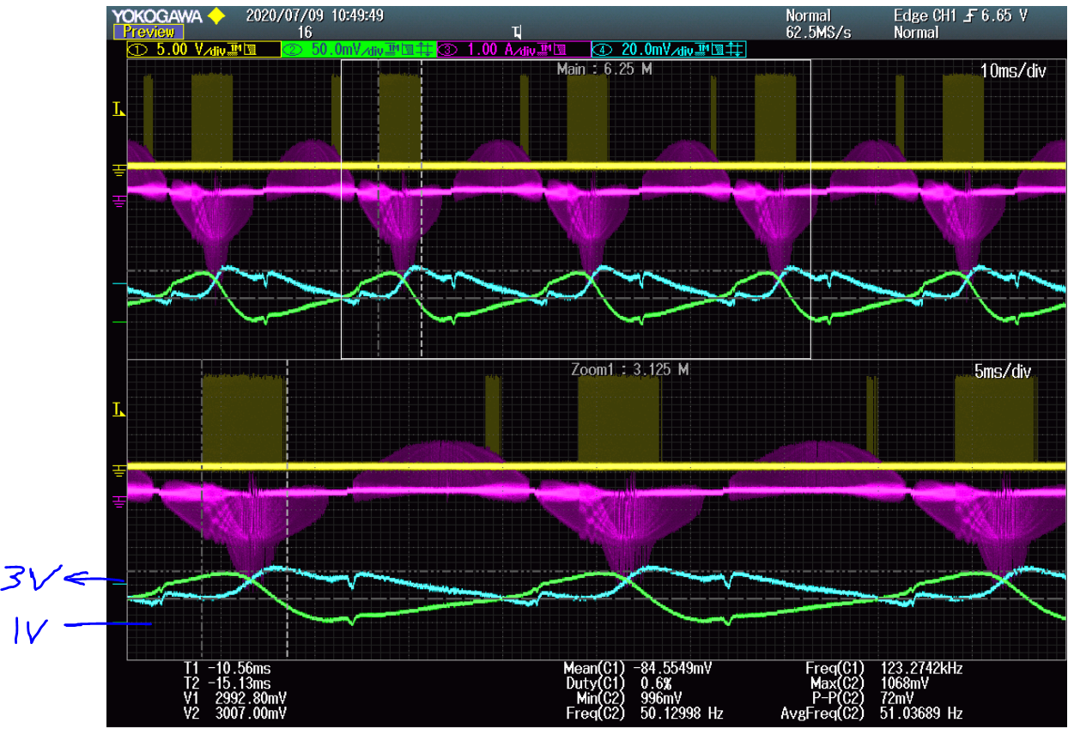

Ch1: DRA; ch2: VAO; ch3: input current ; ch4: Vsense;

We can conclude VAO > 0.75; so it is not root cause;

One question : Vsense > 3V , GDA,GDB is prohibit ?

from pic GDA,GDB is not probit.

Two question: input wave as below pic show on which condition ?

