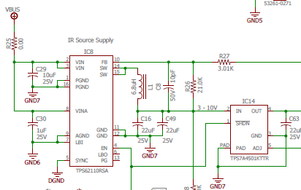

Rvariable

Ifb

Vout

Vfb

Measured raw data

|  |  |  |
| --- | --- | --- |
|  | Vout(V) | Vfb(V) |
| Board1 | 3.389setting1 | 1.162 |
|  | 3.861setting2 | 1.162 |
|  | 4.575setting3 | 1.162 |
| Board2 | 3.429 setting1 | 1.164 |
|  | 3.911 setting2 | 1.164 |
|  | 4.630 setting3 | 1.164 |