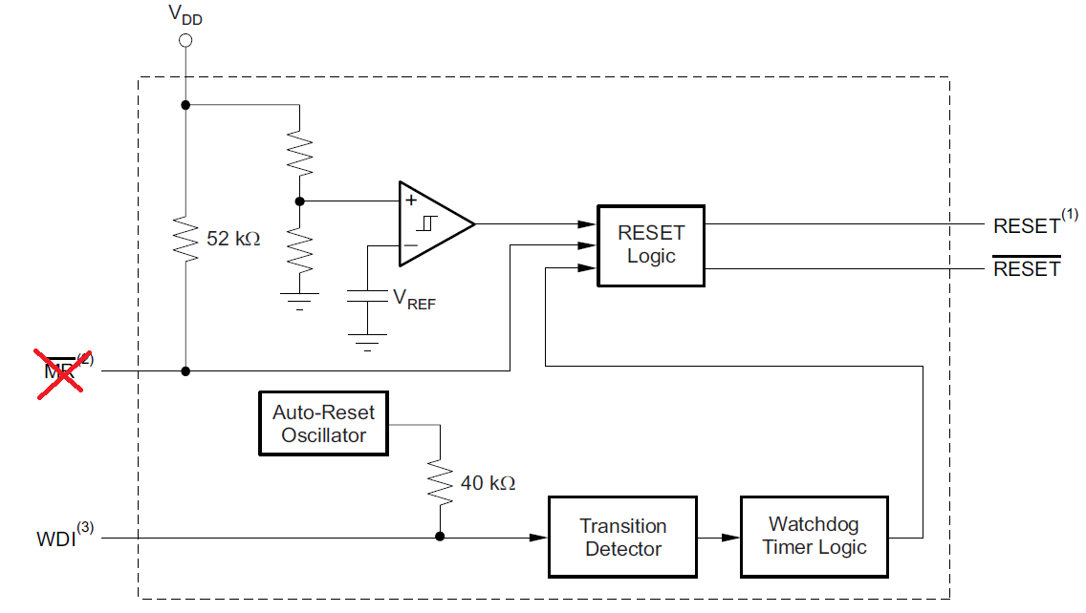 | Fig-2: CH1_VDD, CH2_/RESET, CH3_WDI(Floating)  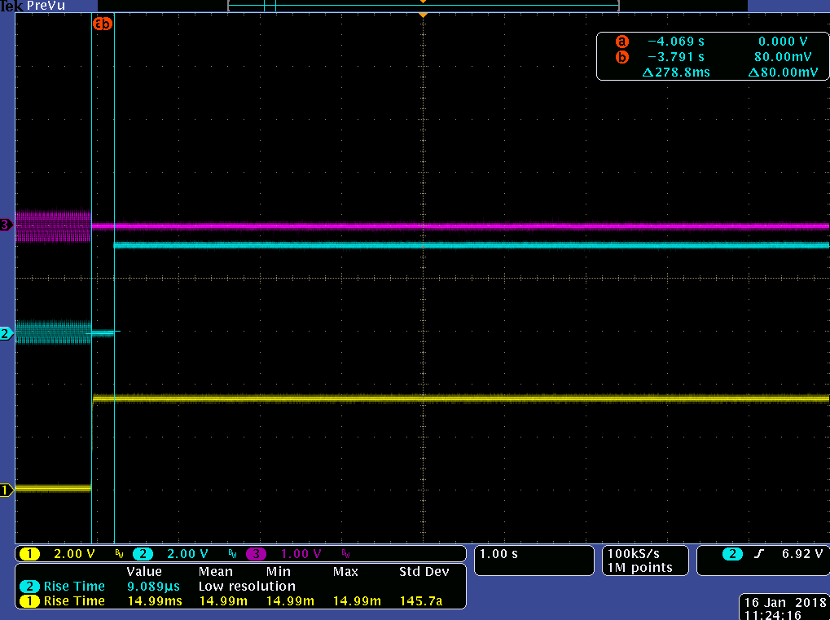
Fig-2: CH1_VDD, CH2_/RESET, CH3_WDI(20K to VDD)  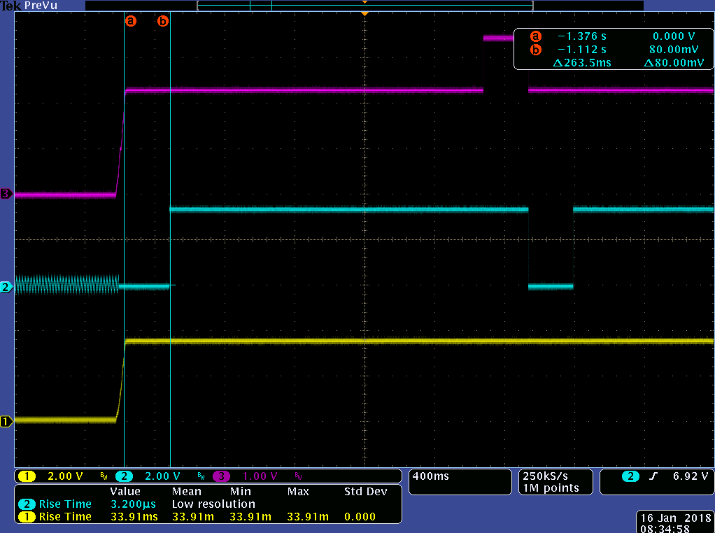 | Fig-3: CH1_VDD, CH2_/RESET, CH3_WDI(2K to GND)  