How can I use the SS/EN pin to control the Hiccup time?
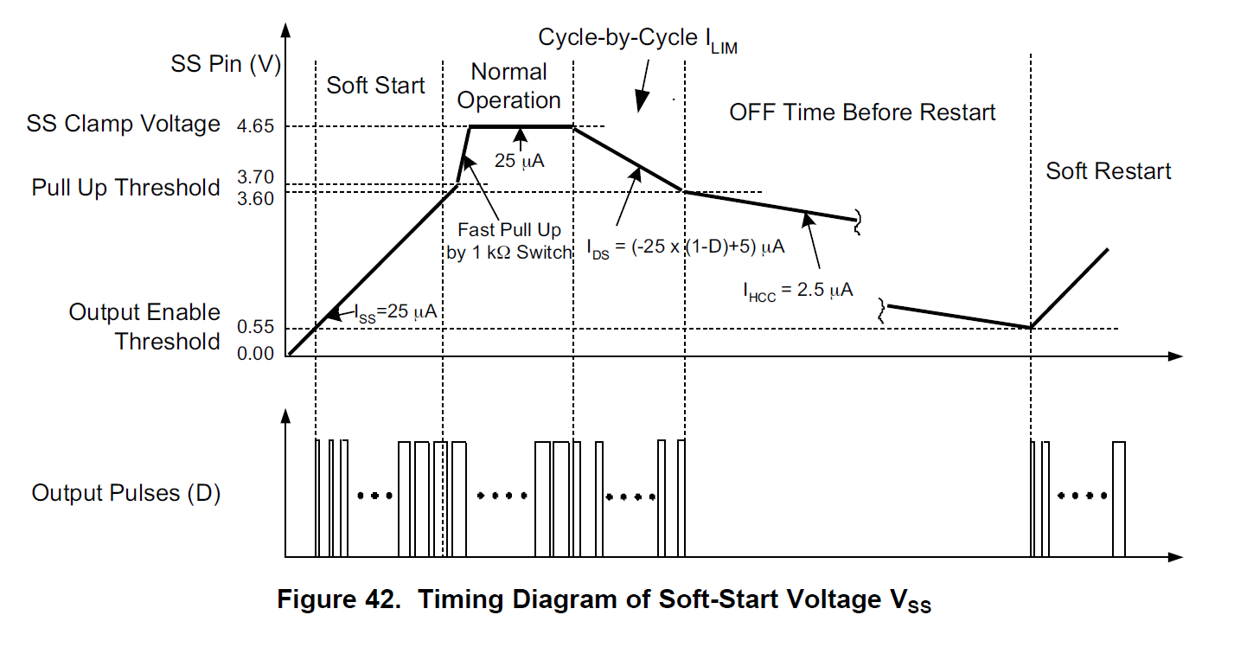
The soft start is controlled by the voltage ramp on the SS/EN pin. In the simplest case only the soft start capacitor C_{SS} is required. Figure 42 in the data sheet shows the currents in and out of the SS/EN pin in the four intervals; Soft-Start, Normal Operation, Cycle-by-Cycle (CbC) and OFF time.
An external MOSFET, Q_{EN} can be used to clamp the SS/EN pin below the Output Enable (OE) threshold and this will prevent the controller from operating.
If the controller is being used in Slave Mode then R_{SL} (825kΩ) is added in parallel with C_{SS}.
The OFF time before restart is set by the amount of time needed for the SS/EN pin to discharge the soft start capacitor to the OE threshold (550mV) and it can be increased by adding the resistor R_{H}.
The OFF time is set by the current in the capacitor C_{SS} and its capacitance. The current is the sum of I_{HCC} into the SS/EN pin and the currents in resistors R_{SL} and R_{H}. The MOSFET is off and its current is negligible. The current in R_{SL} and the SS/EN pin are negative so they will discharge the capacitor but current in R_{H} is positive and will tend to charge it.
The value of RH can be chosen to give three different behaviours.

Hiccup mode with extended OFF time before Restart
If the current in R_{H} is less than I_{HCC} when SS/EN is at the OE threshold, then C_{SS} will be discharged to the threshold and the controller will then re-start. Lower values of R_{H} will increase the OFF time. For example and neglecting tolerances: VREF is 5V so a 3Meg resistor will pass 1.5uA when the SS/EN pin is at 500mV.

Latched OFF mode with no Restart
As the value of R_{H} is reduced, eventually a point will be reached where the resistor prevents C_{SS} being discharged to the OE threshold. The OFF time will be extended indefinitely with no restart unless an external switch is turned on (Q_{EN}). For example and neglecting tolerances: VREF is 5V so a 1 Meg resistor will pass 2.5uA when the SS/EN pin is at 2.5V. Switching will have stopped because the SS/EN pin is below the 3.6V V_{HCC} threshold but there will not be a restart because the SS/EN pin has not fallen to the OutEn threshold.

Continuous operation at I_{LIM}. No Hiccup mode.
If R_{H} is reduced even more then it will prevent the I_{DS} current from pulling the SS/EN pin below the V_{HCC} threshold. The controller will continue to operate in Cycle-by-Cycle mode. The resistor value is R_{H} < (V_{REF} - V_{HCC})/I_{DS} - Typically a value of around 62kOhms would work. If you want the controller to shut down in this condition then you will need to turn Q_{EN}.

