Peak Voltage across 0.5E resistor:

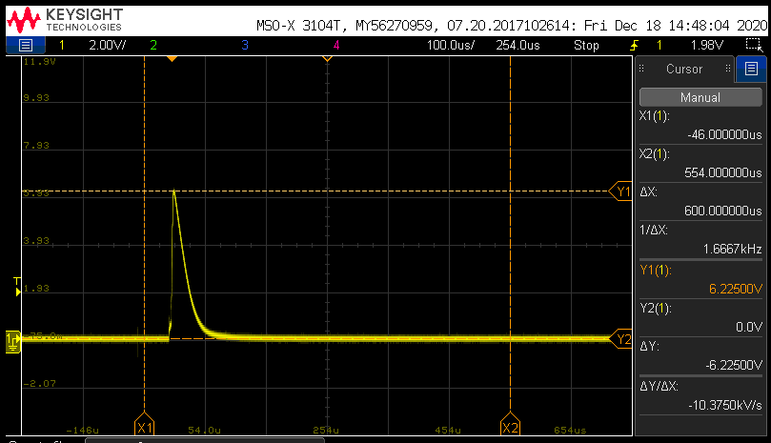

Battery Mosfet Q14 Gate turn on time:

