**Test Report: 13W / 5V**

Class 3 PoE PD (5-V/2.3-A) and Passive 24-V (5-V/2.3-A) Supply Reference Design

**Description**

This reference design utilizes a sync flyback converter for a standard Class 4 Power over Ethernet (PoE) Powered Device (PD) with a 5-V/2.3-A output. In addition, a 24-V passive PoE input can supply a 5-V/2.3-A output. A TPS23730 combination PD/PWM controller provides all PoE PD functions such as Detection, Class and In-rush limiting and the flyback PWM controller in one package. The PWM utilizes opto-less primary side regulation. This reference design is ideally suited for PoE applications such as wireless access points and IP cameras.

# Test Prerequisites

## Voltage and Current Requirements

1. Voltage and Current Requirements

|  |  |
| --- | --- |
| PARAMETER | SPECIFICATIONS |
| Class 4 standard PoE input voltage | 42.5-57 V on pairs 1/2 and 3/6 |
| Passive PoE input voltage | 16-30 V on pairs 4/5 and 7/8 |
| Vout | 5 V |
| Iout (Custom/Class4/Passive) | 2.6.0 A/2.3 A/2.3 A |
| Nominal Switching Frequency | 250 kHz |

## Required Equipment

* IEEE802.3.bt Type 2 PSE
* Isolated DC power source, 16-30 V, 2.0 A minimum
* CAT5e ethernet cables (<100m)
* 5 V/2.6 A electronic load

## Considerations

All measurements taken at approximately 25 C ambient.

# Testing and Results

## Efficiency Graph

## Efficiency Data

|  |  |  |  |  |  |  |
| --- | --- | --- | --- | --- | --- | --- |
|  |  |  |  |  |  |  |
|  |  |  |  |  |  |  |

|  |  |  |  |  |  |  |  |  |
| --- | --- | --- | --- | --- | --- | --- | --- | --- |
| PoE (V) | IIN (A) | DCDC (V) | VOUT (V) | IOUT (A) | Input Power (W) | Output Power (W) | Eff PoE | Eff DCDC |
| 16.002 | 0.02853 | 15.256 | 5.3339 | 0 | 0.46 | 0.00 | 0.00% | 0.00% |
| 16.008 | 0.2068 | 15.065 | 5.308 | 0.5012 | 3.31 | 2.66 | 80.36% | 85.39% |
| 15.999 | 0.2979 | 15 | 5.2891 | 0.7491 | 4.77 | 3.96 | 83.13% | 88.67% |
| 16 | 0.3946 | 14.94 | 5.2681 | 1.0054 | 6.31 | 5.30 | 83.89% | 89.84% |
| 15.996 | 0.4884 | 14.878 | 5.2438 | 1.2501 | 7.81 | 6.56 | 83.91% | 90.21% |
| 15.917 | 0.592 | 14.742 | 5.2148 | 1.5101 | 9.42 | 7.87 | 83.57% | 90.23% |
| 16.004 | 0.6813 | 14.776 | 5.1873 | 1.7477 | 10.90 | 9.07 | 83.15% | 90.06% |
| 16.004 | 0.7885 | 14.703 | 5.1535 | 2.0202 | 12.62 | 10.41 | 82.50% | 89.80% |
| 15.999 | 0.9028 | 14.636 | 5.1151 | 2.3057 | 14.44 | 11.79 | 81.65% | 89.26% |
| 15.998 | 1.0191 | 14.56 | 5.0743 | 2.59 | 16.30 | 13.14 | 80.61% | 88.57% |

|  |  |  |  |  |  |  |
| --- | --- | --- | --- | --- | --- | --- |
|  |  |  |  |  |  |  |

|  |  |  |  |  |  |  |  |  |
| --- | --- | --- | --- | --- | --- | --- | --- | --- |
| PoE (V) | IIN (A) | DCDC (V) | VOUT (V) | IOUT (A) | Input Power (W) | Output Power (W) | Eff PoE | Eff DCDC |
| 24.011 | 0.0232 | 23.26 | 5.319 | 0 | 0.56 | 0.00 | 0.00% | 0.00% |
| 24.012 | 0.1403 | 23.116 | 5.298 | 0.5086 | 3.37 | 2.69 | 79.98% | 83.08% |
| 24.014 | 0.1969 | 23.08 | 5.283 | 0.7511 | 4.73 | 3.97 | 83.92% | 87.32% |
| 24.001 | 0.2564 | 23.024 | 5.2691 | 1.0042 | 6.15 | 5.29 | 85.98% | 89.63% |
| 24.001 | 0.3166 | 22.986 | 5.2548 | 1.256 | 7.60 | 6.60 | 86.86% | 90.69% |
| 23.999 | 0.3757 | 22.944 | 5.2397 | 1.4991 | 9.02 | 7.85 | 87.12% | 91.12% |
| 24.012 | 0.4373 | 22.926 | 5.2221 | 1.7506 | 10.50 | 9.14 | 87.06% | 91.19% |
| 24.013 | 0.5018 | 22.889 | 5.2021 | 2.0179 | 12.05 | 10.50 | 87.12% | 91.39% |
| 24.024 | 0.5706 | 22.857 | 5.1798 | 2.3024 | 13.71 | 11.93 | 87.00% | 91.44% |
| 24.016 | 0.6452 | 22.808 | 5.1551 | 2.6031 | 15.50 | 13.42 | 86.60% | 91.19% |

|  |  |  |  |  |  |  |
| --- | --- | --- | --- | --- | --- | --- |
|  |  |  |  |  |  |  |
|  |  |  |  |  |  |  |
|  |  |  |  |  |  |  |
|  |  |  |  |  |  |  |
|  |  |  |  |  |  |  |
|  |  |  |  |  |  |  |
|  |  |  |  |  |  |  |
|  |  |  |  |  |  |  |

|  |  |  |  |  |  |  |  |  |
| --- | --- | --- | --- | --- | --- | --- | --- | --- |
| PoE (V) | IIN (A) | DCDC (V) | VOUT (V) | IOUT (A) | Input Power (W) | Output Power (W) | Eff PoE | Eff DCDC |
| 48.942 | 0.02044 | 48.063 | 5.289 | 0 | 1.00 | 0.00 | 0.00% | 0.00% |
| 48.908 | 0.07555 | 48.073 | 5.2717 | 0.5019 | 3.69 | 2.65 | 71.61% | 72.85% |
| 48.8892 | 0.1028 | 48.027 | 5.262 | 0.7481 | 5.03 | 3.94 | 78.33% | 79.73% |
| 48.935 | 0.1311 | 48.046 | 5.2517 | 1.0038 | 6.42 | 5.27 | 82.17% | 83.69% |
| 48.98 | 0.15811 | 48.07 | 5.242 | 1.2491 | 7.74 | 6.55 | 84.55% | 86.15% |
| 48.963 | 0.1865 | 48.031 | 5.2326 | 1.5042 | 9.13 | 7.87 | 86.19% | 87.87% |
| 49.022 | 0.21467 | 48.07 | 5.2233 | 1.7596 | 10.52 | 9.19 | 87.34% | 89.07% |
| 49.005 | 0.2409 | 48.036 | 5.2146 | 1.9948 | 11.81 | 10.40 | 88.11% | 89.89% |
| 49.033 | 0.2707 | 48.044 | 5.2044 | 2.2711 | 13.27 | 11.82 | 89.05% | 90.88% |
| 49.099 | 0.3116 | 48.084 | 5.19 | 2.6244 | 15.30 | 13.62 | 89.03% | 90.91% |

|  |  |  |  |  |  |  |  |  |
| --- | --- | --- | --- | --- | --- | --- | --- | --- |
| PoE (V) | IIN (A) | DCDC (V) | VOUT (V) | IOUT (A) | Input Power (W) | Output Power (W) | Eff PoE | Eff DCDC |
| 57.001 | 0.02061 | 56.258 | 5.2859 | 0 | 1.17 | 0.00 | 0.00% | 0.00% |
| 57.0003 | 0.06755 | 56.175 | 5.2694 | 0.4987 | 3.85 | 2.63 | 68.25% | 69.25% |
| 57.003 | 0.092 | 56.152 | 5.2596 | 0.7564 | 5.24 | 3.98 | 75.86% | 77.01% |
| 57.008 | 0.11744 | 56.133 | 5.249 | 1.0251 | 6.70 | 5.38 | 80.37% | 81.62% |
| 57.0004 | 0.1387 | 56.108 | 5.241 | 1.2499 | 7.91 | 6.55 | 82.86% | 84.18% |
| 57.0004 | 0.1615 | 56.089 | 5.232 | 1.491 | 9.21 | 7.80 | 84.74% | 86.12% |
| 57.008 | 0.18634 | 56.082 | 5.2228 | 1.7505 | 10.62 | 9.14 | 86.06% | 87.49% |
| 57.001 | 0.2168 | 56.05 | 5.211 | 2.062 | 12.36 | 10.75 | 86.95% | 88.42% |
| 57.004 | 0.2372 | 56.05 | 5.2039 | 2.273 | 13.52 | 11.83 | 87.48% | 88.97% |
| 57.007 | 0.26873 | 56.022 | 5.1917 | 2.598 | 15.32 | 13.49 | 88.04% | 89.59% |

## Regulation

## Thermal Images

48 V Input, 5 A Load, Top:

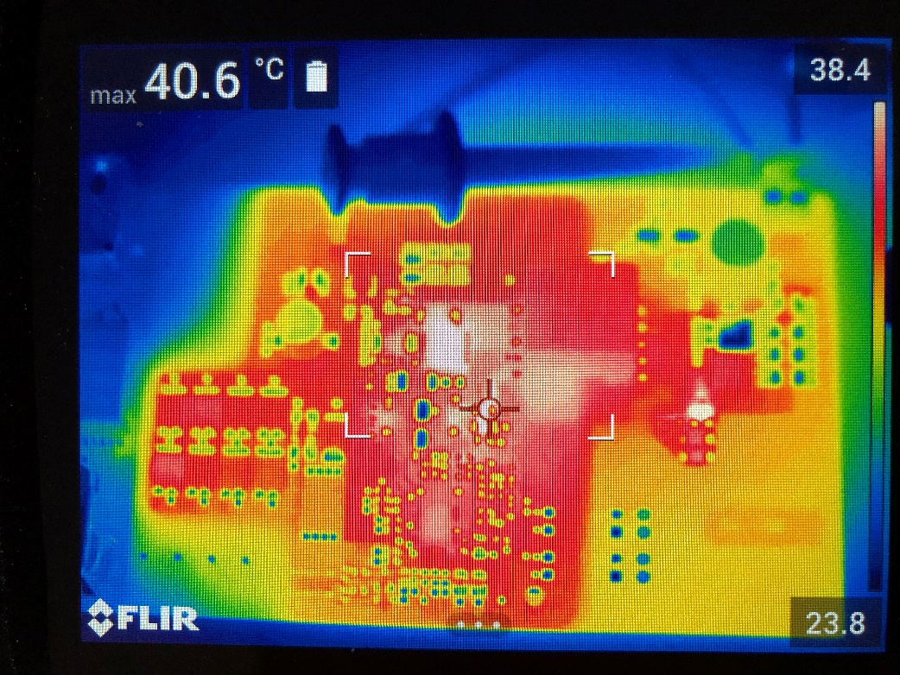

48 V Input, 5 A Load, Bottom:

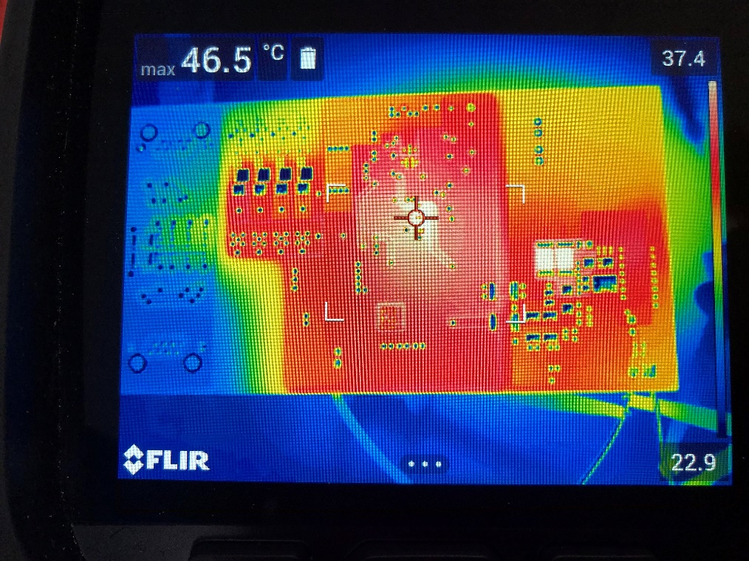

24 V Input, 3.6 A Load, Top:

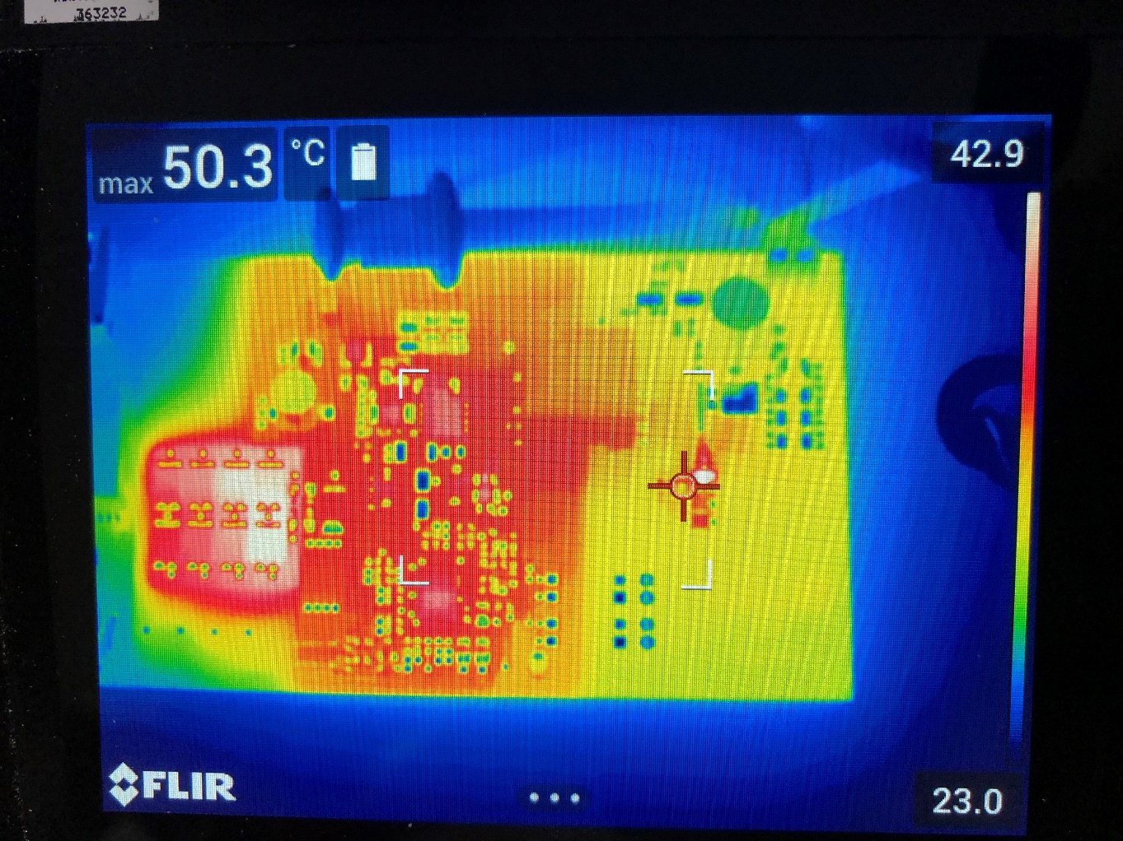

24 V Input, 3.6 A Load, Bottom:

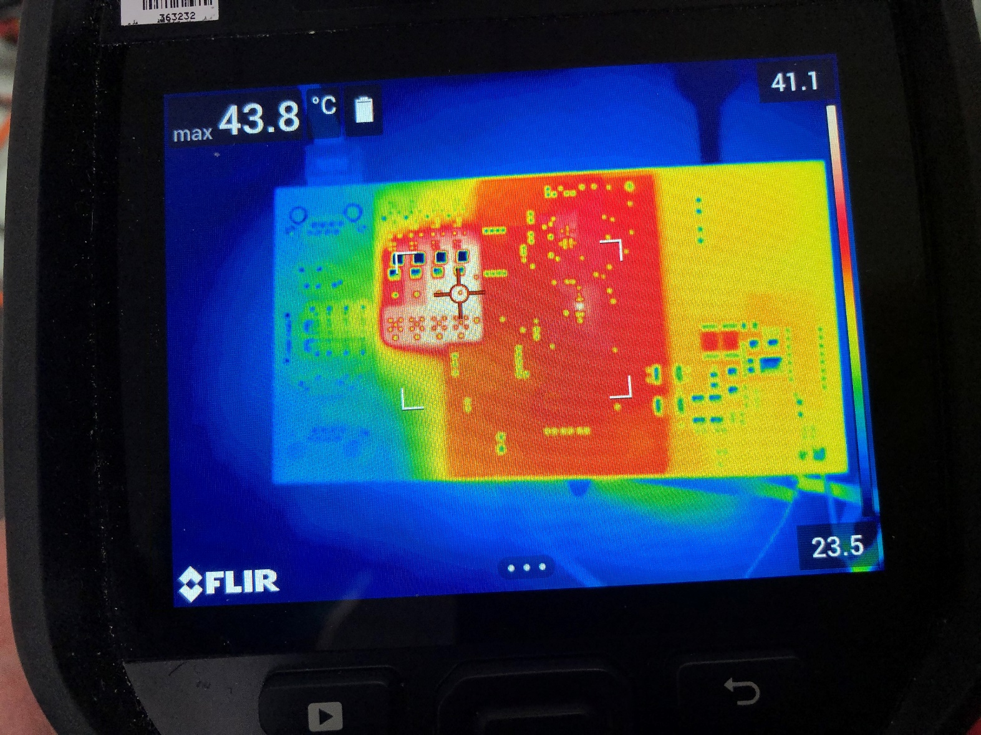

## Photo

The board measures 66 mm x 122 mm.

Top:

Bottom:

# Waveforms

## Switching

VDS, Q11, 57 V input, 0 A load, 10 V/div, 1 usec/div, Measured 30 Vpeak:

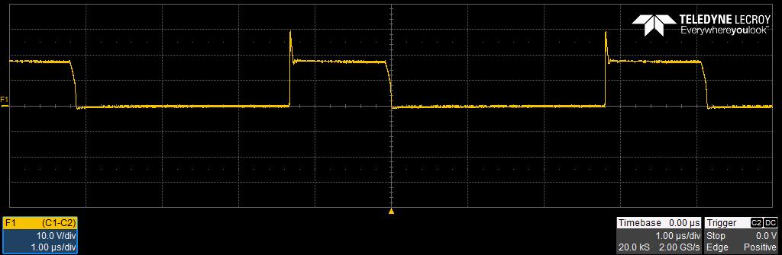

VDS, Q11, 57 V input, 2.3 A load, 10 V/div, 1 usec/div, Measured 24 Vpeak:

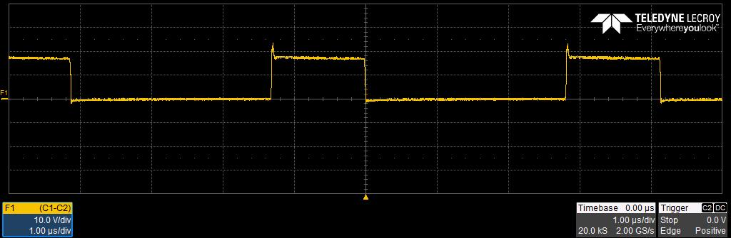

VDS, Q10, 57 V input, 2.3 A load, 20 V/div, 1 usec/div, Measured 100 Vpeak:

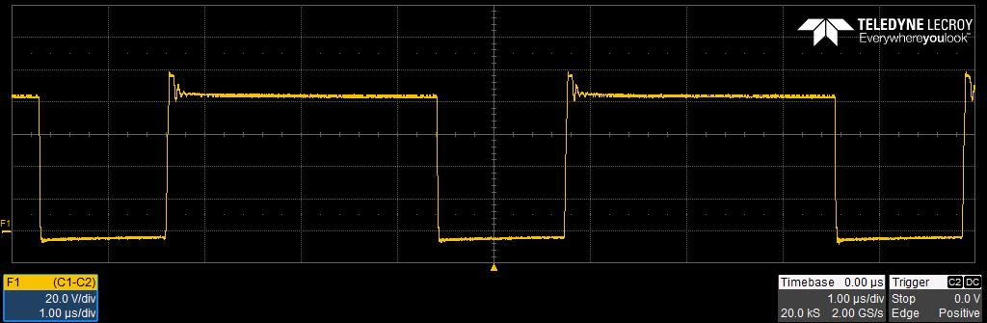

## Voltage Ripple

Input ripple (C18), 48 V input, 2.3 A output, 10 mV/div, 2 usec/div, measured 40 mVpp:

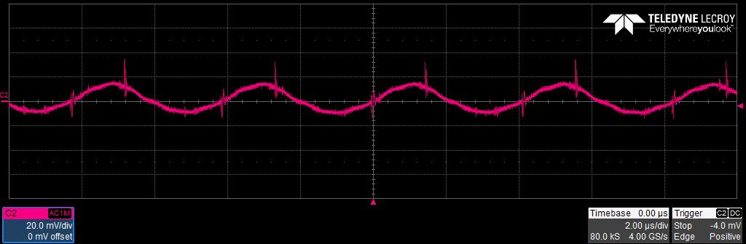

Output ripple (J7), 48 V input, 2.3 A output, 10 mV/div, 2 usec/div, measured 15 mVpp:

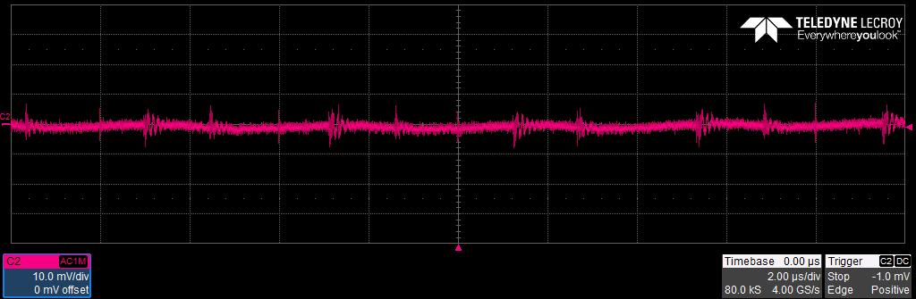

Input ripple (C18), 24 V input, 2.3 A output, 10 mV/div, 2 usec/div, measured 40 mVpp:

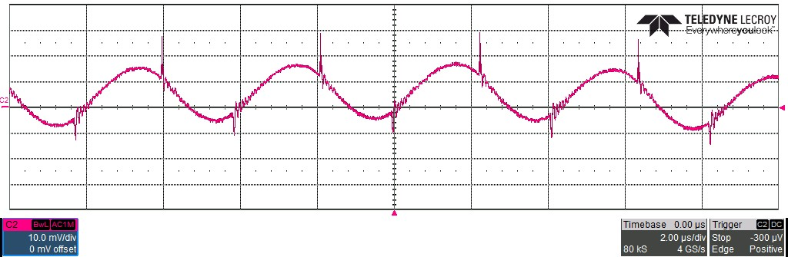

Output ripple (J7), 24 V input, 2.3A output, 20 mV/div, 2 usec/div, measured 30 mVpp:

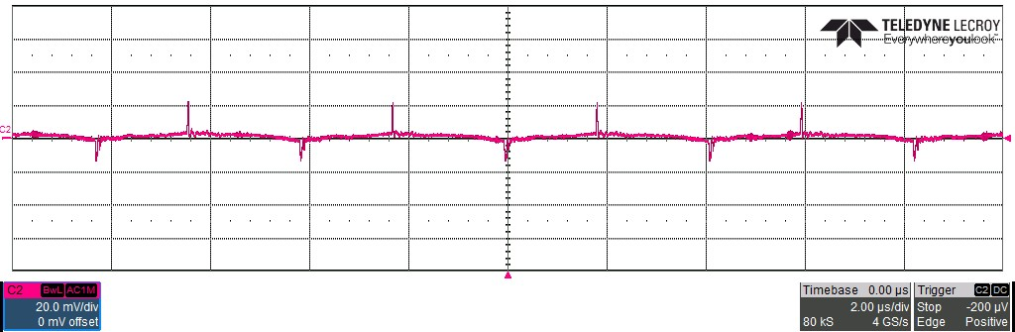

## Short Circuit Current and Thermal

Short circuit measurements were taken 5 minutes after short was applied to a board.

Short circuit output current, 48 V input, 2 A/div, 10 msec/div, measured 9.5 A peak:

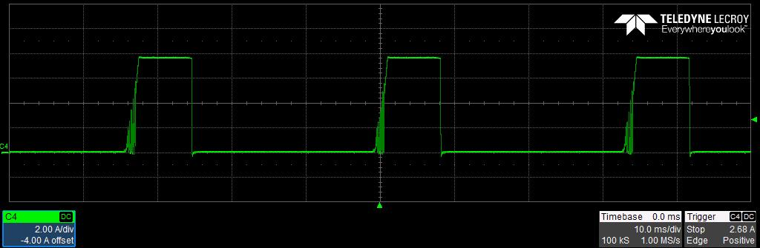

Measured input power: 48.00 V x 108 mA = 5.184 W

Thermal measurement, 48 V input Top:

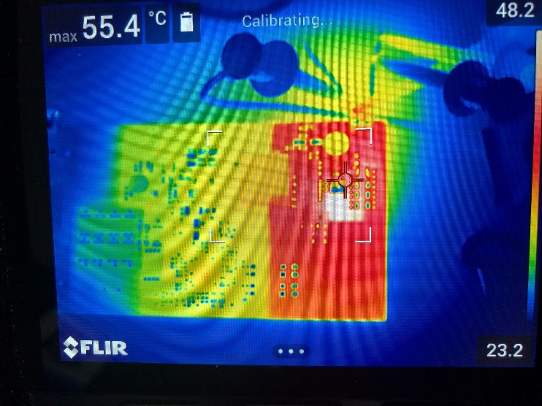

Thermal measurement, 48 V input Bottom:

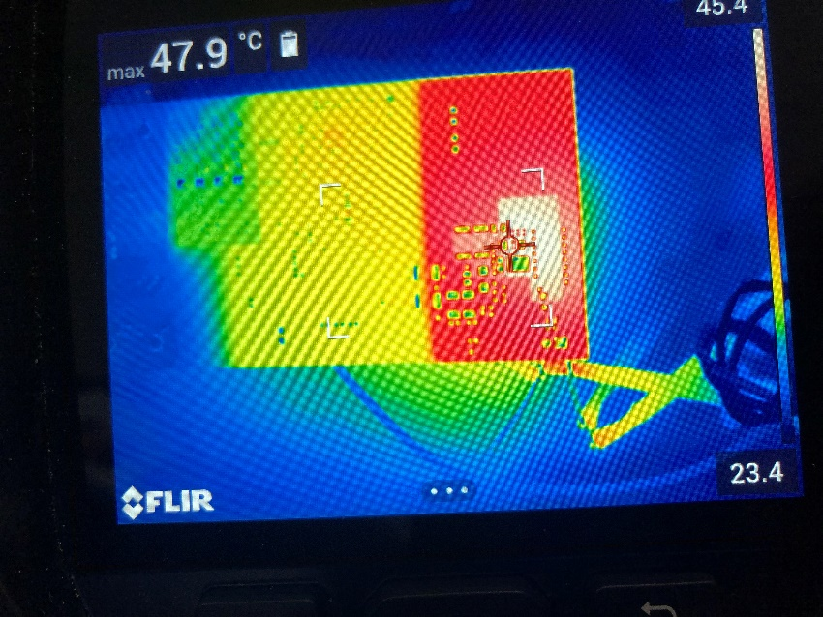

Short circuit output current, 24 V input, 2 A/div, 10 msec/div, measured 9.5 A peak:

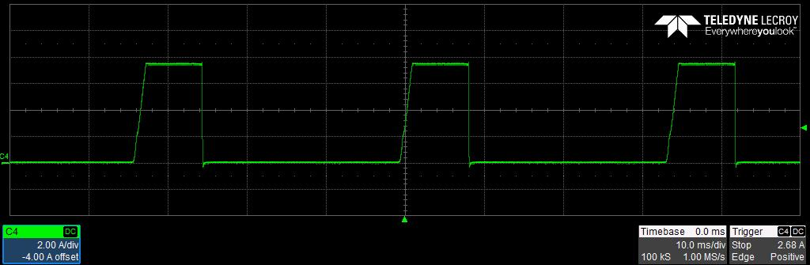 Measured input power: 24.00 V x 224 mA = 5.36 W

Thermal measurement, 24 V input Top:

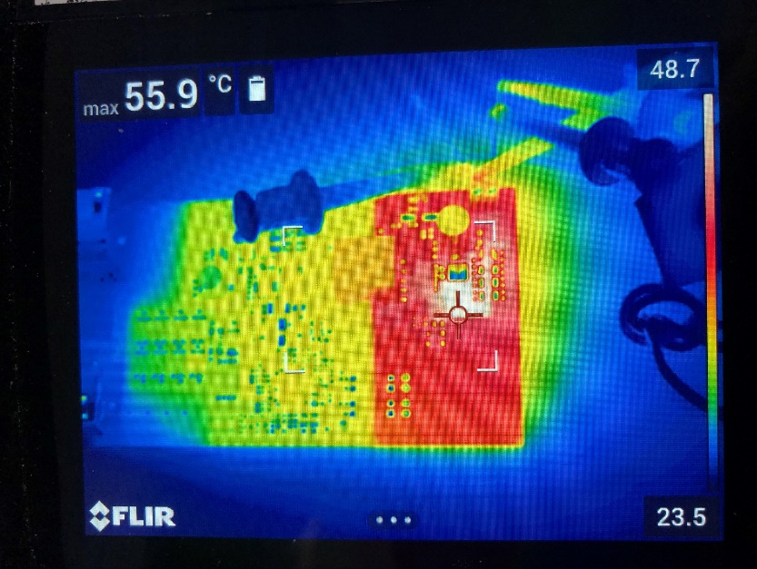

Thermal measurement, 24 V input Bottom:

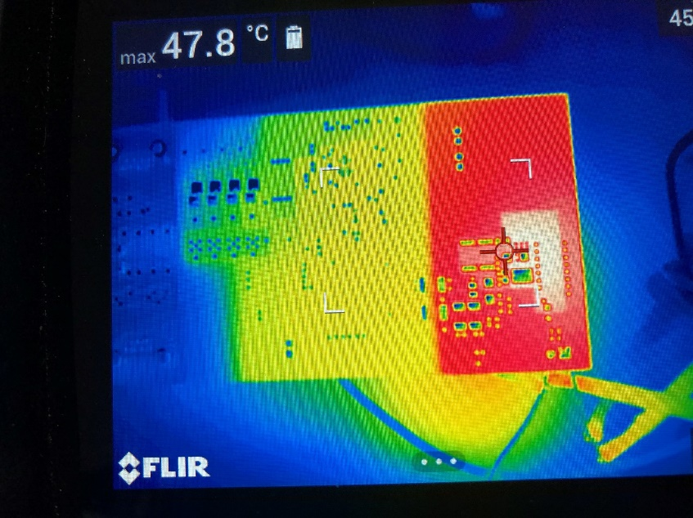

## Bode Plot

16 V Input, 2.3 A Load:

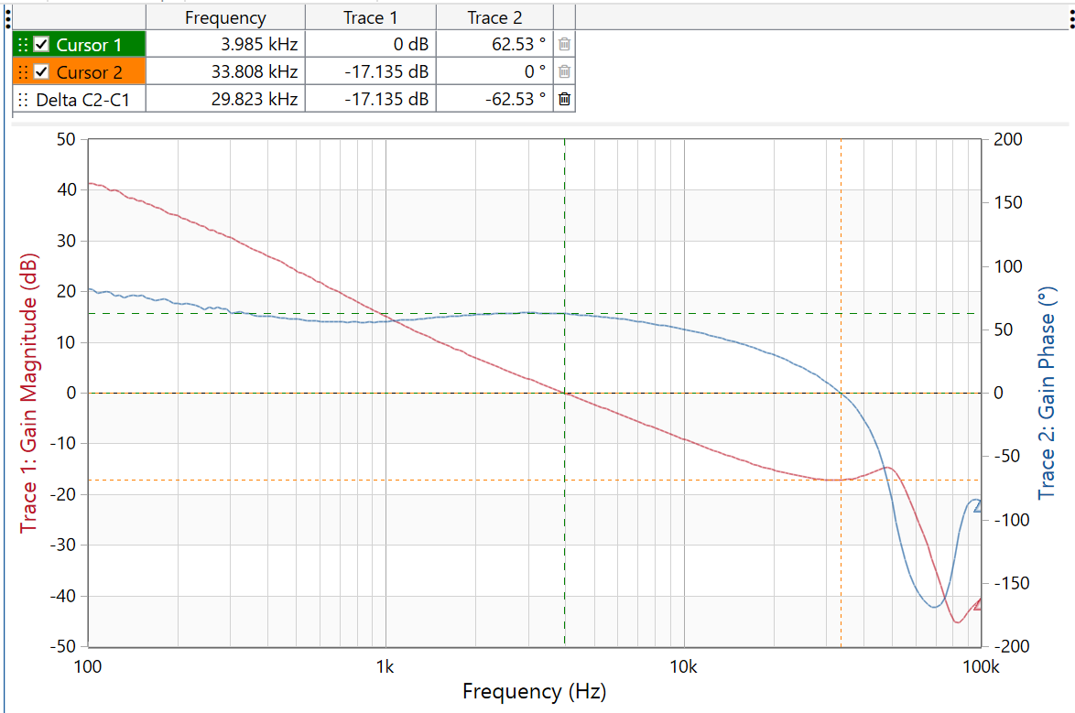

Bandwidth = 3.98 kHz Phase Margin = 62.53 degrees Gain Margin = 17.14 dB

24 V Input, 2.3 A Load:

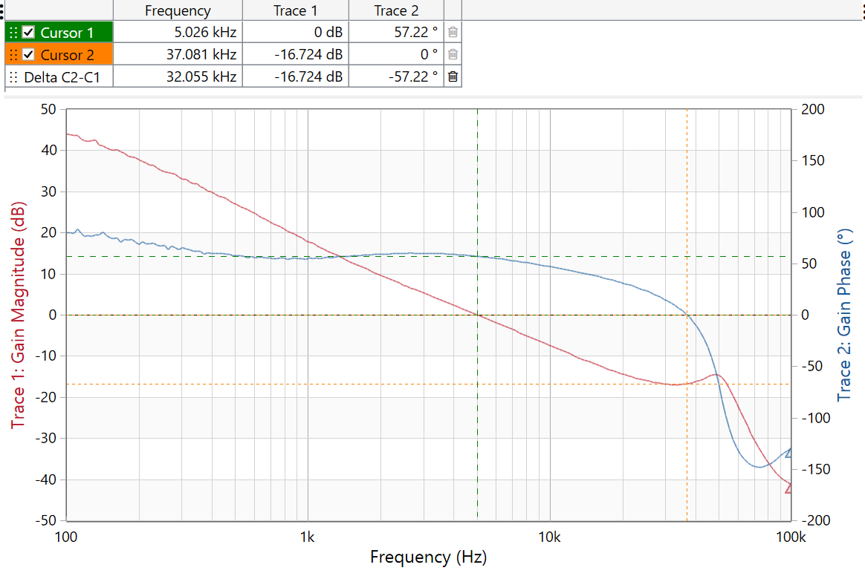

Bandwidth = 5.0 kHz Phase Margin = 57.2 degrees Gain Margin = 16.7 dB

30 V Input, 2.3 A Load:

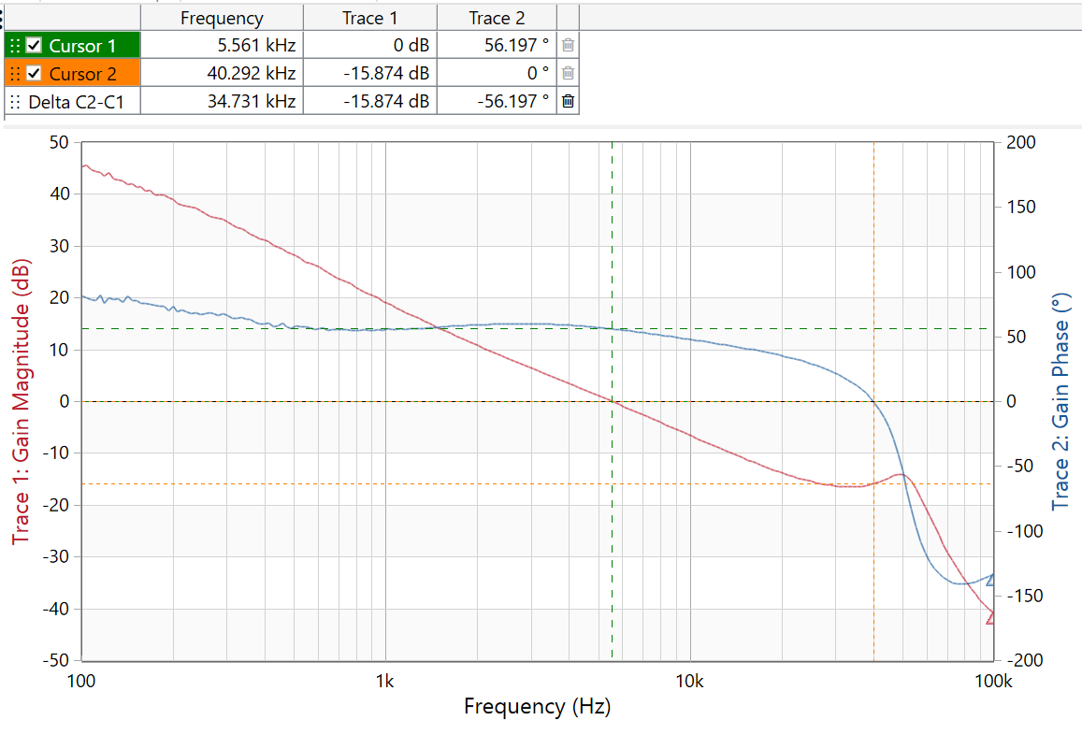

Bandwidth = 5.6 kHz Phase Margin = 56 degrees Gain Margin = 15.9 dB

42.5 V Input, 2.3 A Load:

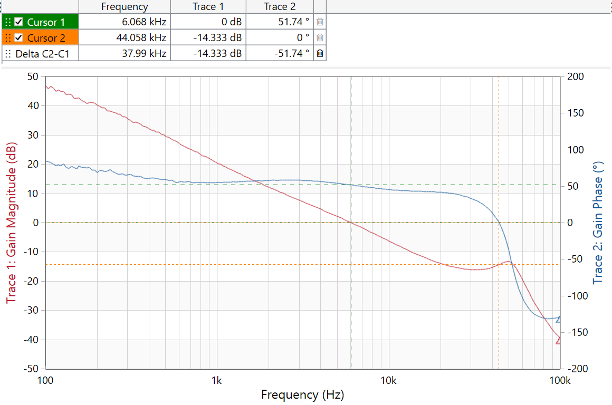

Bandwidth = 6.07 kHz Phase Margin = 51.74 degrees Gain Margin = 14.3 dB

48 V Input, 2.3 A Load:

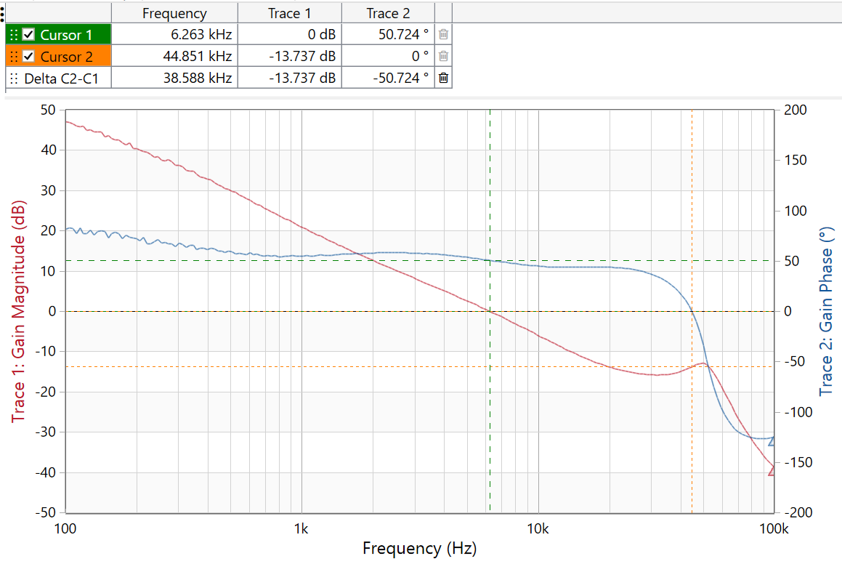

Bandwidth = 6.26 kHz Phase Margin = 50.7 degrees Gain Margin = 13.7 dB

57 V Input, 2.3 A Load:

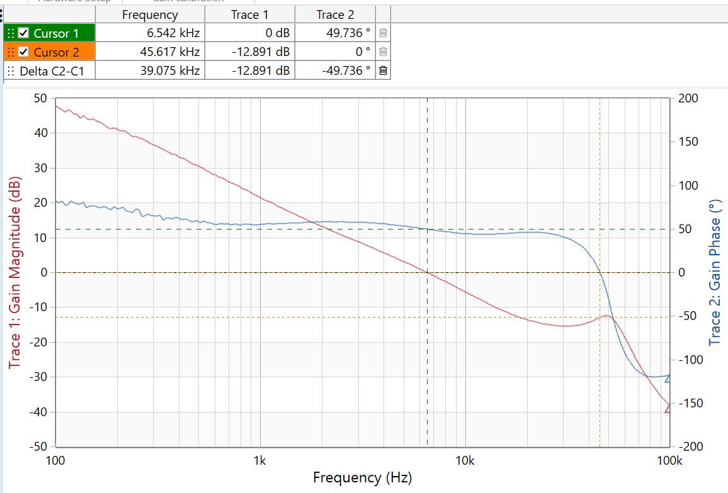

Bandwidth = 6.54 kHz Phase Margin = 49.7 degrees Gain Margin = 12.9 dB

## Load Transients

Output load step response, 24 V input, 1.115A to 2.3 A load step

200 mV/div, 500 mA/div, 200 usec/div, slew rate = 360 mA/usec, measured +153 mVpp/-167 mVpp:

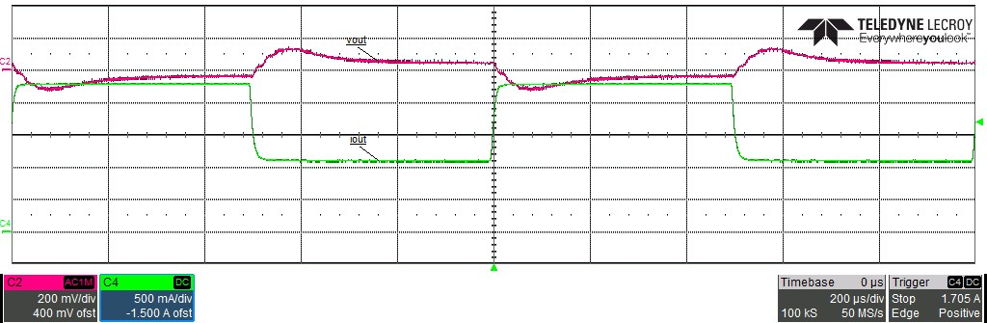

Output load step response, 24 V input, 230 mA to 2.3 A load step

200 mV/div, 500 mA/div, 200 usec/div, slew rate = 360 mA/usec, measured +220 mVpp/-220 mVpp:

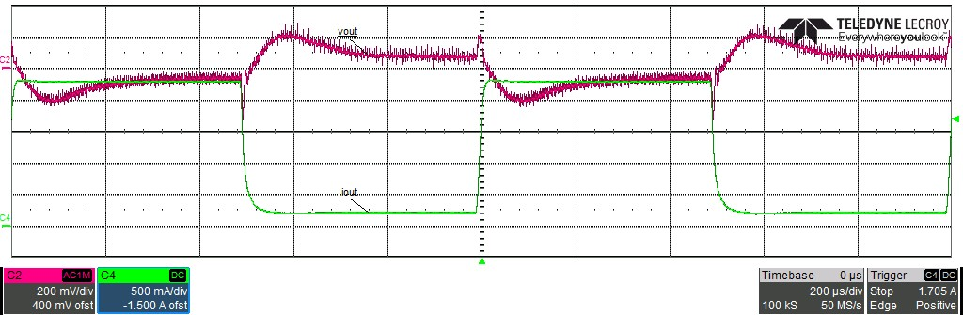

Output load step response, 48 V input 1.115 A to 2.3 A load step

200 mV/div, 500 mA/div, 200 usec/div, slew rate = 360 mA/usec, measured +150 mVpp/-140 mVpp:

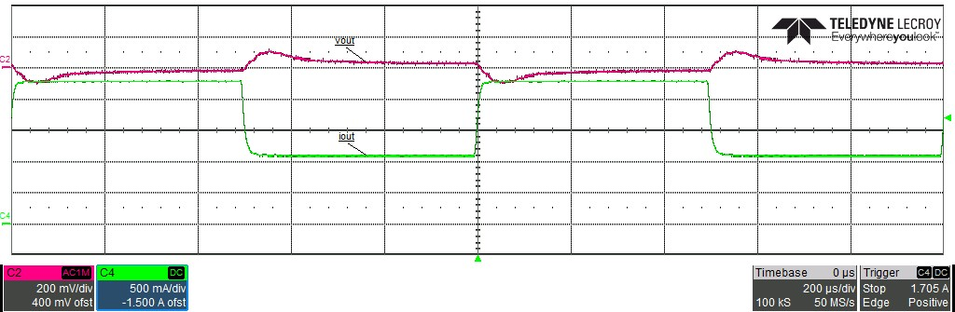

Output load step response, 48 V input, 230 mA to 2.3 A load step

200 mV/div, 500 mA/div, 200 usec/div, slew rate = 360 mA/usec, measured +190 mVpp/--190 mVpp:

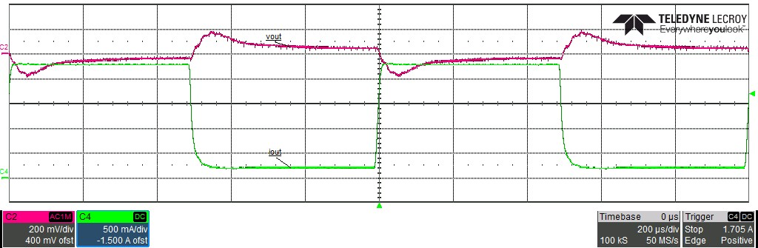

## Start-up

24 V Input, 0 A load, 2 msec/div, 1 V/div:

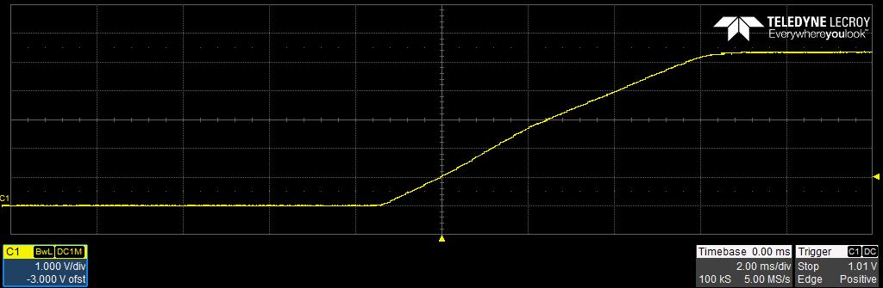

24 V Input, 2.3 A load, 2 msec/div, 1 V/div:

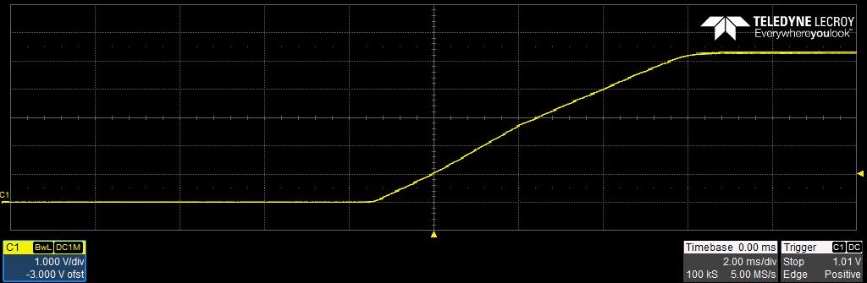

48 V Input, 0 A load, 2 msec/div, 1 V/div: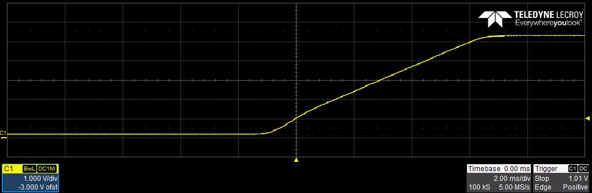

48 V Input, 2.3 A load, 2 msec/div, 1 V/div:

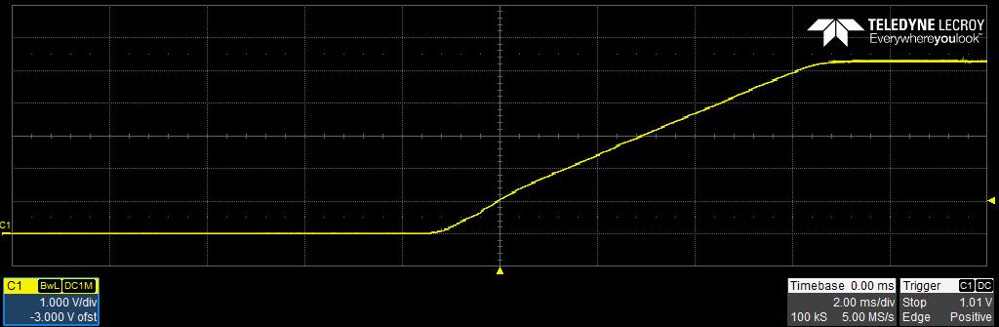

**IMPORTANT NOTICE FOR TI DESIGN INFORMATION AND RESOURCES**

Texas Instruments Incorporated (‘TI”) technical, application or other design advice, services or information, including, but not limited to, reference designs and materials relating to evaluation modules, (collectively, “TI Resources”) are intended to assist designers who are developing applications that incorporate TI products; by downloading, accessing or using any particular TI Resource in any way, you (individually or, if you are acting on behalf of a company, your company) agree to use it solely for this purpose and subject to the terms of this Notice.

TI’s provision of TI Resources does not expand or otherwise alter TI’s applicable published warranties or warranty disclaimers for TI products, and no additional obligations or liabilities arise from TI providing such TI Resources. TI reserves the right to make corrections, enhancements, improvements and other changes to its TI Resources.

You understand and agree that you remain responsible for using your independent analysis, evaluation and judgment in designing your applications and that you have full and exclusive responsibility to assure the safety of your applications and compliance of your applications (and of all TI products used in or for your applications) with all applicable regulations, laws and other applicable requirements. You

represent that, with respect to your applications, you have all the necessary expertise to create and implement safeguards that (1) anticipate dangerous consequences of failures, (2) monitor failures and their consequences, and (3) lessen the likelihood of failures that might cause harm and take appropriate actions. You agree that prior to using or distributing any applications that include TI products, you will thoroughly test such applications and the functionality of such TI products as used in such applications. TI has not conducted any testing other than that specifically described in the published documentation for a particular TI Resource.

You are authorized to use, copy and modify any individual TI Resource only in connection with the development of applications that include the TI product(s) identified in such TI Resource. NO OTHER LICENSE, EXPRESS OR IMPLIED, BY ESTOPPEL OR OTHERWISE TO ANY OTHER TI INTELLECTUAL PROPERTY RIGHT, AND NO LICENSE TO ANY TECHNOLOGY OR INTELLECTUAL PROPERTY RIGHT OF TI OR ANY THIRD PARTY IS GRANTED HEREIN, including but not limited to any patent right, copyright, mask work right, or other intellectual property right relating to any combination, machine, or process in which TI products or services are used. Information regarding or referencing third-party products or services does not constitute a license to use such products or services, or a warranty or endorsement thereof. Use of TI Resources may require a license from a third party under the patents or other intellectual property of the third party, or a license from TI under the patents or other intellectual property of TI.

TI RESOURCES ARE PROVIDED “AS IS” AND WITH ALL FAULTS. TI DISCLAIMS ALL OTHER WARRANTIES OR REPRESENTATIONS, EXPRESS OR IMPLIED, REGARDING TI RESOURCES OR USE THEREOF, INCLUDING BUT NOT LIMITED TO ACCURACY OR COMPLETENESS, TITLE, ANY EPIDEMIC FAILURE WARRANTY AND ANY IMPLIED WARRANTIES OF MERCHANTABILITY, FITNESS FOR A PARTICULAR PURPOSE, AND NON-INFRINGEMENT OF ANY THIRD PARTY INTELLECTUAL PROPERTY RIGHTS.

TI SHALL NOT BE LIABLE FOR AND SHALL NOT DEFEND OR INDEMNIFY YOU AGAINST ANY CLAIM, INCLUDING BUT NOT LIMITED TO ANY INFRINGEMENT CLAIM THAT RELATES TO OR IS BASED ON ANY COMBINATION OF PRODUCTS EVEN IF DESCRIBED IN TI RESOURCES OR OTHERWISE. IN NO EVENT SHALL TI BE LIABLE FOR ANY ACTUAL, DIRECT, SPECIAL, COLLATERAL, INDIRECT, PUNITIVE, INCIDENTAL, CONSEQUENTIAL OR EXEMPLARY DAMAGES IN CONNECTION WITH OR ARISING OUT OF TI RESOURCES OR USE THEREOF, AND REGARDLESS OF WHETHER TI HAS BEEN ADVISED OF THE POSSIBILITY OF SUCH DAMAGES.

You agree to fully indemnify TI and its representatives against any damages, costs, losses, and/or liabilities arising out of your non- compliance with the terms and provisions of this Notice.

This Notice applies to TI Resources. Additional terms apply to the use and purchase of certain types of materials, TI products and services. These include; without limitation, TI’s standard terms for semiconductor products <http://www.ti.com/sc/docs/stdterms.htm>), [evaluation modules](http://www.ti.com/lit/pdf/SSZZ027), and samples (<http://www.ti.com/sc/docs/sampterms.htm>).

Mailing Address: Texas Instruments, Post Office Box 655303, Dallas, Texas 75265

Copyright © 2018, Texas Instruments Incorporated