An error occurred while using the UCD3xxx & UCD9xxx Device GUI to invoke the BidirectionDCDC converter GUI

error

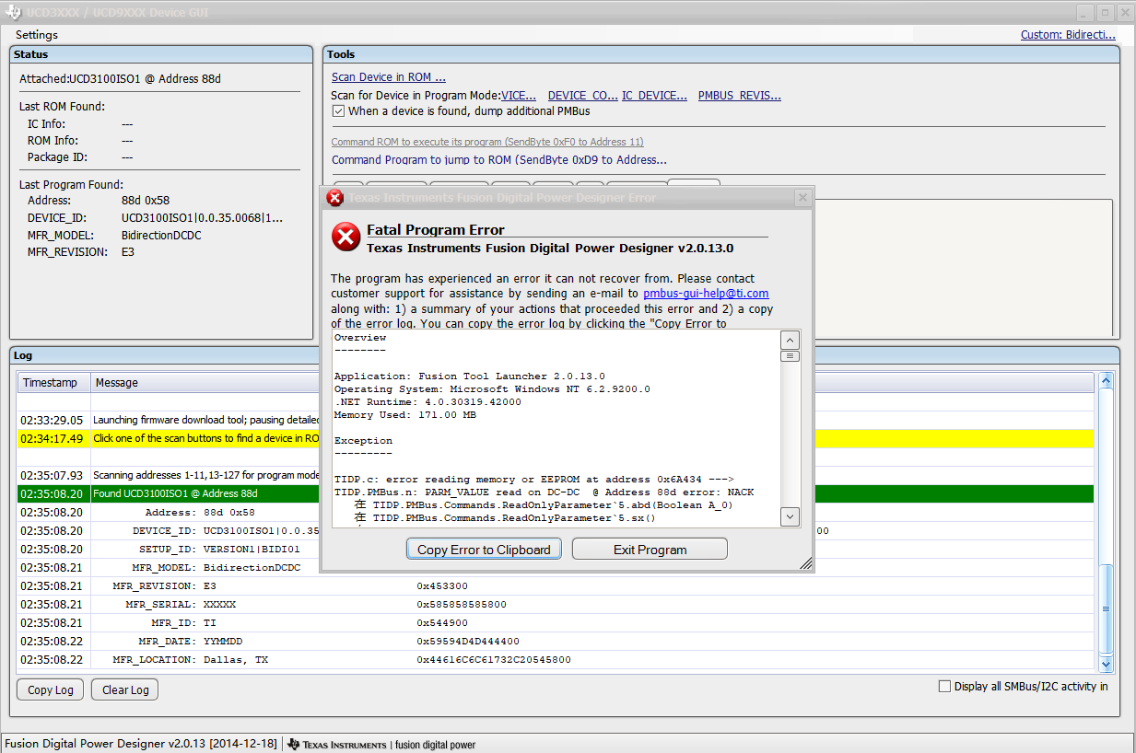

step1-4

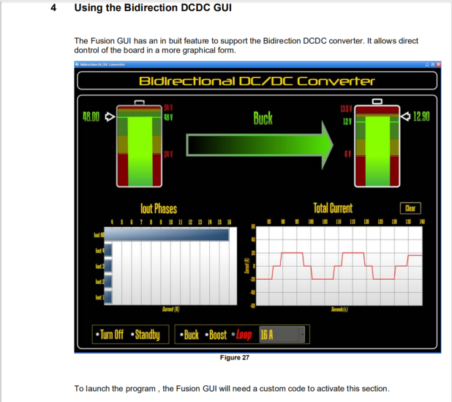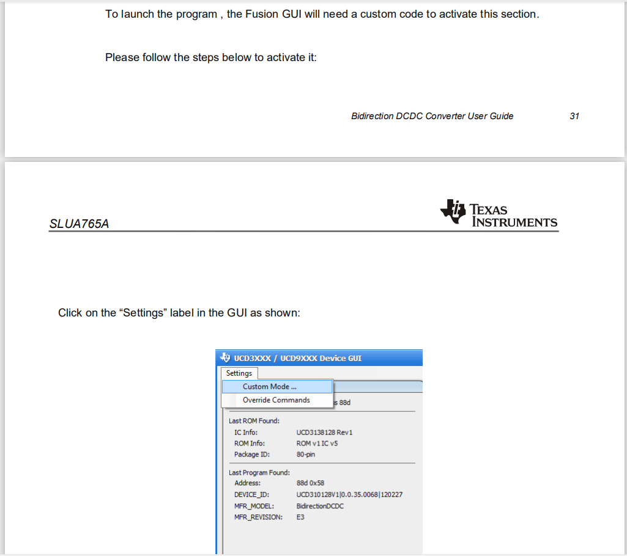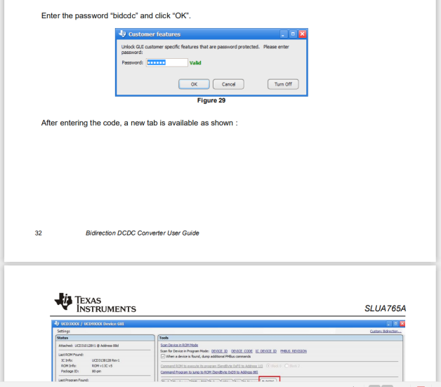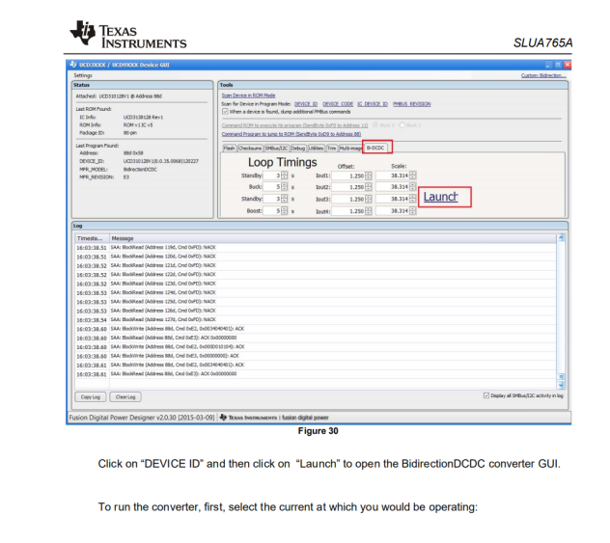

step2

step1

step2

step2

step2

step4

step3

There was no problem with the first three steps, but an error occurred when the fourth step was clicked on launch . I have already used Custom Code to activate this section. There is no problem with calling register parameters using the GUI before this.

Overview

--------

Application: Fusion Tool Launcher 2.0.13.0

Operating System: Microsoft Windows NT 6.2.9200.0

.NET Runtime: 4.0.30319.42000

Memory Used: 167.00 MB

Exception

---------

TIDP.c: error reading memory or EEPROM at address 0x6A434 ---> TIDP.PMBus.n: PARM_VALUE read on DC-DC @ Address 88d error: NACK

在 TIDP.PMBus.Commands.ReadOnlyParameter`5.abd(Boolean A_0)

在 TIDP.PMBus.Commands.ReadOnlyParameter`5.sx()

在 TIDP.PMBus.Parts.UCD3000.c.l(UInt64 A_0, Byte A_1, Byte A_2)

在 TIDP.PMBus.Parts.UCD3000.c.uu(String A_0, UInt32 A_1, UInt32 A_2)

--- 内部异常堆栈跟踪的结尾 ---

在 TIDP.PMBus.Parts.UCD3000.c.uu(String A_0, UInt32 A_1, UInt32 A_2)

在 TIDP.PMBus.PMBusDevice.n(String A_0, UInt32 A_1, UInt32 A_2)

在 TIDP.PMBus.Parts.UCD3000.n.zu(UInt32 A_0)

在 TIDP.Memory.o.j(UInt32 A_0)

在 TIDP.Memory.o.a(Mode A_0, UInt32 A_1, Byte[] A_2, Int32 A_3, Int32 A_4)

在 TIDP.Memory.o.a(UInt32 A_0, Int32 A_1)

在 TIDP.PMBus.Parts.UCD3000.c.l(UInt32 A_0, UInt32 A_1)

在 TIDP.Memory.c.a(UInt32 A_0, UInt32 A_1, Boolean A_2)

在 TIDP.Memory.h.a.a6()

在 TIDP.Memory.h.a.a(Byte[] A_0)

在 TIDP.PMBus.WinForms.BidrectionalDCDCUserControl.a(BiOperation A_0, Int32 A_1)

在 TIDP.PMBus.WinForms.BidrectionalDCDCUserControl.Combo_Input_SelectionChanged(Object A_0, SelectionChangedEventArgs A_1)

在 System.Windows.EventRoute.InvokeHandlersImpl(Object source, RoutedEventArgs args, Boolean reRaised)

在 System.Windows.UIElement.RaiseEventImpl(DependencyObject sender, RoutedEventArgs args)

在 System.Windows.Controls.RadioButton.OnChecked(RoutedEventArgs e)

在 System.Windows.Controls.Primitives.ToggleButton.OnIsCheckedChanged(DependencyObject d, DependencyPropertyChangedEventArgs e)

在 System.Windows.DependencyObject.OnPropertyChanged(DependencyPropertyChangedEventArgs e)

在 System.Windows.FrameworkElement.OnPropertyChanged(DependencyPropertyChangedEventArgs e)

在 System.Windows.DependencyObject.NotifyPropertyChange(DependencyPropertyChangedEventArgs args)

在 System.Windows.DependencyObject.UpdateEffectiveValue(EntryIndex entryIndex, DependencyProperty dp, PropertyMetadata metadata, EffectiveValueEntry oldEntry, EffectiveValueEntry& newEntry, Boolean coerceWithDeferredReference, Boolean coerceWithCurrentValue, OperationType operationType)

在 System.Windows.DependencyObject.SetValueCommon(DependencyProperty dp, Object value, PropertyMetadata metadata, Boolean coerceWithDeferredReference, Boolean coerceWithCurrentValue, OperationType operationType, Boolean isInternal)

在 System.Windows.Controls.Primitives.ToggleButton.set_IsChecked(Nullable`1 value)

在 TIDP.PMBus.WinForms.BidrectionalDCDCUserControl..ctor(BidirectionalDCDCPrefs A_0)

在 TIDP.PMBus.WinForms.BidrectionalDCDCForm..ctor(BidirectionalDCDCPrefs A_0)

在 TIDP.PMBus.DeviceGUI.UCD3000.CustomControls.c.a(Object A_0, LinkLabelLinkClickedEventArgs A_1)

在 System.Windows.Forms.LinkLabel.OnLinkClicked(LinkLabelLinkClickedEventArgs e)

在 TIDP.WinForms.Controls.cf.OnLinkClicked(LinkLabelLinkClickedEventArgs e)

在 System.Windows.Forms.LinkLabel.OnMouseUp(MouseEventArgs e)

在 System.Windows.Forms.Control.WmMouseUp(Message& m, MouseButtons button, Int32 clicks)

在 System.Windows.Forms.Control.WndProc(Message& m)

在 System.Windows.Forms.Label.WndProc(Message& m)

在 System.Windows.Forms.NativeWindow.Callback(IntPtr hWnd, Int32 msg, IntPtr wparam, IntPtr lparam)

Loaded Assemblies

-----------------

Com.Muegel.Misc

Version: 2.0.7.28380

Info Version:

<empty>

Location: file:///E:/Texas Instruments Fusion Digital Power Designer/bin/Com.Muegel.Misc.DLL

Public Key Token:

DevExpress.Data.v6.2

Version: 6.2.10.0

Info Version:

<empty>

Location: file:///E:/Texas Instruments Fusion Digital Power Designer/bin/DevExpress.Data.v6.2.DLL

Public Key Token: 79868B8147B5EAE4

DevExpress.Utils.v6.2

Version: 6.2.10.0

Info Version:

<empty>

Location: file:///E:/Texas Instruments Fusion Digital Power Designer/bin/DevExpress.Utils.v6.2.DLL

Public Key Token: 79868B8147B5EAE4

DevExpress.XtraBars.v6.2

Version: 6.2.10.0

Info Version:

<empty>

Location: file:///E:/Texas Instruments Fusion Digital Power Designer/bin/DevExpress.XtraBars.v6.2.DLL

Public Key Token: 79868B8147B5EAE4

DevExpress.XtraEditors.v6.2

Version: 6.2.10.0

Info Version:

<empty>

Location: file:///E:/Texas Instruments Fusion Digital Power Designer/bin/DevExpress.XtraEditors.v6.2.DLL

Public Key Token: 79868B8147B5EAE4

DevExpress.XtraGrid.v6.2

Version: 6.2.10.0

Info Version:

<empty>

Location: file:///E:/Texas Instruments Fusion Digital Power Designer/bin/DevExpress.XtraGrid.v6.2.DLL

Public Key Token: 79868B8147B5EAE4

Free.CommandLine

Version: 2.0.7.28484

Info Version:

<empty>

Location: file:///E:/Texas Instruments Fusion Digital Power Designer/bin/Free.CommandLine.DLL

Public Key Token:

Free.Hid

Version: 2.0.7.28484

Info Version:

<empty>

Location: file:///E:/Texas Instruments Fusion Digital Power Designer/bin/Free.Hid.DLL

Public Key Token:

Free.Misc

Version: 2.0.7.28483

Info Version:

<empty>

Location: file:///E:/Texas Instruments Fusion Digital Power Designer/bin/Free.Misc.DLL

Public Key Token:

Free.WinForms.Misc

Version: 2.0.7.28484

Info Version:

<empty>

Location: file:///E:/Texas Instruments Fusion Digital Power Designer/bin/Free.WinForms.Misc.DLL

Public Key Token:

Fusion Tool Launcher

Version: 2.0.13.0

Info Version:

<empty>

Location: file:///E:/Texas Instruments Fusion Digital Power Designer/bin/Fusion Tool Launcher.exe

Public Key Token:

Microsoft.Expression.Drawing

Version: 4.0.0.0

Info Version:

<empty>

Location: file:///E:/Texas Instruments Fusion Digital Power Designer/bin/Microsoft.Expression.Drawing.DLL

Public Key Token: 31BF3856AD364E35

Microsoft.GeneratedCode

Version: 1.0.0.0

Info Version:

<empty>

Location: file:///C:/WINDOWS/Microsoft.Net/assembly/GAC_MSIL/System.Xml/v4.0_4.0.0.0__b77a5c561934e089/System.Xml.dll

Public Key Token:

Microsoft.mshtml

Version: 7.0.3300.0

Info Version:

<empty>

Location: file:///C:/WINDOWS/assembly/GAC/Microsoft.mshtml/7.0.3300.0__b03f5f7f11d50a3a/Microsoft.mshtml.dll

Public Key Token: B03F5F7F11D50A3A

Microsoft.VisualBasic

Version: 10.0.0.0

Info Version:

<empty>

Location: file:///C:/WINDOWS/Microsoft.Net/assembly/GAC_MSIL/Microsoft.VisualBasic/v4.0_10.0.0.0__b03f5f7f11d50a3a/Microsoft.VisualBasic.dll

Public Key Token: B03F5F7F11D50A3A

mscorlib

Version: 4.0.0.0

Info Version:

4.8.4250.0

Location: file:///C:/Windows/Microsoft.NET/Framework64/v4.0.30319/mscorlib.dll

Public Key Token: B77A5C561934E089

mscorlib.resources

Version: 4.0.0.0

Info Version:

<empty>

Location: file:///C:/WINDOWS/Microsoft.Net/assembly/GAC_MSIL/mscorlib.resources/v4.0_4.0.0.0_zh-Hans_b77a5c561934e089/mscorlib.resources.dll

Public Key Token: B77A5C561934E089

PresentationCore

Version: 4.0.0.0

Info Version:

4.0.30319.0

Location: file:///C:/WINDOWS/Microsoft.Net/assembly/GAC_64/PresentationCore/v4.0_4.0.0.0__31bf3856ad364e35/PresentationCore.dll

Public Key Token: 31BF3856AD364E35

PresentationFramework

Version: 4.0.0.0

Info Version:

4.8.4220.0

Location: file:///C:/WINDOWS/Microsoft.Net/assembly/GAC_MSIL/PresentationFramework/v4.0_4.0.0.0__31bf3856ad364e35/PresentationFramework.dll

Public Key Token: 31BF3856AD364E35

PresentationFramework.Aero2

Version: 4.0.0.0

Info Version:

4.8.3752.0

Location: file:///C:/WINDOWS/Microsoft.Net/assembly/GAC_MSIL/PresentationFramework.Aero2/v4.0_4.0.0.0__31bf3856ad364e35/PresentationFramework.Aero2.dll

Public Key Token: 31BF3856AD364E35

PresentationFramework.resources

Version: 4.0.0.0

Info Version:

<empty>

Location: file:///C:/WINDOWS/Microsoft.Net/assembly/GAC_MSIL/PresentationFramework.resources/v4.0_4.0.0.0_zh-Hans_31bf3856ad364e35/PresentationFramework.resources.dll

Public Key Token: 31BF3856AD364E35

PresentationFramework-SystemXml

Version: 4.0.0.0

Info Version:

4.8.3752.0

Location: file:///C:/WINDOWS/Microsoft.Net/assembly/GAC_MSIL/PresentationFramework-SystemXml/v4.0_4.0.0.0__b77a5c561934e089/PresentationFramework-SystemXml.dll

Public Key Token: B77A5C561934E089

System

Version: 4.0.0.0

Info Version:

4.8.4200.0

Location: file:///C:/WINDOWS/Microsoft.Net/assembly/GAC_MSIL/System/v4.0_4.0.0.0__b77a5c561934e089/System.dll

Public Key Token: B77A5C561934E089

System.Configuration

Version: 4.0.0.0

Info Version:

4.8.4190.0

Location: file:///C:/WINDOWS/Microsoft.Net/assembly/GAC_MSIL/System.Configuration/v4.0_4.0.0.0__b03f5f7f11d50a3a/System.Configuration.dll

Public Key Token: B03F5F7F11D50A3A

System.Core

Version: 4.0.0.0

Info Version:

4.8.4220.0

Location: file:///C:/WINDOWS/Microsoft.Net/assembly/GAC_MSIL/System.Core/v4.0_4.0.0.0__b77a5c561934e089/System.Core.dll

Public Key Token: B77A5C561934E089

System.Data

Version: 4.0.0.0

Info Version:

4.8.4261.0

Location: file:///C:/WINDOWS/Microsoft.Net/assembly/GAC_64/System.Data/v4.0_4.0.0.0__b77a5c561934e089/System.Data.dll

Public Key Token: B77A5C561934E089

System.Drawing

Version: 4.0.0.0

Info Version:

4.8.3752.0

Location: file:///C:/WINDOWS/Microsoft.Net/assembly/GAC_MSIL/System.Drawing/v4.0_4.0.0.0__b03f5f7f11d50a3a/System.Drawing.dll

Public Key Token: B03F5F7F11D50A3A

System.resources

Version: 4.0.0.0

Info Version:

<empty>

Location: file:///C:/WINDOWS/Microsoft.Net/assembly/GAC_MSIL/System.resources/v4.0_4.0.0.0_zh-Hans_b77a5c561934e089/System.resources.dll

Public Key Token: B77A5C561934E089

System.Web

Version: 4.0.0.0

Info Version:

4.8.4250.0

Location: file:///C:/WINDOWS/Microsoft.Net/assembly/GAC_64/System.Web/v4.0_4.0.0.0__b03f5f7f11d50a3a/System.Web.dll

Public Key Token: B03F5F7F11D50A3A

System.Windows.Controls.DataVisualization.Toolkit

Version: 3.5.40128.1

Info Version:

<empty>

Location: file:///E:/Texas Instruments Fusion Digital Power Designer/bin/System.Windows.Controls.DataVisualization.Toolkit.DLL

Public Key Token: 31BF3856AD364E35

System.Windows.Forms

Version: 4.0.0.0

Info Version:

4.8.4250.0

Location: file:///C:/WINDOWS/Microsoft.Net/assembly/GAC_MSIL/System.Windows.Forms/v4.0_4.0.0.0__b77a5c561934e089/System.Windows.Forms.dll

Public Key Token: B77A5C561934E089

System.Windows.Forms.resources

Version: 4.0.0.0

Info Version:

<empty>

Location: file:///C:/WINDOWS/Microsoft.Net/assembly/GAC_MSIL/System.Windows.Forms.resources/v4.0_4.0.0.0_zh-Hans_b77a5c561934e089/System.Windows.Forms.resources.dll

Public Key Token: B77A5C561934E089

System.Xaml

Version: 4.0.0.0

Info Version:

4.8.4220.0

Location: file:///C:/WINDOWS/Microsoft.Net/assembly/GAC_MSIL/System.Xaml/v4.0_4.0.0.0__b77a5c561934e089/System.Xaml.dll

Public Key Token: B77A5C561934E089

System.Xaml.resources

Version: 4.0.0.0

Info Version:

<empty>

Location: file:///C:/WINDOWS/Microsoft.Net/assembly/GAC_MSIL/System.Xaml.resources/v4.0_4.0.0.0_zh-Hans_b77a5c561934e089/System.Xaml.resources.dll

Public Key Token: B77A5C561934E089

System.Xml

Version: 4.0.0.0

Info Version:

4.8.3752.0

Location: file:///C:/WINDOWS/Microsoft.Net/assembly/GAC_MSIL/System.Xml/v4.0_4.0.0.0__b77a5c561934e089/System.Xml.dll

Public Key Token: B77A5C561934E089

TIDP.DevEx.Skin1

Version: 1.0.0.0

Info Version:

<empty>

Location: file:///E:/Texas Instruments Fusion Digital Power Designer/bin/TIDP.DevEx.Skin1.DLL

Public Key Token: 95FC6C5621878F0A

TIDP.Factory.Core.ManualOnly

Version: 2.0.7.28404

Info Version:

<empty>

Location: file:///E:/Texas Instruments Fusion Digital Power Designer/bin/TIDP.Factory.Core.ManualOnly.DLL

Public Key Token:

TIDP.Factory.TaskLibrary.Fusion.ManualOnly

Version: 1.9.63.28410

Info Version:

<empty>

Location: file:///E:/Texas Instruments Fusion Digital Power Designer/bin/TIDP.Factory.TaskLibrary.Fusion.ManualOnly.DLL

Public Key Token:

TIDP.Misc

Version: 2.0.7.28378

Info Version:

<empty>

Location: file:///E:/Texas Instruments Fusion Digital Power Designer/bin/TIDP.Misc.DLL

Public Key Token:

TIDP.Net.ProxyPrefs

Version: 1.4.0.0

Info Version:

<empty>

Location: file:///E:/Texas Instruments Fusion Digital Power Designer/bin/TIDP.Net.ProxyPrefs.DLL

Public Key Token:

TIDP.PMBus

Version: 2.0.7.28387

Info Version:

<empty>

Location: file:///E:/Texas Instruments Fusion Digital Power Designer/bin/TIDP.PMBus.DLL

Public Key Token:

TIDP.PMBus.DeviceGUI.Drivers

Version: 1.9.63.28408

Info Version:

<empty>

Location: file:///E:/Texas Instruments Fusion Digital Power Designer/bin/TIDP.PMBus.DeviceGUI.Drivers.DLL

Public Key Token:

TIDP.PMBus.DeviceGUI.UCD3000

Version: 1.9.63.28409

Info Version:

<empty>

Location: file:///E:/Texas Instruments Fusion Digital Power Designer/bin/TIDP.PMBus.DeviceGUI.UCD3000.DLL

Public Key Token:

TIDP.PMBus.WinForms

Version: 2.0.7.28407

Info Version:

<empty>

Location: file:///E:/Texas Instruments Fusion Digital Power Designer/bin/TIDP.PMBus.WinForms.DLL

Public Key Token:

TIDP.SAA

Version: 2.0.7.28380

Info Version:

<empty>

Location: file:///E:/Texas Instruments Fusion Digital Power Designer/bin/TIDP.SAA.DLL

Public Key Token:

TIDP.SAA.WinForms.Misc

Version: 2.0.7.28381

Info Version:

<empty>

Location: file:///E:/Texas Instruments Fusion Digital Power Designer/bin/TIDP.SAA.WinForms.Misc.DLL

Public Key Token:

TIDP.WinForms.Apps.DPGUI

Version: 1.9.63.28411

Info Version:

<empty>

Location: file:///E:/Texas Instruments Fusion Digital Power Designer/bin/TIDP.WinForms.Apps.DPGUI.DLL

Public Key Token:

TIDP.WinForms.Apps.DPGUI.DPGUITools

Version: 1.0.0.0

Info Version:

<empty>

Location: file:///E:/Texas Instruments Fusion Digital Power Designer/bin/TIDP.WinForms.Apps.DPGUI.DPGUITools.DLL

Public Key Token:

TIDP.WinForms.Apps.DPGUI.HelpCenter

Version: 1.9.63.28382

Info Version:

<empty>

Location: file:///E:/Texas Instruments Fusion Digital Power Designer/bin/TIDP.WinForms.Apps.DPGUI.HelpCenter.DLL

Public Key Token:

TIDP.WinForms.Misc

Version: 2.0.7.28380

Info Version:

<empty>

Location: file:///E:/Texas Instruments Fusion Digital Power Designer/bin/TIDP.WinForms.Misc.DLL

Public Key Token:

TIDP.WinForms.Util

Version: 2.0.7.28378

Info Version:

<empty>

Location: file:///E:/Texas Instruments Fusion Digital Power Designer/bin/TIDP.WinForms.Util.DLL

Public Key Token:

UIAutomationProvider

Version: 4.0.0.0

Info Version:

4.8.4220.0

Location: file:///C:/WINDOWS/Microsoft.Net/assembly/GAC_MSIL/UIAutomationProvider/v4.0_4.0.0.0__31bf3856ad364e35/UIAutomationProvider.dll

Public Key Token: 31BF3856AD364E35

UIAutomationTypes

Version: 4.0.0.0

Info Version:

4.8.4220.0

Location: file:///C:/WINDOWS/Microsoft.Net/assembly/GAC_MSIL/UIAutomationTypes/v4.0_4.0.0.0__31bf3856ad364e35/UIAutomationTypes.dll

Public Key Token: 31BF3856AD364E35

WindowsBase

Version: 4.0.0.0

Info Version:

4.8.4220.0

Location: file:///C:/WINDOWS/Microsoft.Net/assembly/GAC_MSIL/WindowsBase/v4.0_4.0.0.0__31bf3856ad364e35/WindowsBase.dll

Public Key Token: 31BF3856AD364E35

WindowsFormsIntegration

Version: 4.0.0.0

Info Version:

4.8.4150.0

Location: file:///C:/WINDOWS/Microsoft.Net/assembly/GAC_MSIL/WindowsFormsIntegration/v4.0_4.0.0.0__31bf3856ad364e35/WindowsFormsIntegration.dll

Public Key Token: 31BF3856AD364E35

WPFToolkit

Version: 3.5.40128.1

Info Version:

<empty>

Location: file:///E:/Texas Instruments Fusion Digital Power Designer/bin/WPFToolkit.DLL

Public Key Token: 31BF3856AD364E35

XtraDataTempAssembly

Version: 0.0.0.0

Info Version:

<empty>

Location: file:///E:/Texas Instruments Fusion Digital Power Designer/bin/DevExpress.Data.v6.2.dll

Public Key Token: