二次电源输出异常

在并联使用ti_lmz23610产生5v输出时，原理图如下：

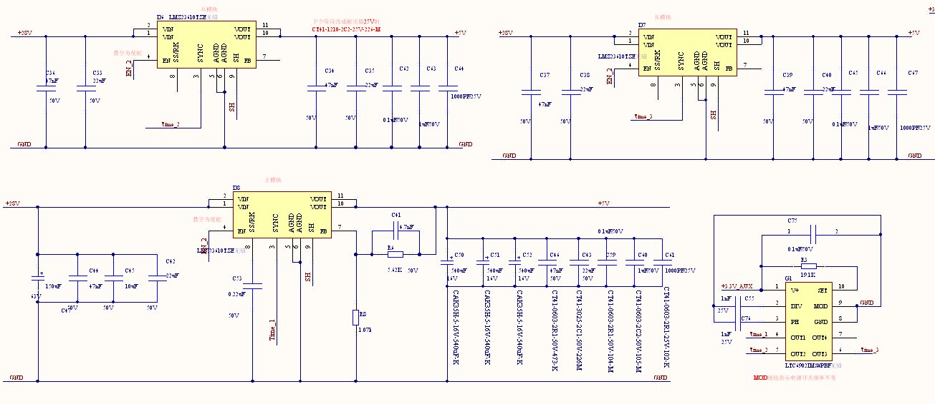

Figure 1. Three model schematic

**Two query as below：**

1. One of models power on with no-load, there was 10V output, waveform as figure 2. When add load with 2A，there was periodicity 10V output，waveform as figure 3.

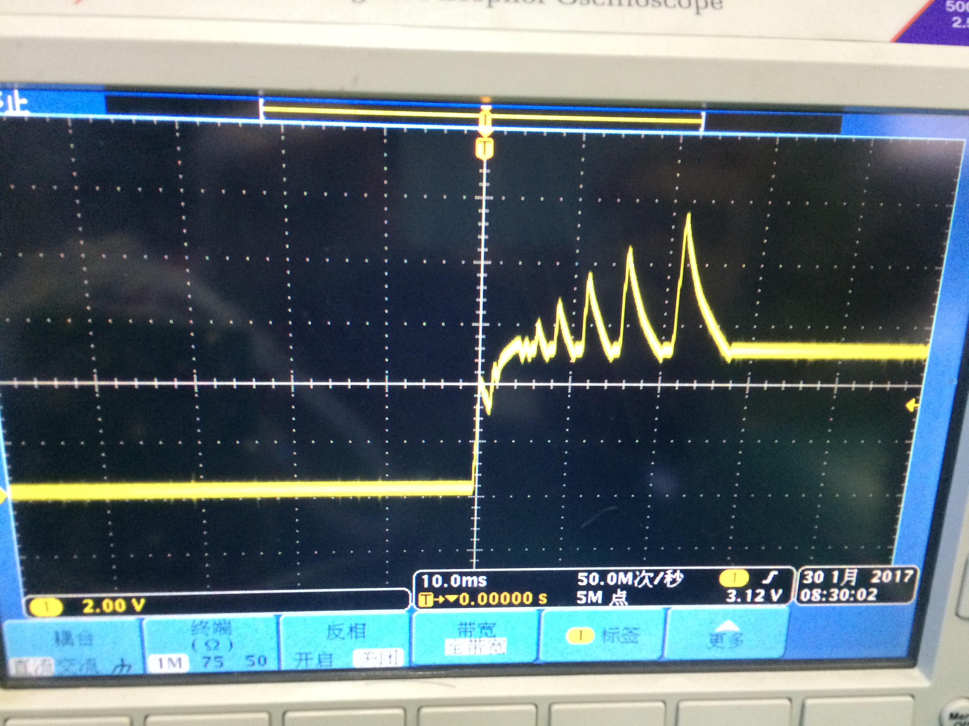 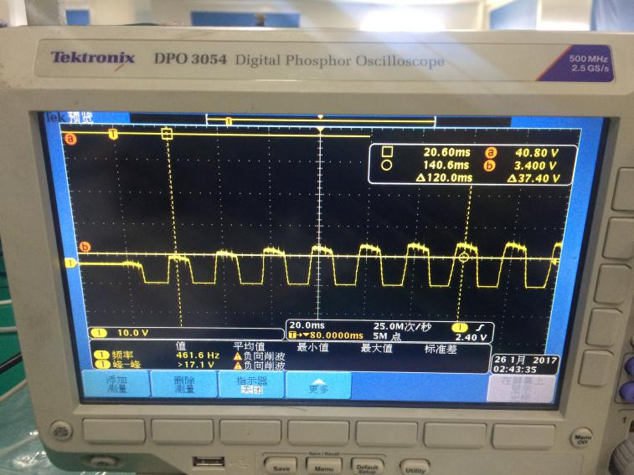  
Figure 2. The three modules are in parallel with the power output waveform.

Figure 3 The three modules are in parallel with 2A resistive load

1. One of models power on with no-load，the output is normal, when increase the load current，the ripple of output 5V increase also It is accompanied by periodic oscillations. 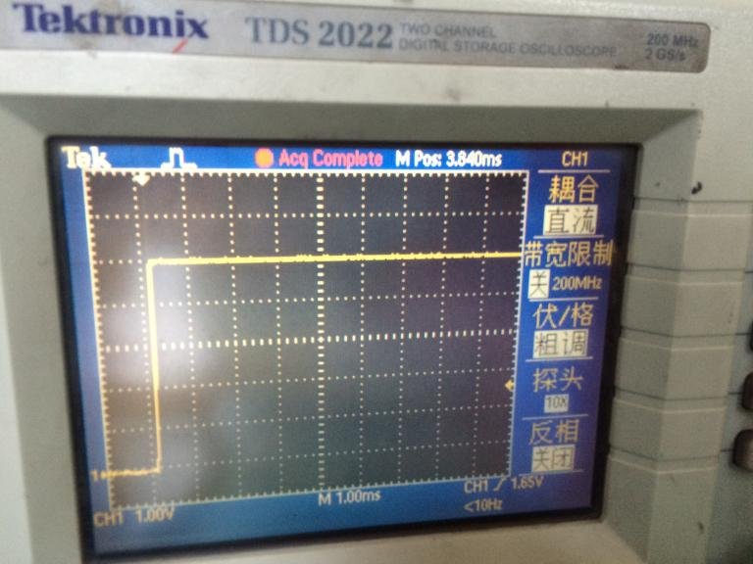 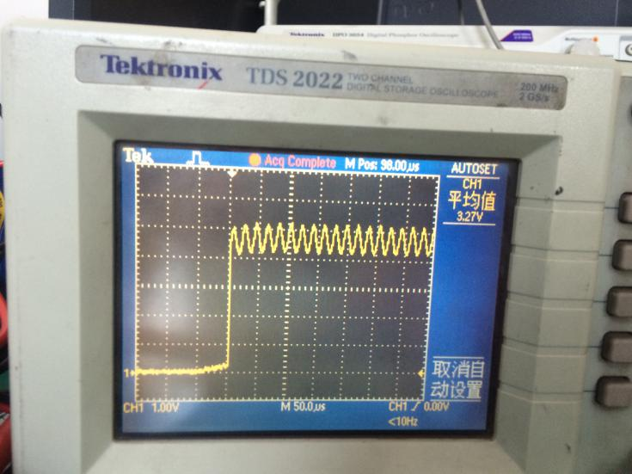

Figure 4. no-load output waveform Figure 5 20A output waveform