File: | RE | Data: | #2 | Date: | 2016-12-8 | Temperature: | 21.2 
 |  |  |  | Time: | 10:27:55 | Humidity: | 52 %

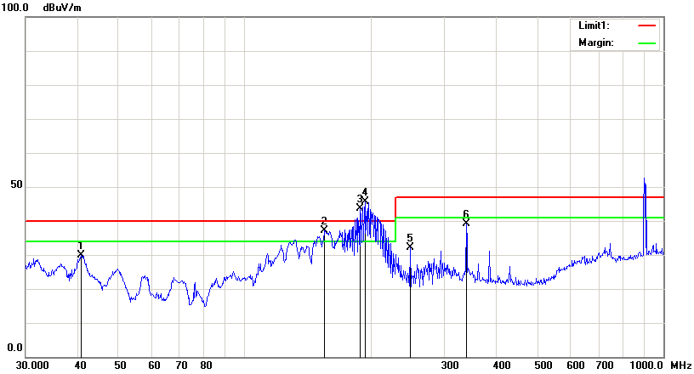

Condition: | EN55022 RE-Class B 3M | Polarization: | Vertical
EUT: | 4200L | Power:
Model: |  | Distance: | 3m
Test Mode:
Note: | AUX

No. | Frequency | Reading | Detector | Ant_F | PA_G | Cab_L | Result | Limit | Margin | Height | Degree
 | (MHz) | (dBuV/m) |  | (dB/m) | (dB) | (dB) | (dBuV/m) | (dBuV/m) | (dB) | (cm) | (  )
1 | 40.7016 | 59.13 | peak | 15.31 | 45.74 | 1.06 | 29.76 | 40.00 | -10.24 | 99 | 282
2 | 155.3644 | 69.08 | peak | 13.64 | 47.61 | 2.08 | 37.19 | 40.00 | -2.81 | 99 | 98
3 | 188.4125 | 75.54 | peak | 12.43 | 46.64 | 2.21 | 43.54 | 40.00 | 3.54 | 200 | 83
4 | 194.4534 | 76.82 | peak | 13.52 | 46.99 | 2.24 | 45.59 | 40.00 | 5.59 | 200 | 76
5 | 248.5519 | 62.51 | peak | 14.90 | 47.67 | 2.50 | 32.24 | 47.00 | -14.76 | 99 | 291
6 | 338.4001 | 69.36 | peak | 15.74 | 48.89 | 2.94 | 39.15 | 47.00 | -7.85 | 200 | 6

