File: | RE | Data: | #4 | Date: | 2016-12-8 | Temperature: | 21.2 
 |  |  |  | Time: | 10:44:54 | Humidity: | 52 %

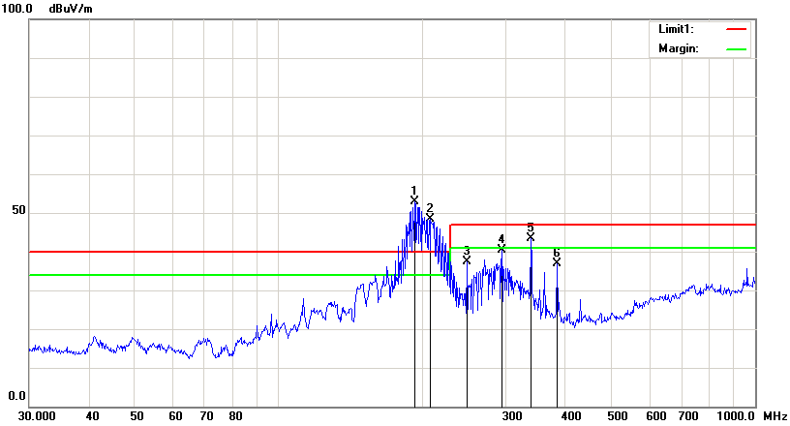

Condition: | EN55022 RE-Class B 3M | Polarization: | Horizontal
EUT: | 4200L | Power:
Model: |  | Distance: | 3m
Test Mode:
Note: | WIFI

No. | Frequency | Reading | Detector | Ant_F | PA_G | Cab_L | Result | Limit | Margin | Height | Degree
 | (MHz) | (dBuV/m) |  | (dB/m) | (dB) | (dB) | (dBuV/m) | (dBuV/m) | (dB) | (cm) | (  )
1 | 193.0945 | 84.45 | peak | 12.98 | 46.90 | 2.23 | 52.76 | 40.00 | 12.76
2 | 208.5803 | 79.87 | peak | 13.69 | 47.55 | 2.30 | 48.31 | 40.00 | 8.31
3 | 248.5519 | 67.43 | peak | 15.09 | 47.67 | 2.50 | 37.35 | 47.00 | -9.65
4 | 294.1137 | 69.30 | peak | 16.69 | 48.33 | 2.74 | 40.40 | 47.00 | -6.60
5 | 338.4001 | 72.66 | peak | 16.55 | 48.89 | 2.94 | 43.26 | 47.00 | -3.74
6 | 383.9318 | 66.27 | peak | 16.14 | 48.80 | 3.16 | 36.77 | 47.00 | -10.23

