File: | RE | Data: | #3 | Date: | 2016-12-8 | Temperature: | 21.2 
 |  |  |  | Time: | 10:38:25 | Humidity: | 52 %

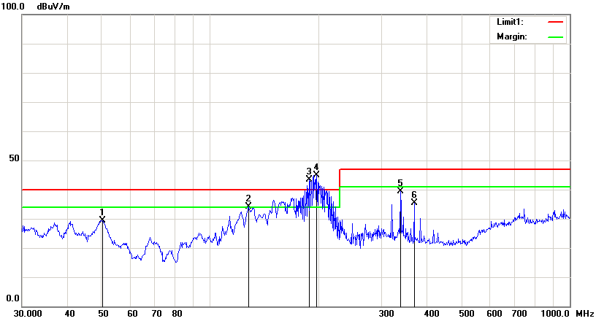

Condition: | EN55022 RE-Class B 3M | Polarization: | Vertical
EUT: | 4200L | Power:
Model: |  | Distance: | 3m
Test Mode:
Note: | WIFI

No. | Frequency | Reading | Detector | Ant_F | PA_G | Cab_L | Result | Limit | Margin | Height | Degree
 | (MHz) | (dBuV/m) |  | (dB/m) | (dB) | (dB) | (dBuV/m) | (dBuV/m) | (dB) | (cm) | (  )
1 | 50.2325 | 65.64 | peak | 9.02 | 46.46 | 1.25 | 29.45 | 40.00 | -10.55 | 100 | 104
2 | 128.1130 | 63.24 | peak | 16.27 | 47.16 | 1.84 | 34.19 | 40.00 | -5.81 | 100 | 235
3 | 188.4125 | 75.42 | peak | 12.43 | 46.64 | 2.21 | 43.42 | 40.00 | 3.42 | 100 | 94
4 | 197.8928 | 75.55 | peak | 14.35 | 47.21 | 2.25 | 44.94 | 40.00 | 4.94 | 200 | 74
5 | 338.4001 | 69.57 | peak | 15.74 | 48.89 | 2.94 | 39.36 | 47.00 | -7.64 | 200 | 183
6 | 369.4047 | 64.72 | peak | 16.37 | 48.76 | 3.09 | 35.42 | 47.00 | -11.58 | 200 | 195

