SM72445 EVM and USB2ANY User Guide

# Step1. Hardware setup

Instruments list:

1. USB2ANY Interface Adapter (Use J4 10 pin cable connector)

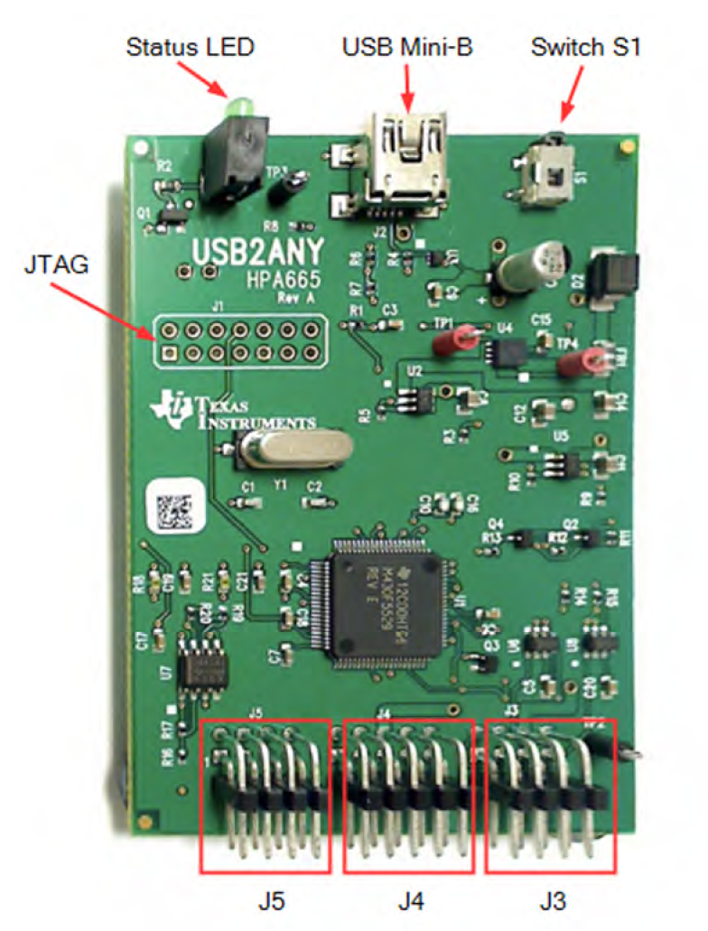

1. Power Supply – Agilent E3634A

20V for SM72445 EVM PV(+) to PV(-) is OK.

1. Connect wire.
2. PC with USB2ANY Explorer.exe



EXE Download link:

<http://www.ti.com/tool/USB2ANY?keyMatch=usb2any&tisearch=Search-EN-Everything>

# Step2. Software setup

1. Install USB2ANY Explorer.exe
2. Open exe → click ‘I2C’ → click ‘select interfaces’ → choose ‘I2C’.

Attention: If your PC screen resolution is very high(e.g: 2560*1440), you will not able to see ‘I2C’ sheet. So you should decrease resolution first.

Then you will see the following picture. Setting bit rate =100Khz.

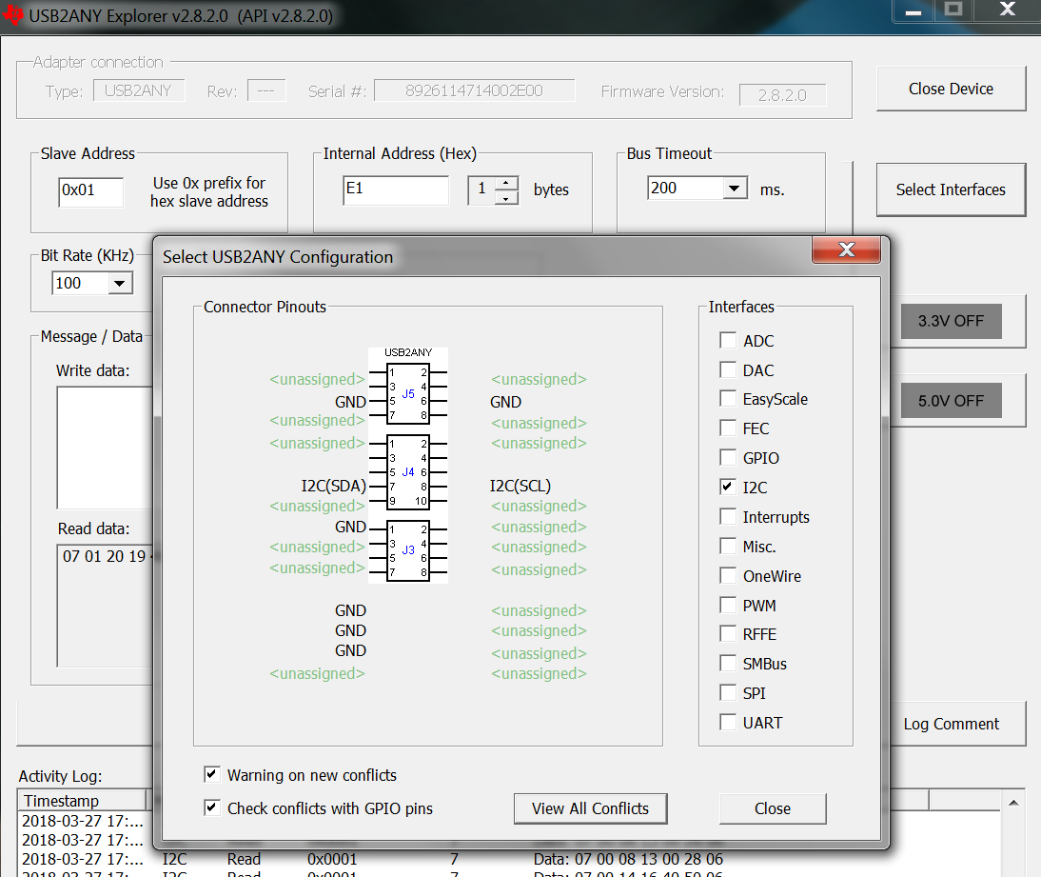

1. From SM72445 datasheet, we know the EVM schematic and I2C master & slaver address.

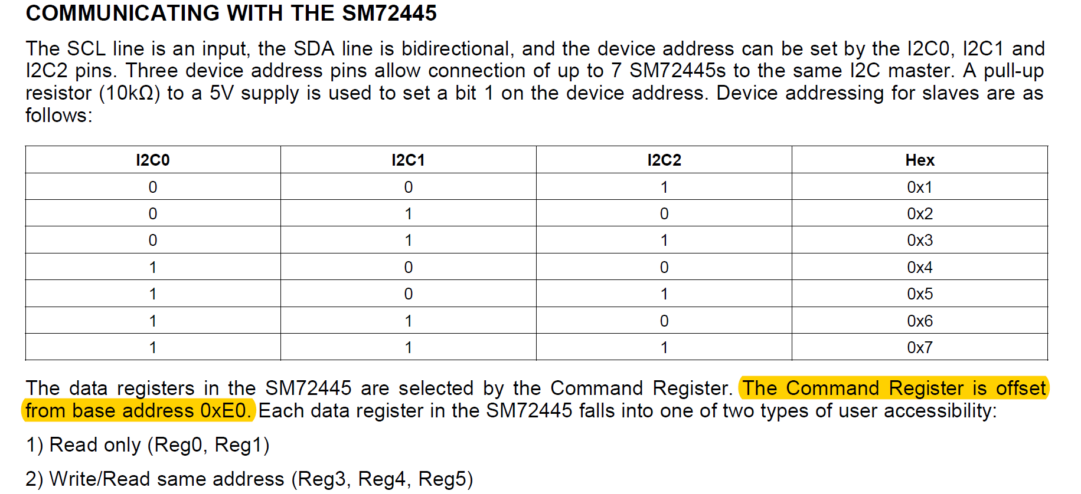

So the internal address is base on 0xE0, if you want read reg0 information. Just type E0 in the following blank: for reg1, just type E1.

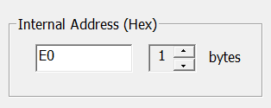

Due to EVM schematic we know. I2C0 pull high, I2C1/I2C2 pull low. Show as following schematic.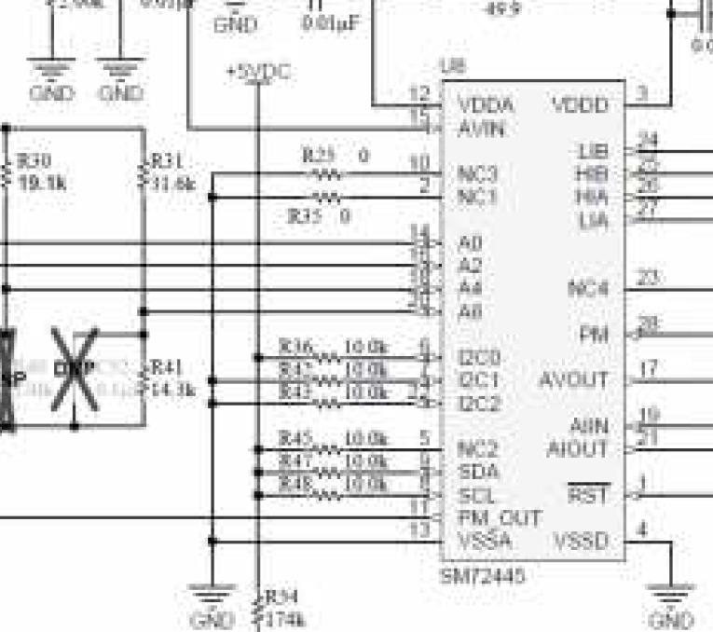

So A0=1, A1=0, A2=0. We set A2,A1,A0=0,0,1 as slaver address. The following figure shows.

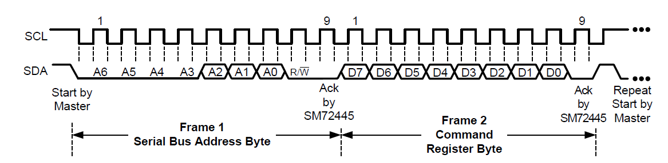

Then we type 0x01 as slaver address in the following blank.

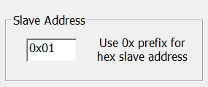

# Step3. Communicating

After set parameter. We can read or write register information now.

For example:

If we want to read reg1 information. Just type 0x01 as slave address and E1 as internal address.

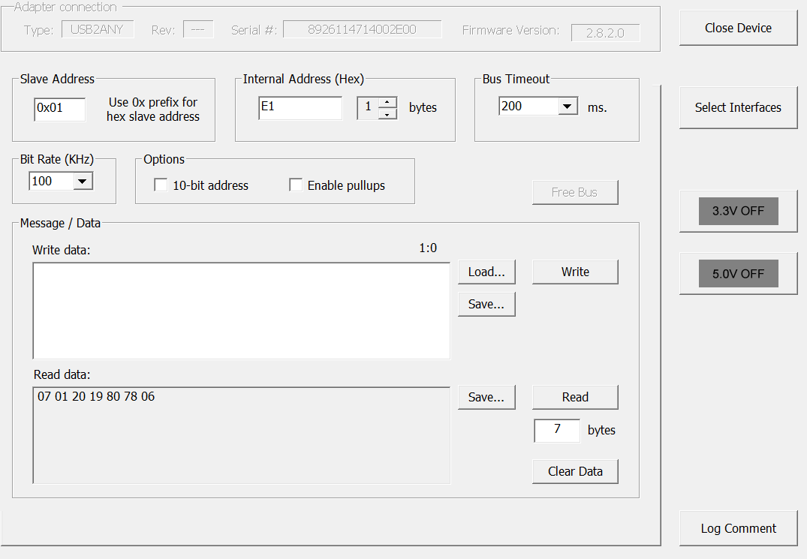

Then click ‘read’.

07 01 20 19 80 78 06 is 7 bytes (56bits) reg1 data. You can also write in reg3,4,5 by the above operation.