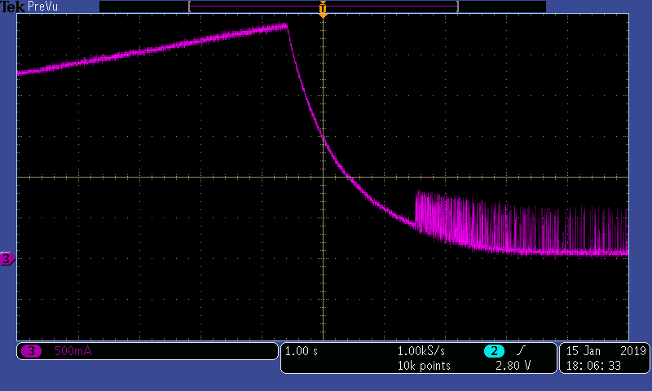

AbNormal state, charge current oscillation when CV mode, 4 MOSFET has drive signals

Normal state, no input current limit, input current increases as charge voltage increases

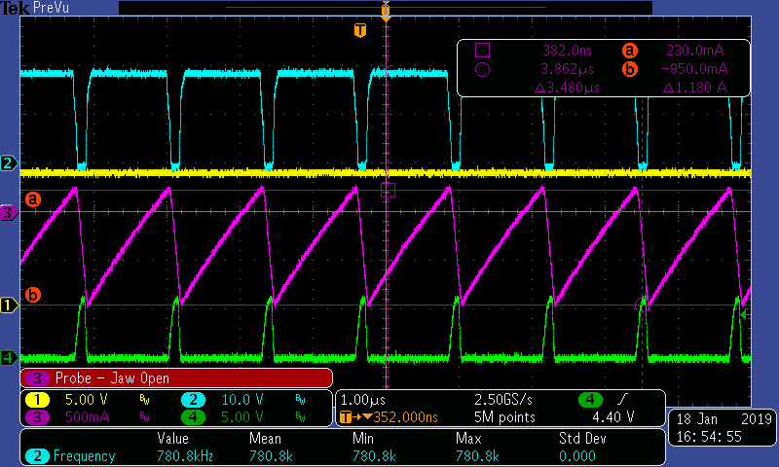

System load >0.25A, the signals are OK.

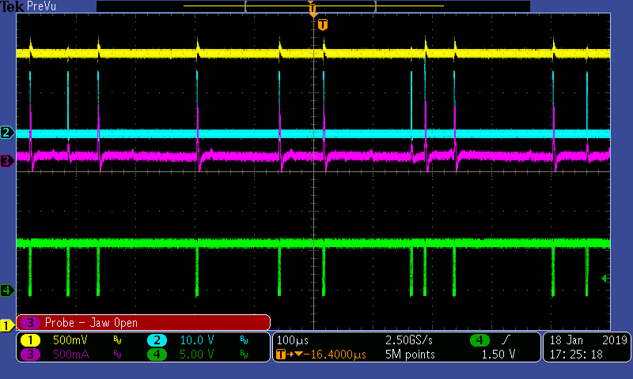

System load <0.13A,

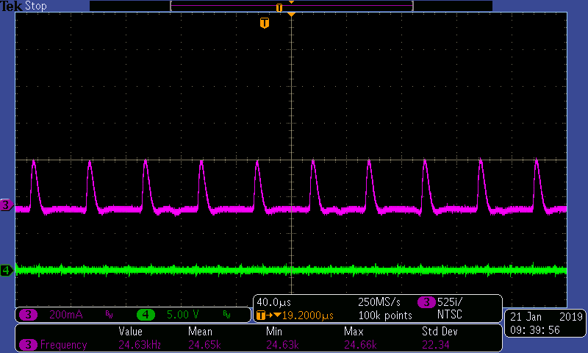

Charge current

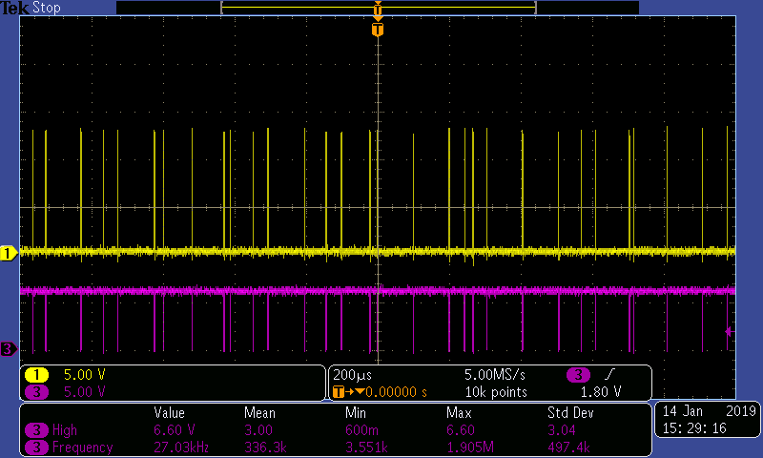

Drive signals