Oscillation Issue of TPS5430DDAR

Schematic
This circuit converts 24V to 16.2V, used for the bootstrap power supply of the low-side and high-side of the IPM module. The schematic is shown below:
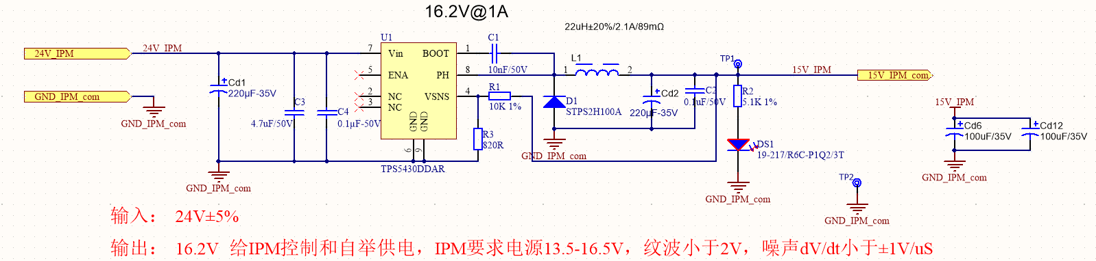
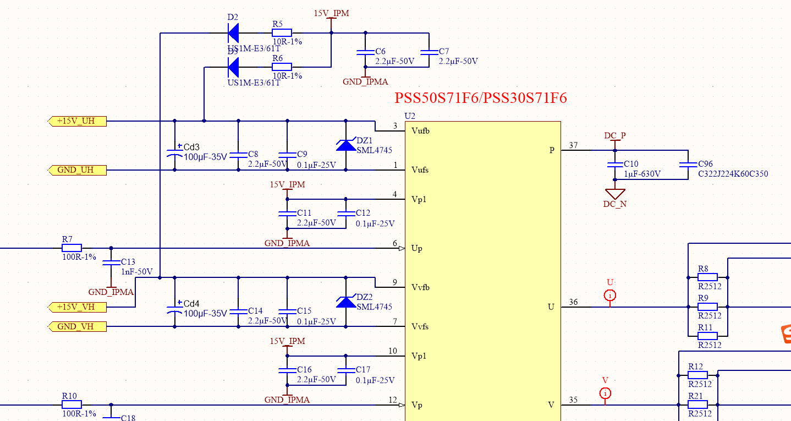
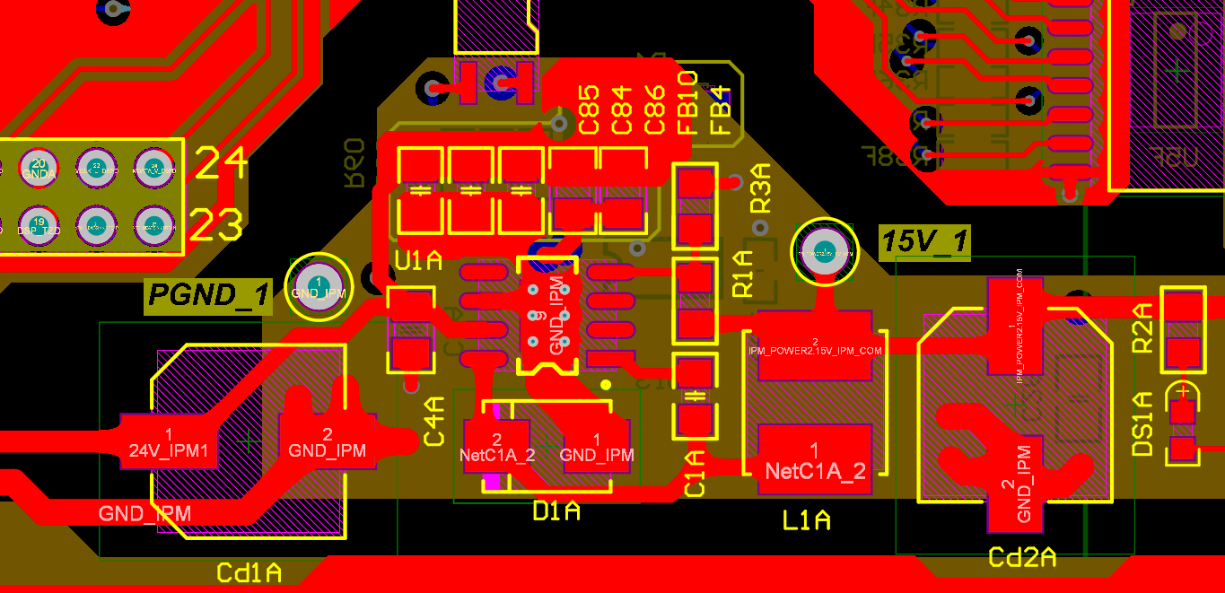

Problem
At the moment the motor is enabled, the 15V output voltage shows periodic oscillation with a period of 0.029s. The measured oscillation waveform is shown below:

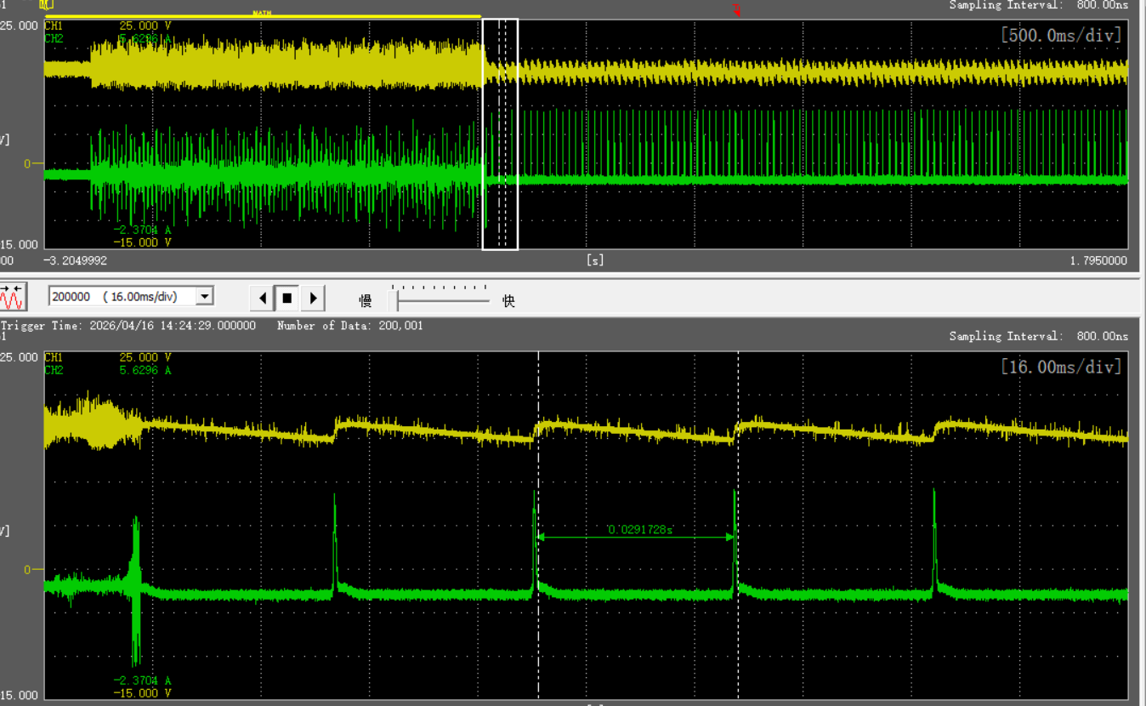
Oscilloscope channel definition:
CH1:Output voltage
CH2:Output current
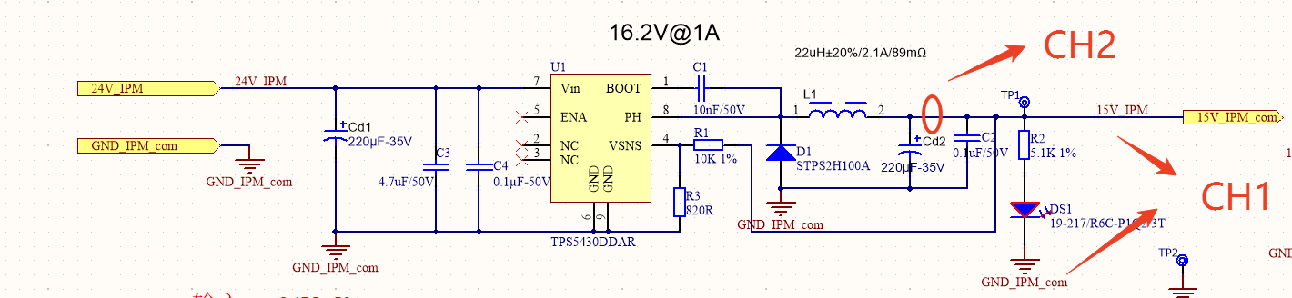

Test Items
（1）Replace with a new TPS5430; the test is normal and no oscillation occurs. The waveform is shown below:
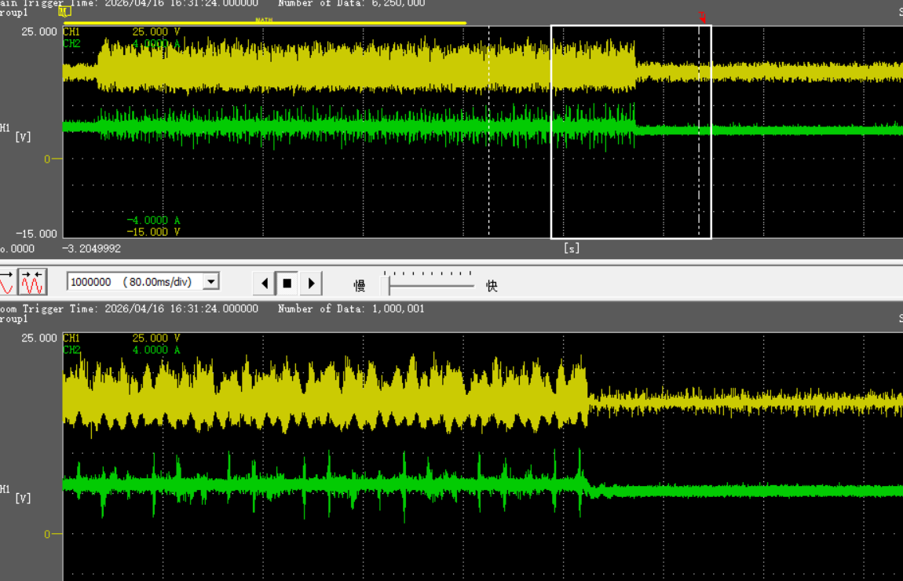
（2）Reload during oscillation; the output returns to normal. The waveform is shown below
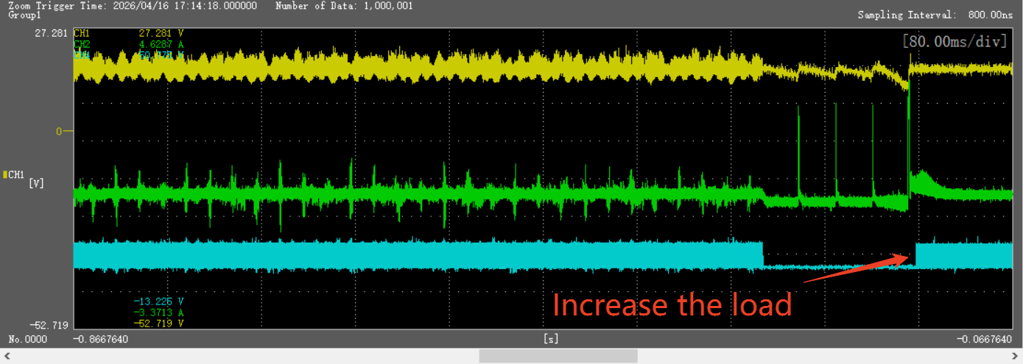
- Divide 24V to 5V and connect to the ENA pin with a 10nF filter capacitor; the problem still occurs.
- Parallel a 56pF capacitor with the diode as shown below:

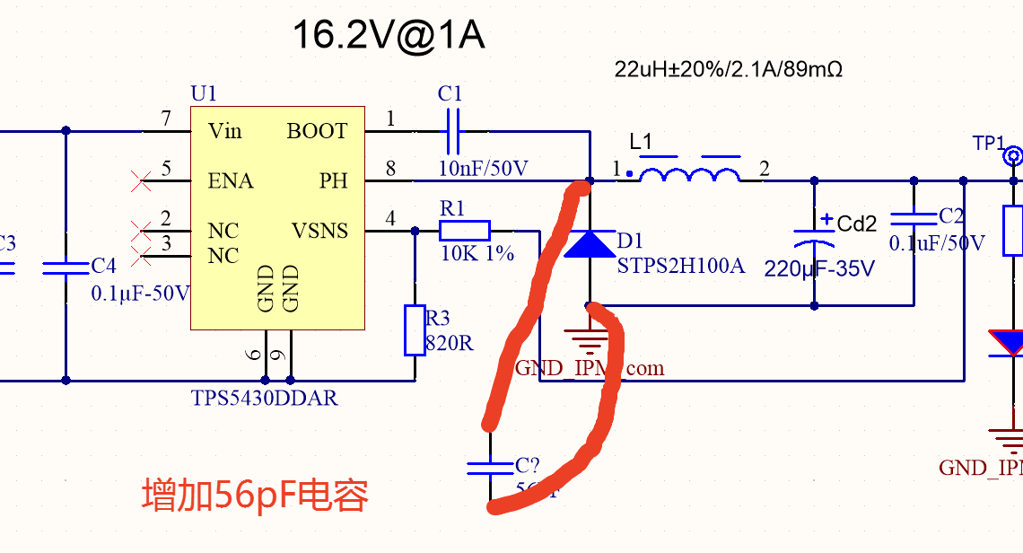
No oscillation occurs. The measured waveform is shown below:

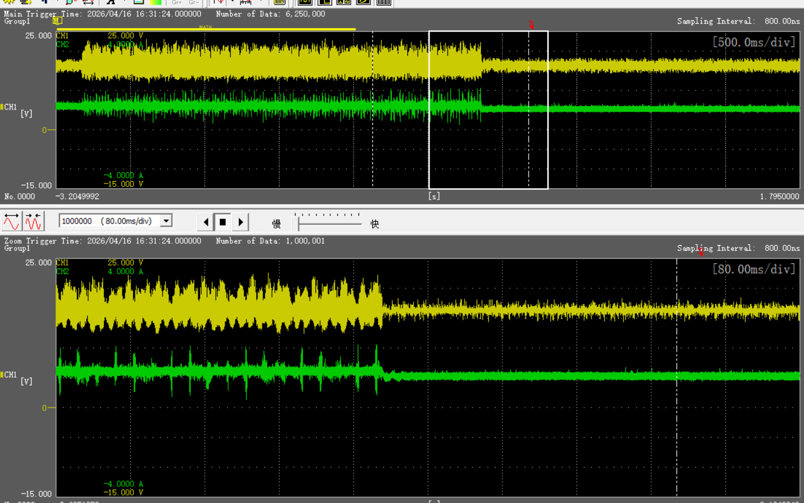

Questions
- No large current is detected during triggering. Why does the chip oscillate? The actual operating current is less than 300mA.
- Why does adding a capacitor eliminate the oscillation?
- Why does the oscillation disappear and the voltage return to normal after reloading?

