Upper : SW-node 50[V/div]
Middle : Clamp-SW Gate
Lower : Vin

Case 1
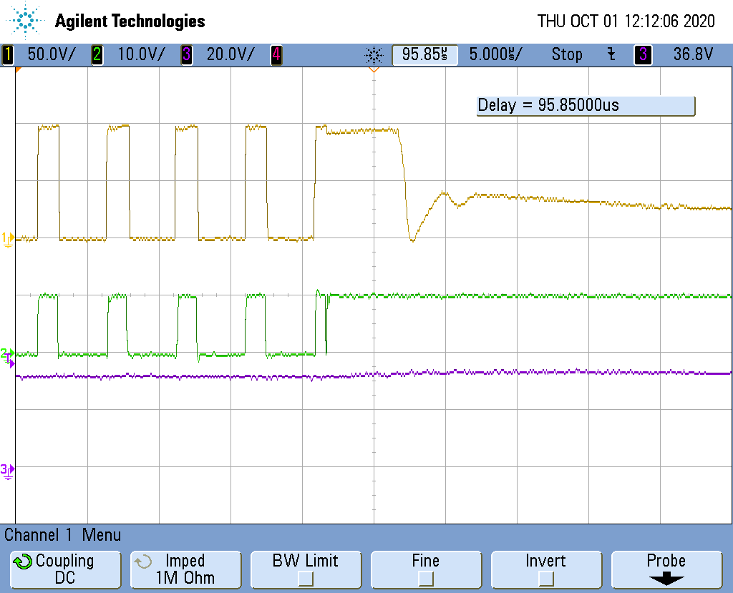
Gate signal of Clamp－SW goes OFF state with keeping High. (Controller output) goes off

Case 2
Gate signal of Clamp－SW goes OFF state with keeping Low.
