Hello,
Greetings of the day,
We are currently working on “Vienna Rectifier-Based, Three-Phase Power Factor
Correction (PFC) Reference Design Using C2000 MCU”. We have some of the doubts on it. Those are clearly mentioned below point wise.
- In the DC voltage balance controller given below, there only equation is mentioned but, in the overall loop where should it added in order.
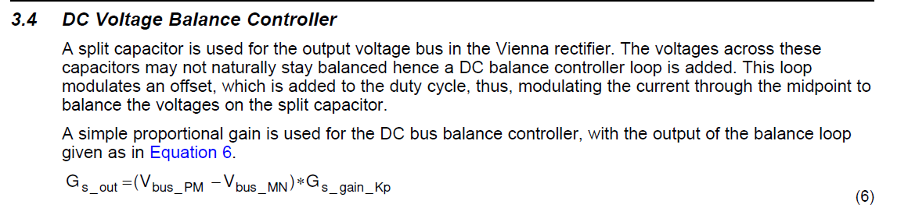
- Where, as mentioned in the build level 4 control diagram, what is the feedforward elements, please tell us in the block and equations present in the Feed forward elements block. And what is the logic implemented in that feed forward block.
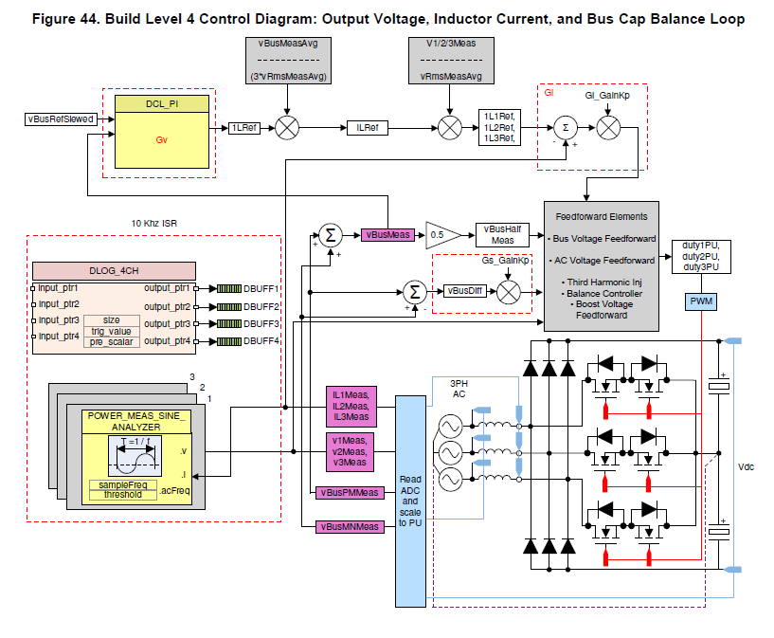
- As shown in the build level 4 control diagram what are the VBusMeasAvg and V1/2/3Meas. Should they are Sensing volage blocks or constant blocks used for calculation purposes.

Please, explain the loop up to generating PWM signals, which is used in simulation.

