Customer use LM5160 as fly-buck controller to provide Aux power for IGBT gate driver application, and reported several issues for startup/overcurrent/Cbst drop down.

The system setting is list as below:

* Input Range: 15~18V[Typical: 16.5V]
* Primary Output: 7V @ No load;
* Secondary Output: 24V @ 0.13A;

And the system setting are list as below excel file, the schematic shown as below:

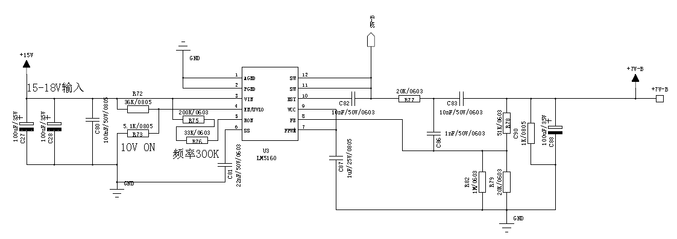

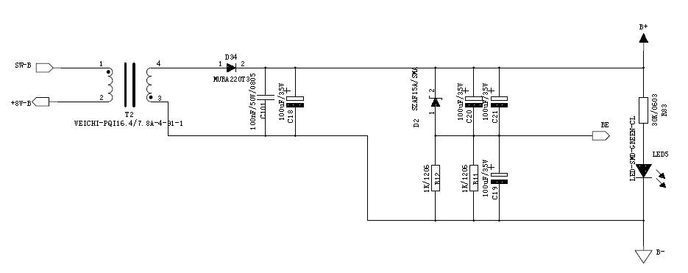



Reported Issues:

1. Could not build the output voltage while in no load operation, test waveform as figure 1:

|  |
| --- |
| CH1: Input Current CH2: Input Voltage  CH3: EN/UVLO PIN CH4: Secondary output(Setting to 25V, [+14 – (-11)]; |

1. The input current reach up to 4A during start-up, no matter output is ready or not, shown as figure 1& Figure 2;

|  |
| --- |
| CH1: Input Current CH2: Input Voltage  CH3: EN/UVLO PIN CH4: Secondary output(Setting to 25V, [+14 – (-11)]; |

1. The bootstrap(CBST) capacitor voltage would dropped down, shown as figure 3;

|  |
| --- |
| CH3: CBST Voltage |

Support Needs:

1. Could you kindly review the schematic and the parameters setting, and give comments on issue 1/2/3;
2. For Issue1, could you kindly give comments why the no load/light load may not build correctly output?
3. While using LM5160 as fly-buck controller, the Primary-side output should less than ½ of input minimum, the general understanding is for helping minimize the secondary peak current and improving load regulation, could you kindly share more information?