Using “4CC” commands with the PD controller
This document goes over the basic steps for using the One-PD Controller commands(“4CC”). The TPS65987D is the PD Controller used for examples in this document.

Introduction
The One-PD Controller Commands (“4CC” commands) are a set of commands that simplify the use some of the PD Controller’s commonly used functions. It allows the user to send a single command that manages more complex subroutines and function specific register writes for them.

The 4CC command structure is similar to a software function, where you have input arguments (Input DataX), a function call (writing the 4CC command to the Cmd1 register), and a returned output (Output DataX). There are cases where there will not be an input or an output and you can skip the related steps.

In the Technical Reference Manual, the table corresponding to the Command will give a description of the commands function, will provide the Input DataX and Output DataX requirements, and will describe the state of command completion, side Effects, and any additional information.

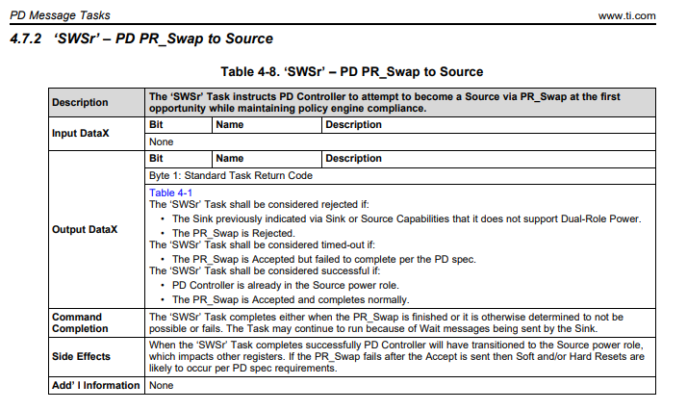
Figure 1: 4CC 'SWSr' Command table taken from TPS65987DDH TRM

The 4CC (4-byte character code) commands that are written to the Cmd1 register are obtained by converting the 4-character commands to ascii. You can use an ASCII converter to help you translate the codes (for example, the 4CC command ‘SWSr’ gets converted to “53 57 53 72”). Please keep in mind that the commands are case-sensitive.

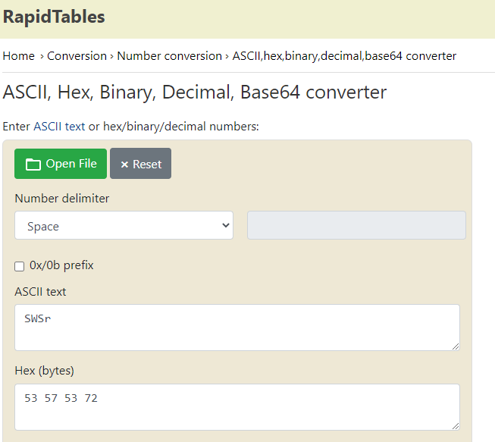
Figure 2: ASCII Calculation

The Cmd1 (0x08) register will have the 4CC commands written to it over I2C. Any “Data” (InputDataX, OutputDataX) is written to/read from the Data1 (0x09) register. There is a second set of registers at 0x10 and 0x11.

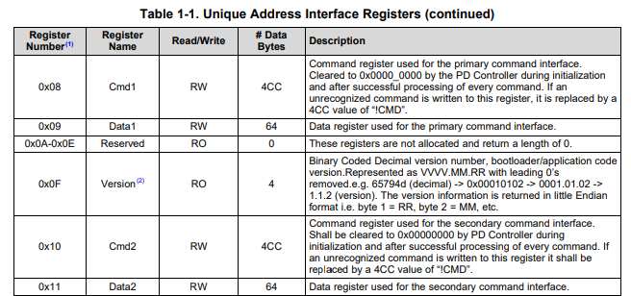
Figure 3: Cmd and Data Register information (taken from TPS65987DDH TRM)

Basic I2C command flow for ‘4CC’

This section will provide the steps for using the ‘4CC’ commands and an example using the ‘SWSr’ command.

Steps

- Write Input Data (Input DataX) into the Data register (0x09). If the Input Data is “None”, nothing needs to be written to the register.
- Write the 4CC command to the Cmd1 (0x08) register.
- Read the Cmd1 register to determine if the command executed properly. Continue to read the register until you see “0x00” or “!CMD”.
  - If the register reads back the 4CC command you wrote in step 2, the command is still executing.
  - If the register reads “0x00”, the command executed successfully
  - If the register reads “!CMD”, the command was rejected
- Read Output Data (Output DataX) from Data1 (0x09) after the command executes successfully. If the Output Data is “None”, nothing needs to be read from the register.
  - In many cases, the Output Data will return a “Standard Task Code”. The table referenced within the Output DataX section maps the value read from the register to each case in Output DataX. There is an example that navigates this case below.

Example with ‘SWSr’

Figure 4: 4CC 'SWSr' Command table taken from TPS65987DDH TRM

1.
Input DataX is “None”, so skip this step.

2.
First, convert the 4CC Command to ASCII
‘SWSr’ => 53 57 53 72

Next, register write “53 57 53 72” the Cmd1 register at 0x08

When using the Aardvark in simple mode, the I2C command looks like this
08 04 53 57 53 72

08: Register being written to
04: 4-byte payload to write
53 57 53 72: Payload (‘SWSr’)

3.
Read the Cmd1(0x08) register until you see 0x00

4.
Read Register Data1 (0x10). Reference Output DataX in the table for how many bytes need to be read. In this case, there is only 1 byte of output data.

Understanding the Output Data for ‘SWSr’ is a little confusing. For ‘SWSr’, you need to reference Table 4-1 to see what return codes correspond to what information. You read the code from table 4-1, and use the description in 4-1 to find what Output Data information is given. There is an example below.

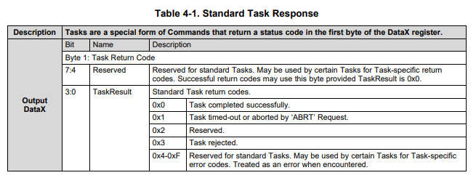
Figure 5: 4CC Standard Task Response table taken from TPS65987DDH TRM

Example 1:

Step 4 returns 0x00,
From table 4-1, the execution was successful.

Example 2:

Step 4 reads 0x1
From table 4-1, the task timed-out or aborted if an ‘ABRT’ Request was made

Let us assume there was no ‘ABRT’ Request, which means the task timed out.
Going to the Output DataX information for the ‘SWSr’ command (Figure 4), we see that “The PR_Swap is Accepted but failed to complete per the PD spec”.

