DS.No :4300315R2 Date : 27.11.2015

- Electrical Drawing

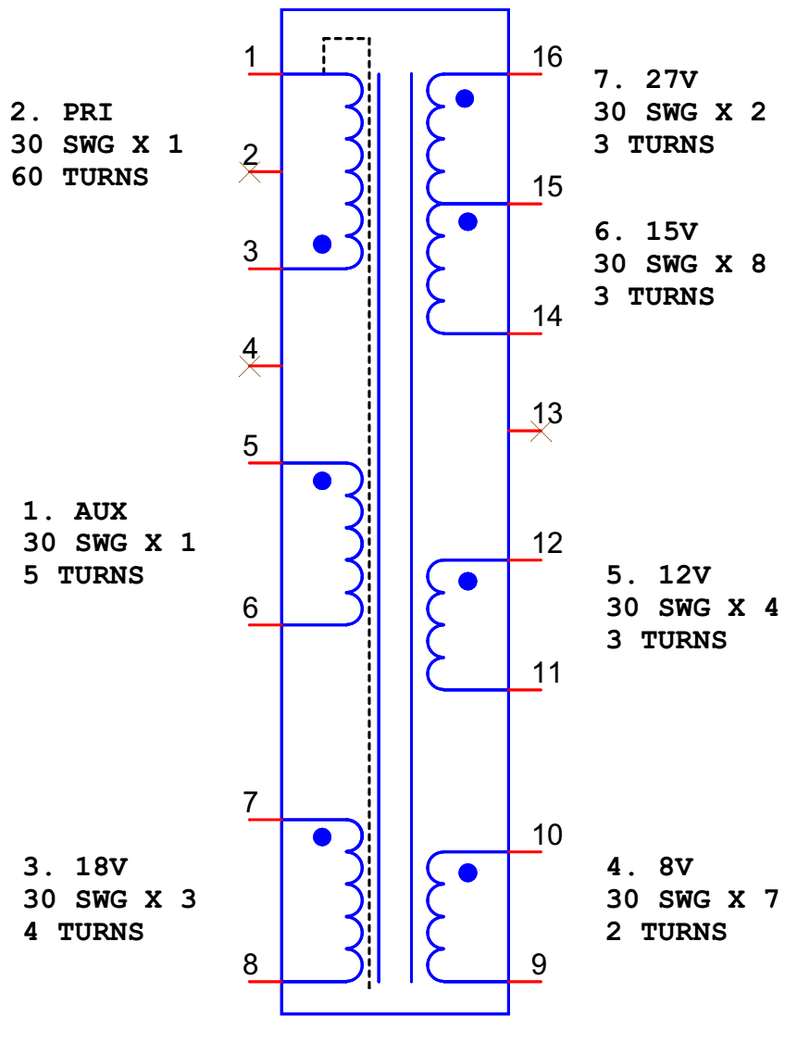

DS.No :4300315R2 Date : 27.11.2015

- Winding Table:

Sl.No. | Layer | Start | Finish | Description | Details
01 | A | -- | -- | 1 Layer of Insulation Tape
02 | B | 5 | 6 | 5T, 30SWG | 1 strand of 30SWG wire
03 | C | -- | -- | 2 Layers of Insulation Tape
04 | D | 3 | 1 | 60T, 30SWG | 1 strand of 30SWG wire
05 | E | -- | -- | 2 Layers of Insulation Tape
06 | F | 7 | 8 | 4T, 30SWG | 3 strands of 30SWG wire
07 | G | -- | 1 | 1 Layer of Insulation Tape  Shield as shown in figure 3. Connect shield to pin 1.  1 Layer of Insulation Tape
08 | H | 10 | 9 | 2T, 30SWG | 7 strands of 30SWG wire
09 | I | 12 | 11 | 3T,30SWG | 4 strands of 30SWG wire
10 | J | -- | -- | 3 Layers of Insulation Tape
11 | K | 16 | 15 | 3T, 30SWG | 2 strands of 30SWG wire
12 | L | 15 | 14 | 3T, 30SWG | 8 strands of 30SWG wire
13 | M | -- | -- | 2 Layers of Insulation Tape
14 | -- | Set the core, match the primary inductance between pin 1 and pin 3
15 | N | External Shield |  | 1T, Copper Foil | Outside of core

