**Issue1: enter CV mode, the charge current has big ripple, how to decrease the ripple. I have discussed the issue on E2E, you capture the current ripple about 300mA, in our test, the current is about 500mA, how to decrease?**

**Issue2: start charge with low voltage, the current oscillated.**

**I set 0x30[0] =0 to disable “auto wakeup enable” function.**

**Related conditions: VIN=12V, charge voltage is 13200mV,**

**REGN=5.99V; Cell_BATPRESZ=3.48V; 58%-3cells;**

**VBAT<7.24V, current oscillated; how to fix the issue?**

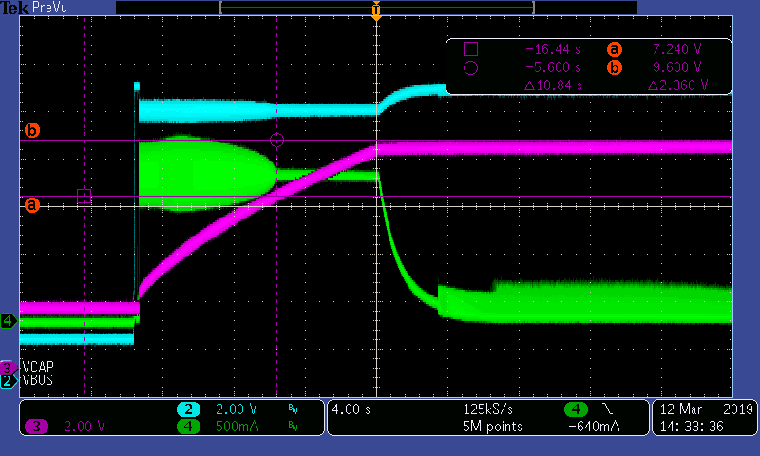

VCAP<7.2V, current oscillated, how to fix?

How to decrease the ripple

**Issue3, CV charger switch to OTG mode, both in light load, why the ripple is big difference?**

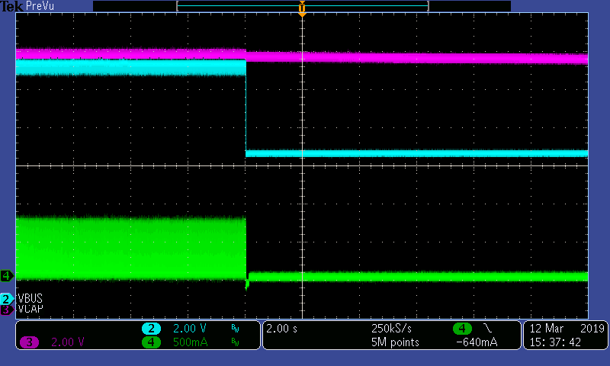

OTG current oscillation

CV charge oscillation



OTG start 10ms after conditions valid; we disconnect the VIN and VBUS (pin1 of the BQ25700) use the LDO as the 10ms power supply; is there any risk ?

Other suggestions?