CH1: Vin; CH2: GATE; CH3: TIMER; CH4: Iin
Iout: from 0A to 2.5A
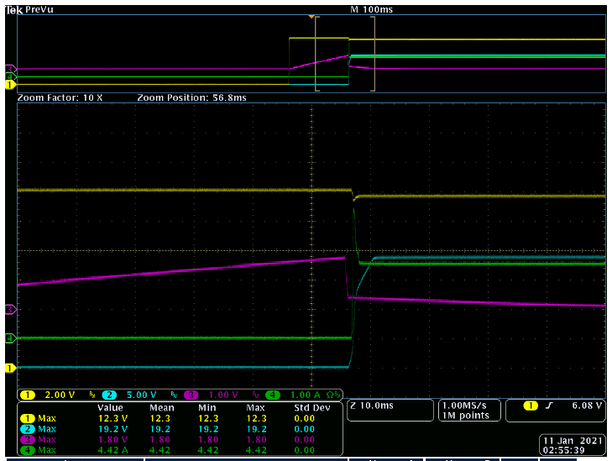

CH1: Vin; CH2: GATE; CH3: TIMER; CH4: Iin
Iout: from 0A to 5A
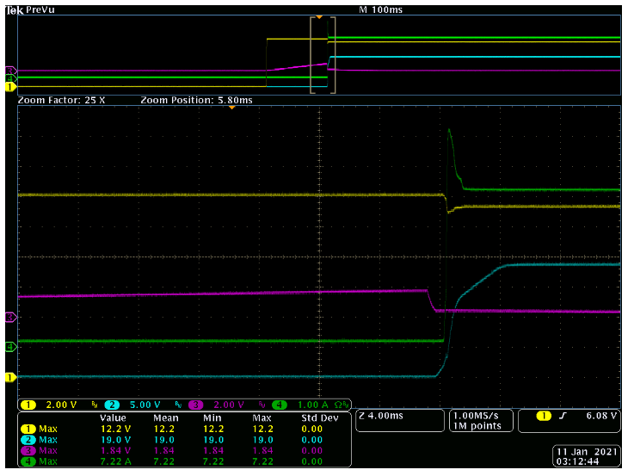

CH1: Vin; CH2: GATE; CH3: Vout; CH4: Iin
Iout: from 0A to 2.5A
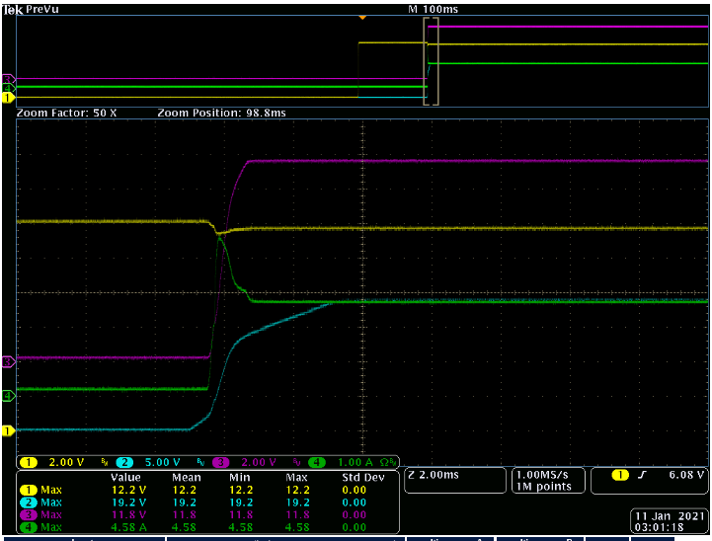

CH1: Vin; CH2: GATE; CH3: Vout; CH4: Iin
Iout: from 0A to 5A
