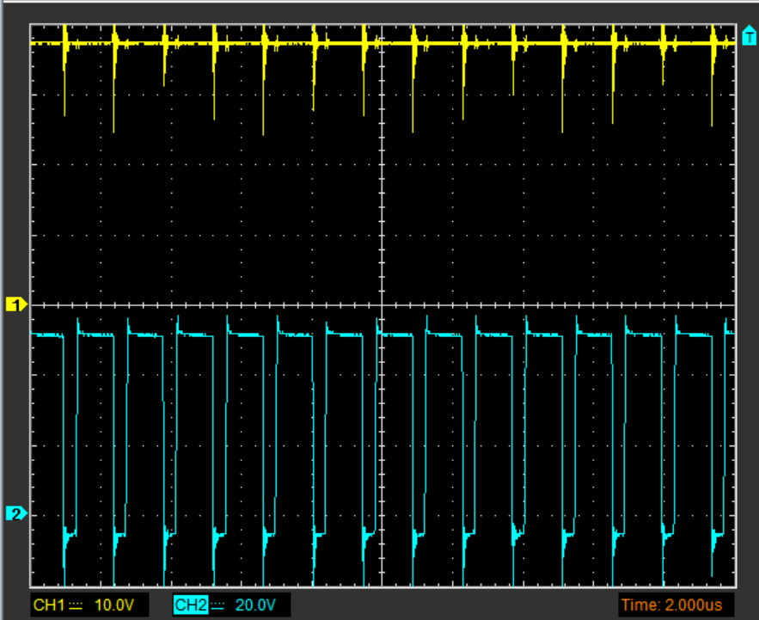  CH1=VIN(37V), CH2=VSW | 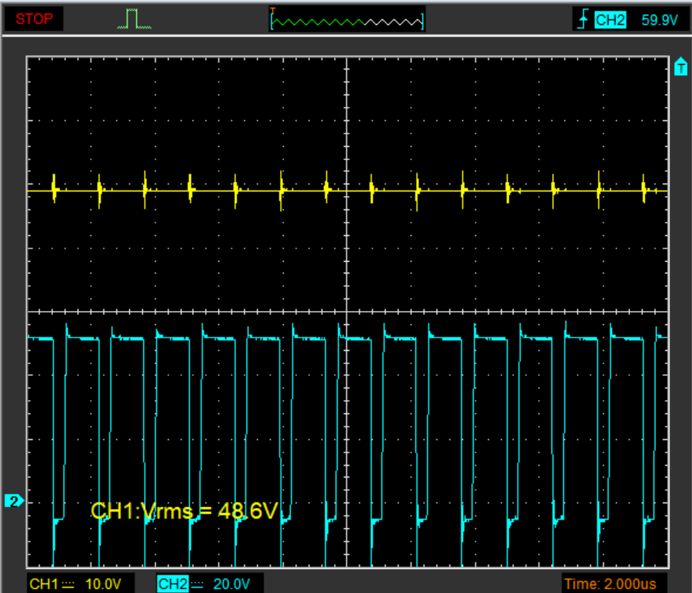CH1=VOUT(48V), CH2=VSW
Audible sound is present but minimal. Tested till 240mA load.
Sound is proportional to the amount of load. Max load requireemnt is 400mA.
Schematic for the above waveforms

