Block diagram:
EN pin voltage: 100K+ 22K, below test are based on 100K+15K
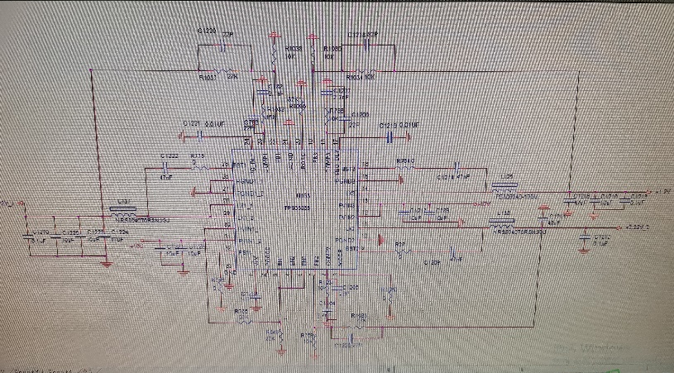
100k+15K, 10Vin, EN1/2/3 in parallel, Mode float. Output works.
When EN 1/2/3 >1.22 V threshold voltage, VIN>8V
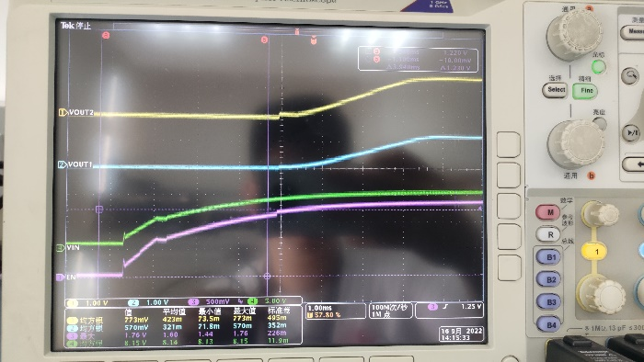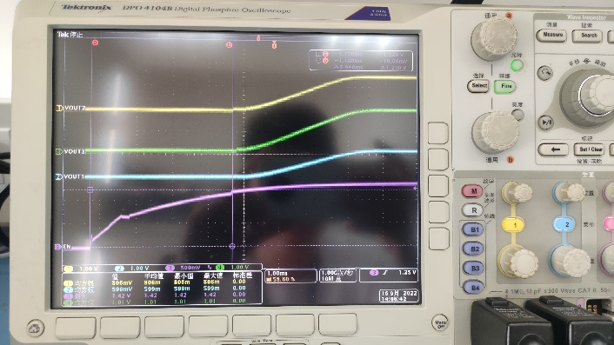

100k+15K, 10Vin, EN1/2/3 in parallel, Mode GND. No output.
When EN 1/2/3 >1.22 V threshold voltage, VIN>8V
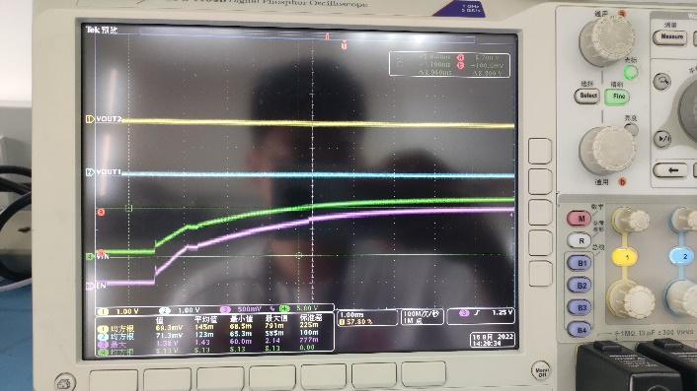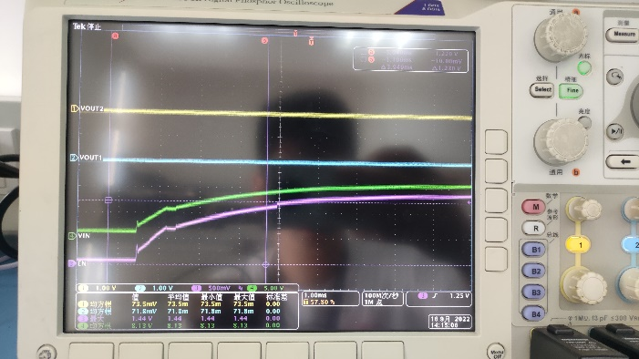

100k+15K, 17Vin, EN1/2/3 in parallel, Mode GND. No output.
When EN 1/2/3 >1.22 V threshold voltage, VIN>8V
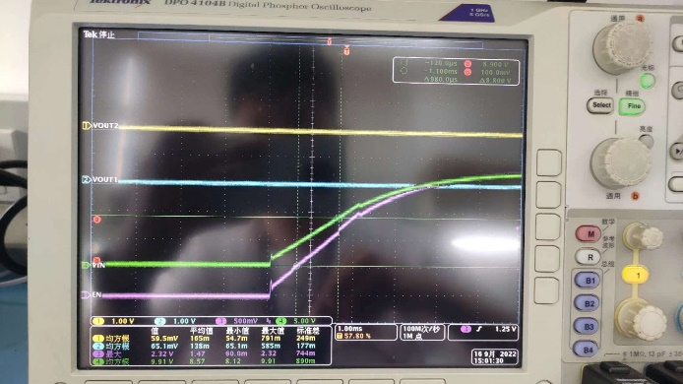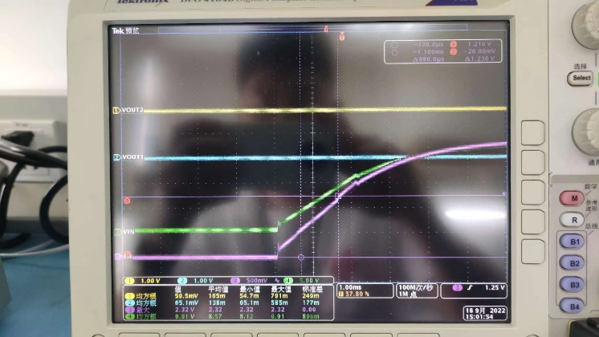
100k+15K, 17Vin, EN1/2/3 in parallel, Mode float. Output works.
When EN 1/2/3 >1.22 V threshold voltage, VIN>8V
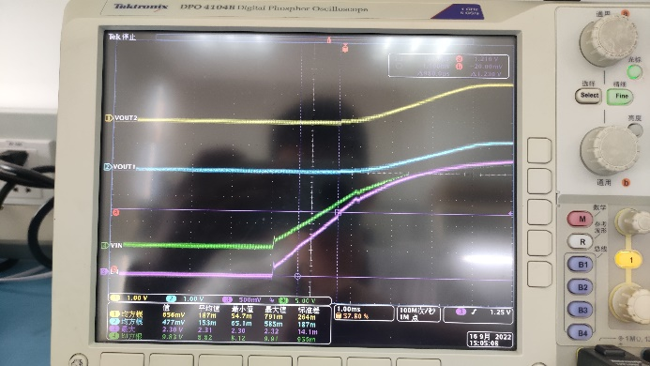

100k+33K, 10Vin, EN1/2/3 in parallel, Mode GND. Output works.
When EN 1/2/3 >1.22 V threshold voltage, VIN>4V
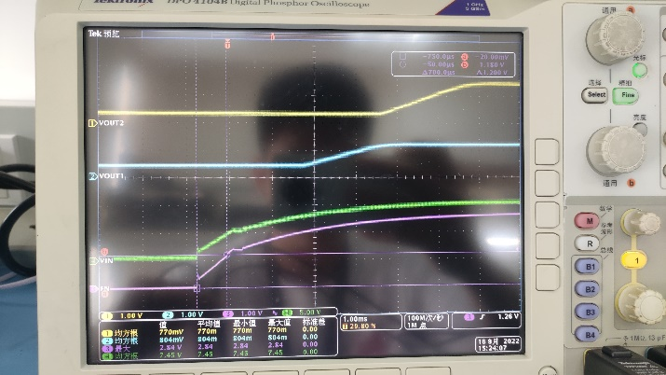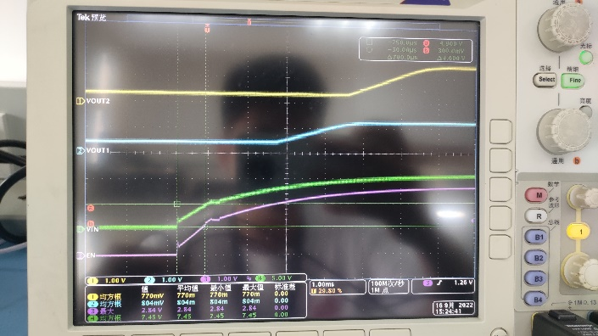

100k+33K, 10Vin, EN1/2/3 in parallel, Mode float. Output works.
When EN 1/2/3 >1.22 V threshold voltage, VIN>4V
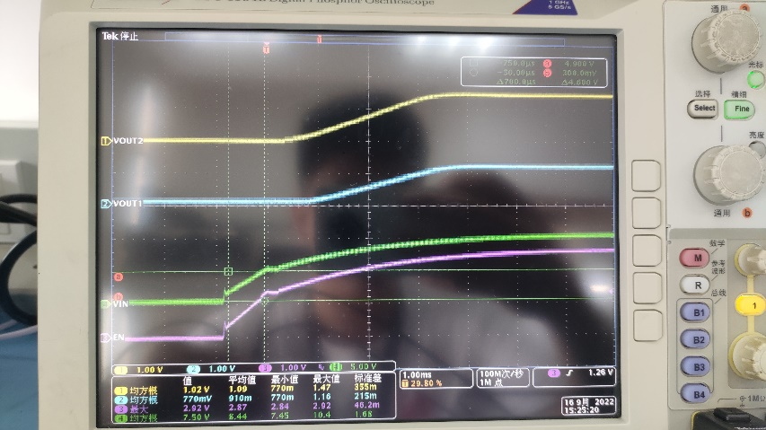
100k+33K, 17Vin, EN1/2/3 in parallel, Mode float. Output works.
When EN 1/2/3 >1.22 V threshold voltage, VIN>4V
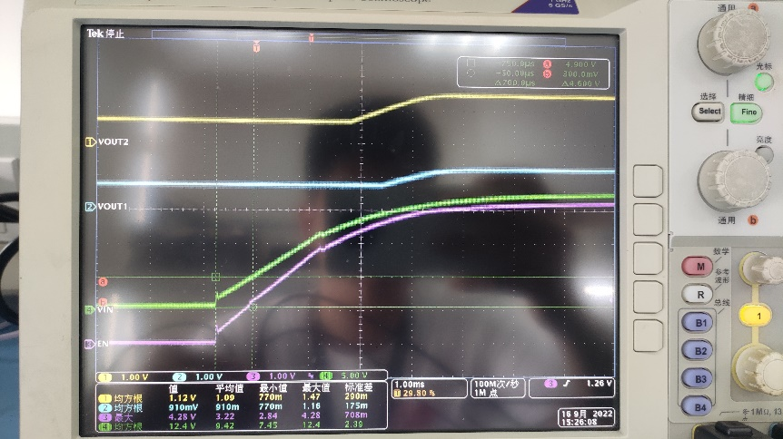
100k+33K, 17Vin, EN1/2/3 in parallel, Mode GND. Output works.
When EN 1/2/3 >1.22 V threshold voltage, VIN>4V
