|  |
| --- |
| CH1: PFC_VGS |
| CH2: PFC_VDS |
| CH3: Input current |
| CH3: UCC27511_Pin5 to GND with BNC probe |

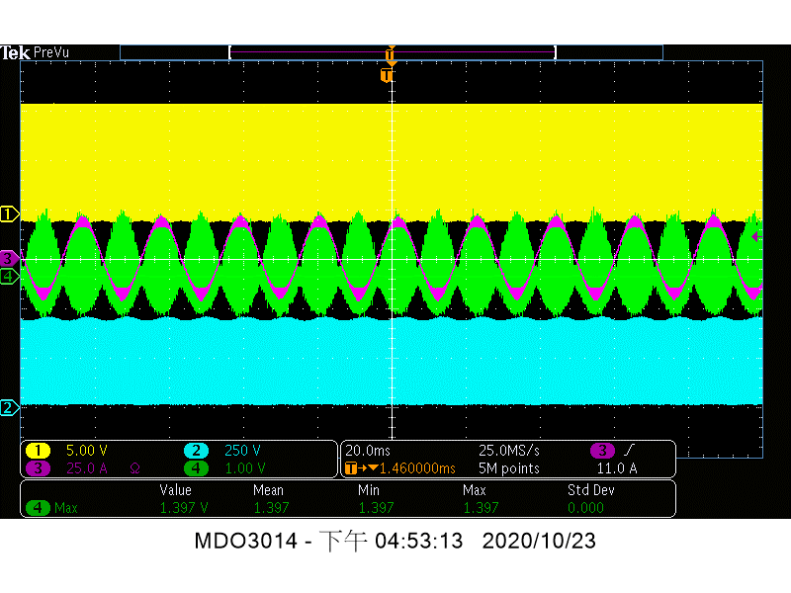

PSU Start-up waveform

|  |
| --- |
| CH1: PFC_VGS |
| CH2: PFC_VDS |
| CH3: Input current |
| CH3: UCC27511_Pin5 to GND with BNC probe |

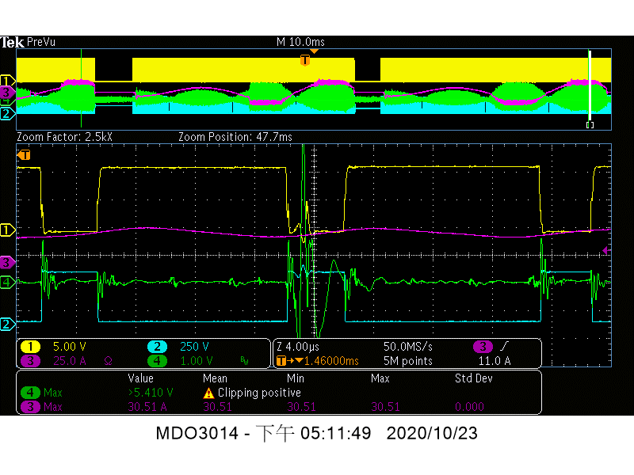

PSU Start-up waveform

|  |
| --- |
| CH1: PFC_VGS |
| CH2: PFC_VDS |
| CH3: Input current |
| CH3: UCC27511_Pin6 to GND with BNC probe |

