CH1: Vin; CH2: GATE; CH3: TIMER; CH4: Iin

Iout: from 0A to 2.5A

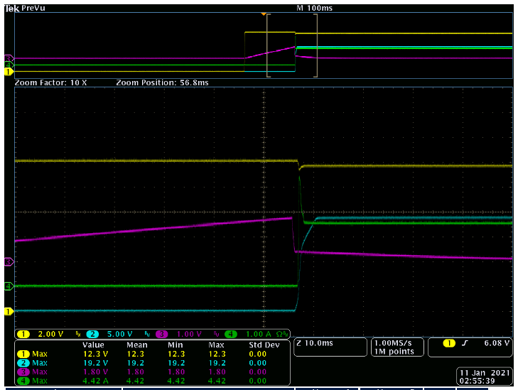

CH1: Vin; CH2: GATE; CH3: TIMER; CH4: Iin

Iout: from 0A to 5A

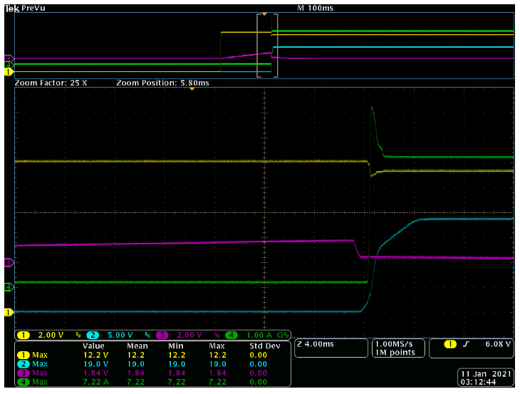

CH1: Vin; CH2: GATE; CH3: Vout; CH4: Iin

Iout: from 0A to 2.5A

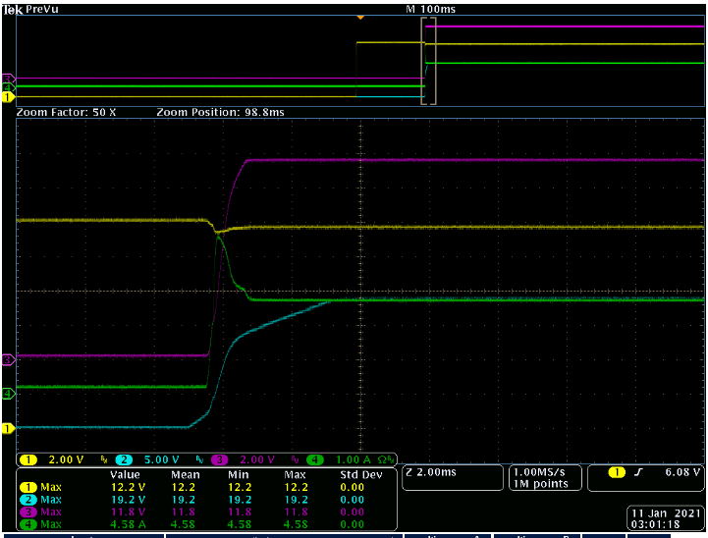

CH1: Vin; CH2: GATE; CH3: Vout; CH4: Iin

Iout: from 0A to 5A

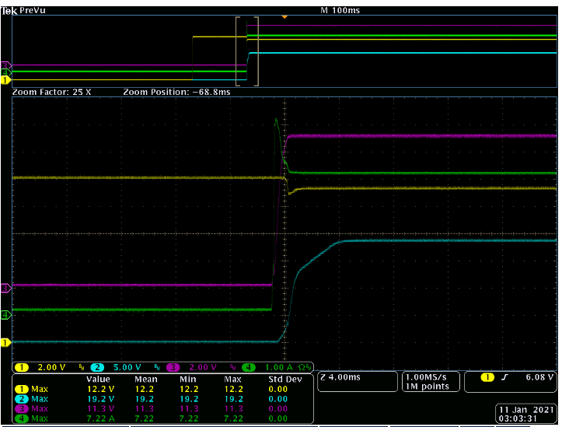

CH1: Vin; CH2: GATE; CH3: TIMER; CH4: Iin

