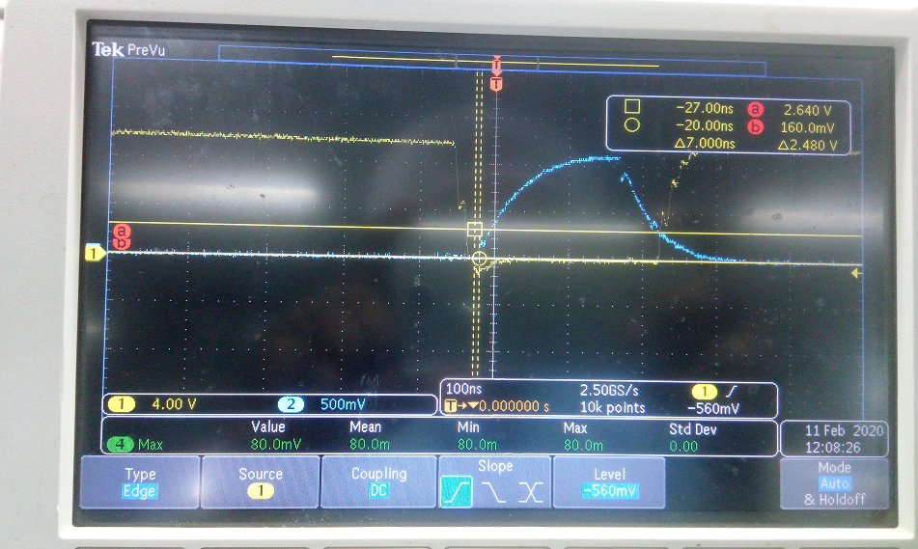

1)Out of 4 MOSFET only one MOSFET connected in top side gate driver and 3 MOSFET connected with respect to LM5041 application circuit Q1and Q2. That time above image got it. Yellow colour: Top side gate(HO),Blue colour :Low side gate(LO)

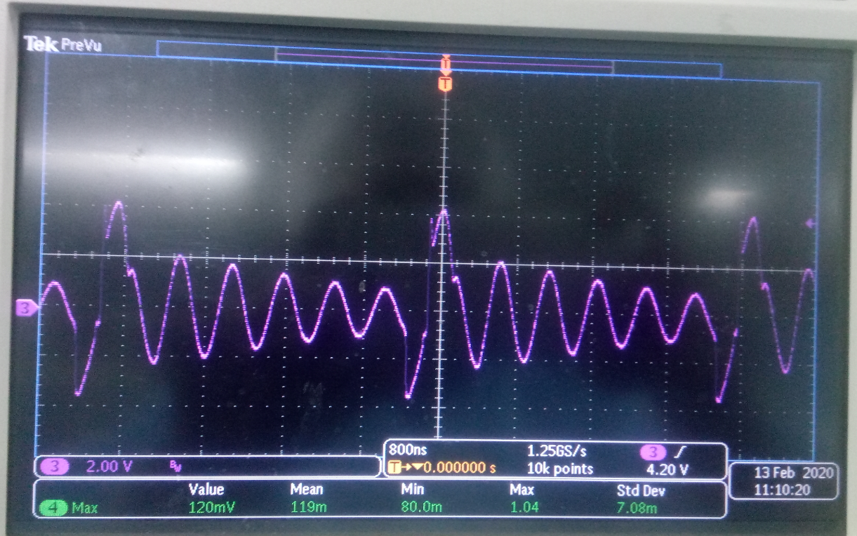

2)4MOSFETs and 3 MOSFETs connected with respect to LM5041 application circuit Q1 and Q2 location. Then waveform found like above image. Now with MOSFET and without MOSFET, gate driver pin HO pin it showing like above waveform. It is measured across HO pin and HS pin. That time checked HO and HS pin showing 7ohm.

By the time Below image taken at LO pin of driver IC.

