I have a client here named Shanghai Huazhijian that is working on quadruped robots for Huawei. The design requirements are as follows: 240W internal charging and 100W external charging (the battery system is required to be 48V, with 240W PD for internal charging and 100W Huawei SCP for external charging, both through a single Type-C port). There is no need for USB3 data transmission. The reference solution is:
https://www.ti.com.cn/cn/lit/ta/zhct861a/zhct861a.pdf?ts=1767757894897&ref_url=https%253A%252F%252Fwww.ti.com.cn%252Fproduct%252Fcn%252FTPS25751
https://www.ti.com.cn/cn/lit/ug/zhcubj0b/zhcubj0b.pdf?ts=1768529530593&ref_url=https%253A%252F%252Fwww.ti.com.cn%252Fsitesearch%252Fzh-cn%252Fdocs%252Funiversalsearch.tsp%253FlangPref%253Dzh-CN%2526nr%253D2083%2526searchTerm%253Dtps25751
https://www.ti.com.cn/cn/lit/an/zhcaem6/zhcaem6.pdf?ts=1768526519365&ref_url=https%253A%252F%252Fwww.ti.com.cn%252Fproduct%252Fzh-cn%252FTPS26750%253FkeyMatch%253DTPS26750%2526tisearch%253Duniversal_search%2526usecase%253DGPN
https://www.ti.com.cn/tool/cn/PMP41115
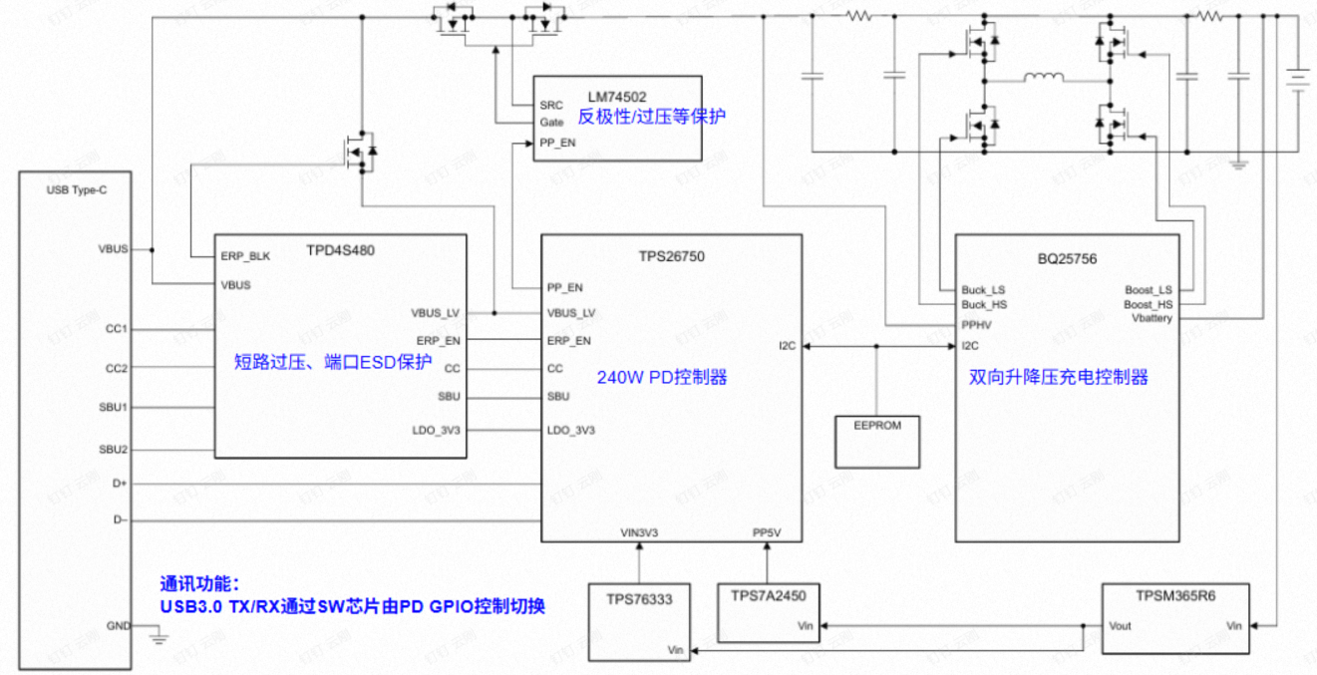
There are two questions:
1. Is there a way to support Huawei's SCP protocol for external use?
2. For PD 240W internally and 100W externally, the charging port and discharging port are not the same. The current customer requires a different port. It is necessary to switch the charging port and discharging port on the PD side. It can be considered to use a multi-channel switch or MOSFET to try, but it is not certain whether the entire framework is correct or can be implemented.

