**Fig.1 Schematic**

In above schematic Fig1, Now depletion mode mosfet (Q1) is not available so we go with the enhancement mode mosfet the circuit is fig.2 **UG: This Q1 change should be okay.**

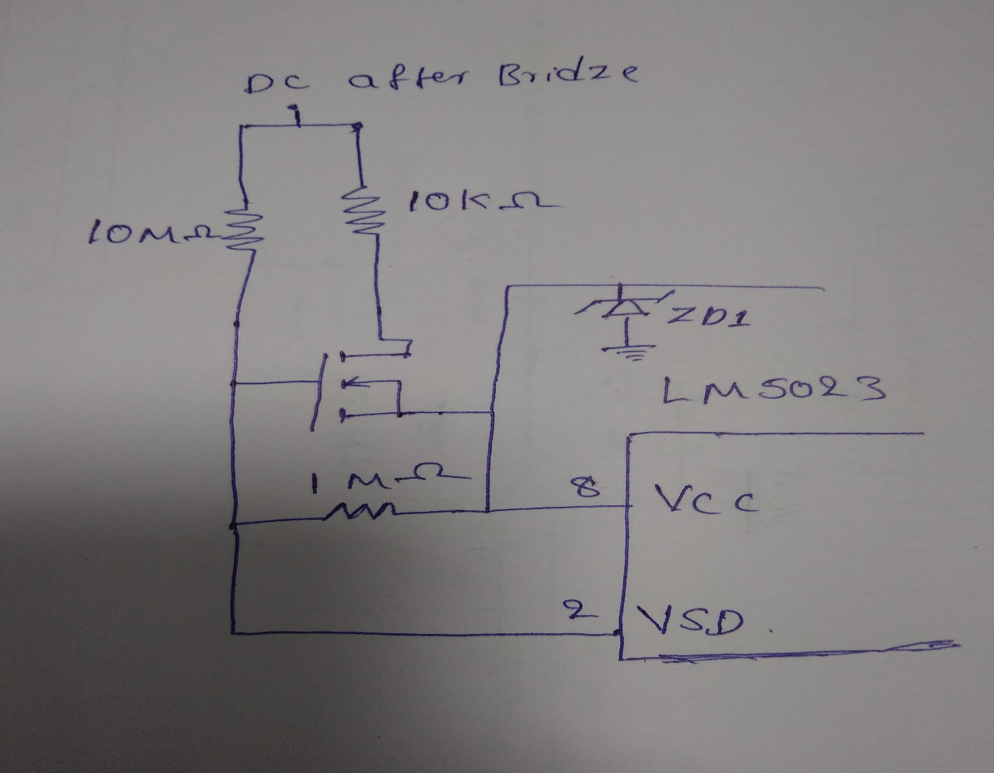

**Fig.2 Enhancement mode mosfet connection**

We apply AC supply nearly 180VAC to J1 connector. In enhancement mode we are getting the pulses is like fig.3

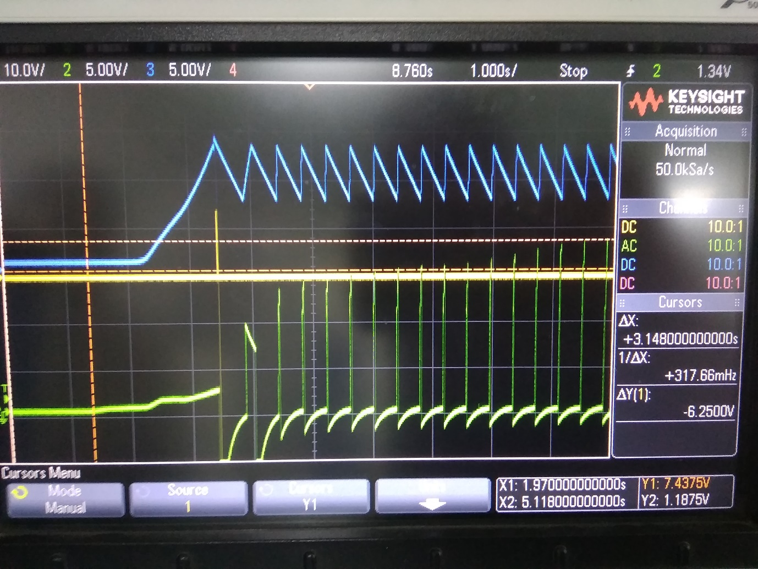

**Fig: 3**

Blue: VCC 5V/div

Green: VSD 5V/div (AC coupled?)

Yellow : Output 10V/div

Sweep 1s/div

And we have reduced the R10 resistor value decreasing step by step, That time Q2 mosfet and iC LM5023 damaged. Kindly suggest any Working schematic is there for enhancement mode.

Please give some suggestion to this schematic for how to get the output Pulses.

**UG: See next page.**

**UG: Problem in red-circle area. See below for changes.**

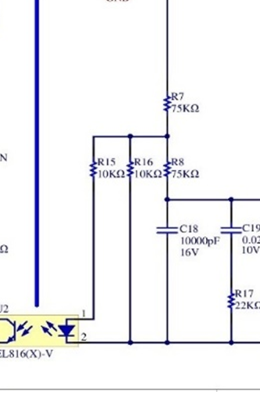

**On primary side, change value of R10 to 5.6 KΩ.   
Should result in OVP at ~27V on output. Can fine tune later.**

**Disconnect R15 and R16 where indicated.**

**Reconnect R15 to top of R7.**

**Reconnect R16 to anode of U2.  
Change value of R16 to 1 KΩ.**

**1K**