**Dear XX:**

In the document of " tiduc43a 20-Series Battery Management Module Reference Design", Figure 7 as follow:

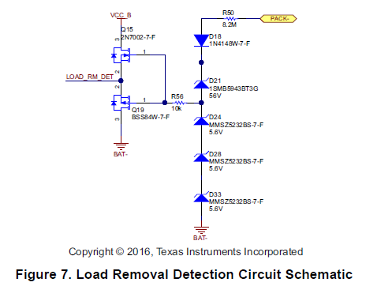

TDELAY is the time from the moment when the load is removed to the next moment when

the voltage VLOAD goes to the voltage below 0.5 V again，Why is there a delay?

The load removal event can then be detected by the MCU, Is LOAD_RM_DET signal configured to pull or drop-down ?

If the battery is 16 s, Is D21,D24,D28,D33 steady voltage equal to the total battery voltage? How to choose?

Can D24, D28, D33 replace it with a zener diode ?

Why D21 package is SMB,SMA is ok?

Thanks for your reply!