**How to update battery pack firmware**

**1 Circuit board**

1.1: Evaluation board bq40z80evm-020, bms020b, hereinafter referred to as EVM

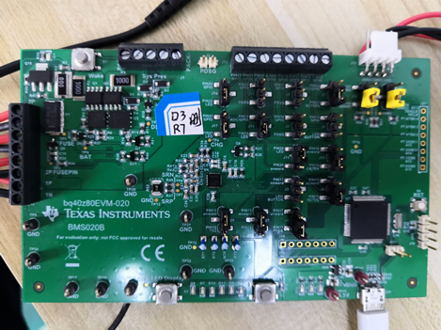

EVMP

1.2: Circuit board BP, hereinafter referred to as BP

U3 model in the figure is bq40z80rsmt

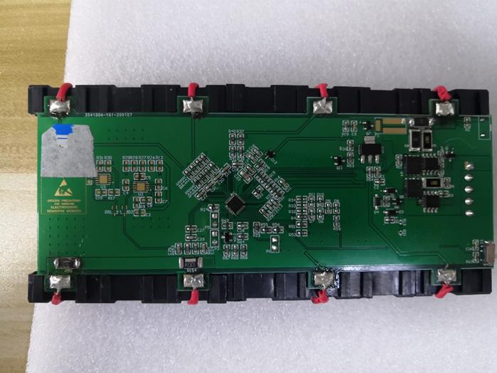

P2-1=0V

P2-3=8V

P2-5=16V

P2-7=24V

P2-2=4V

P2-4=12V

P2-6=20V

P2-8=28V

P4-1=PACK+

P4-2=SMBC

P4-3=SMBD

P4-4=

P4-5=PACK-

BP

U3

40Z80

**2** **Before and after firmware update**

bqStudio Version No：BatteryManagementStudio-1.3.92

For the new chip (BQ40Z80RSMR), restarting bqStudio after firmware installation will automatically identify the firmware and automatically establish communication

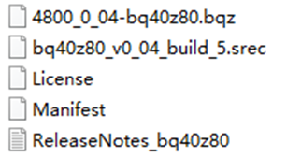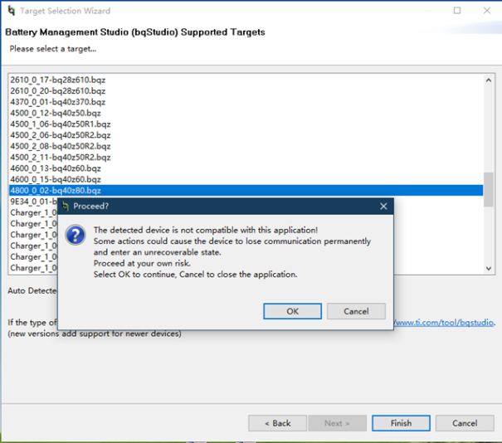

Before firmware update

4800_0_02-bq40z80.bqz

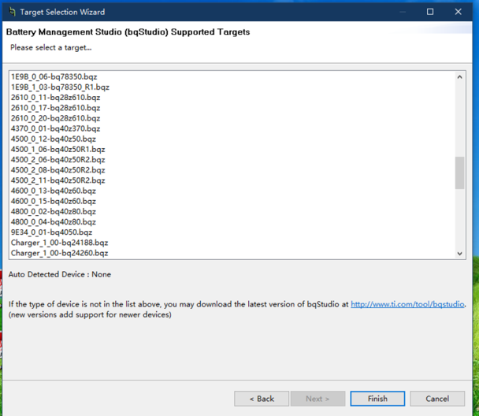

4800_0_04-bq40z80.bqz

After firmware update

**3 bqStudio establish firmware process**

Firmware prompt after update:

Program Srec: Packet checksum mismatch.

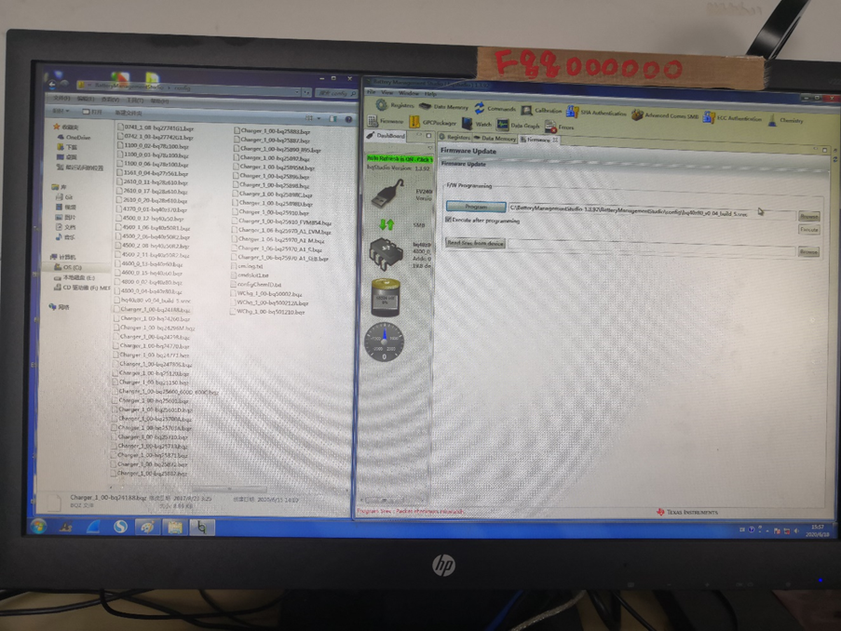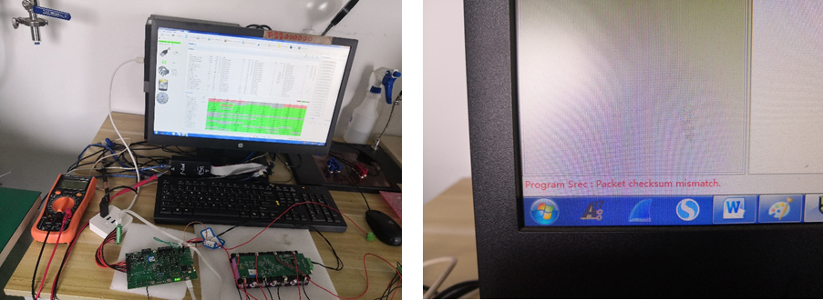

更新后固件4800_0_04-bq40z80.bqz