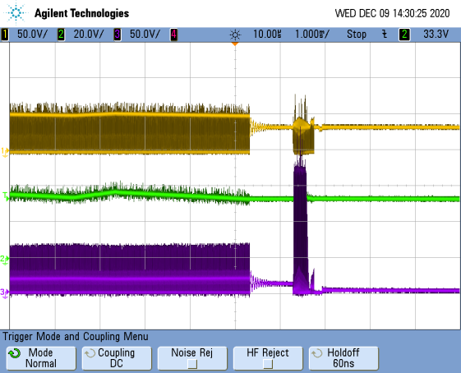
＜Fig 1＞

1[ms/div]
Main-SW_Vds 50[V/div]
Vin 20[V/div]
Forward-SW_Vds 50[V/div]

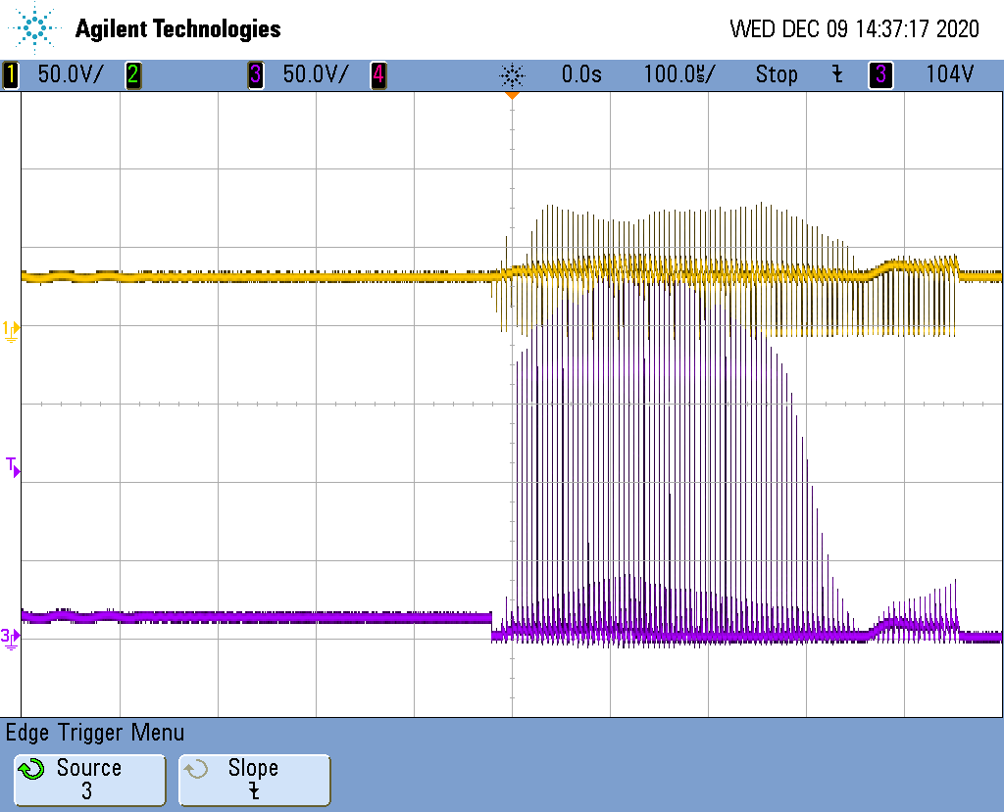
＜Fig 2>
10[us/div]
Main-SW_Vds 50[V/div]
Forward-SW_Vds 50[V/div]

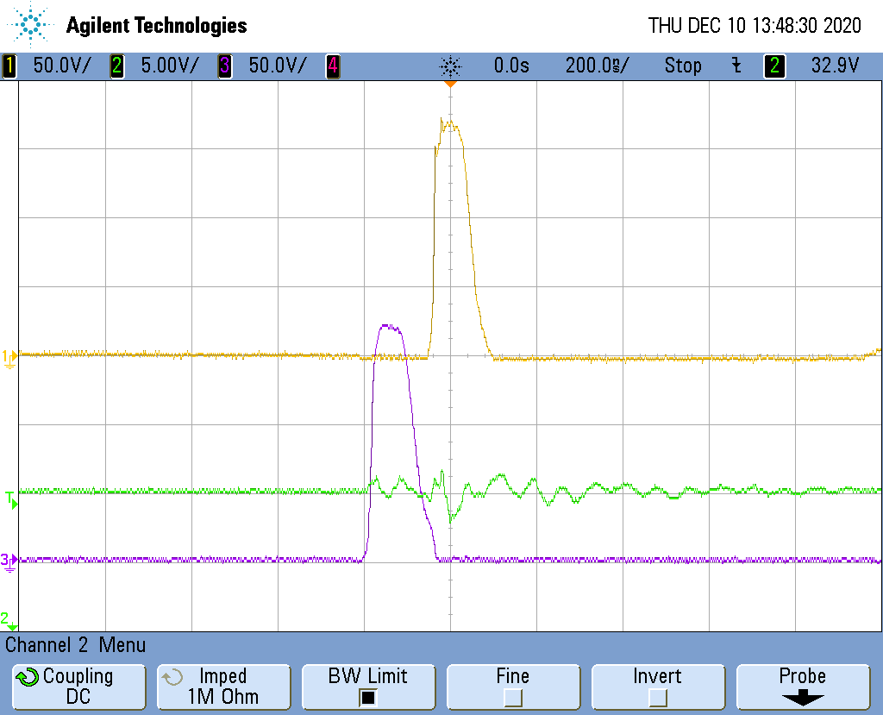
<Fig 3>
200[ns/div]
Catch-SW_Vds 50[V/div]
Vin 5[V/div]
Forward-SW_Vds 50[V/div]

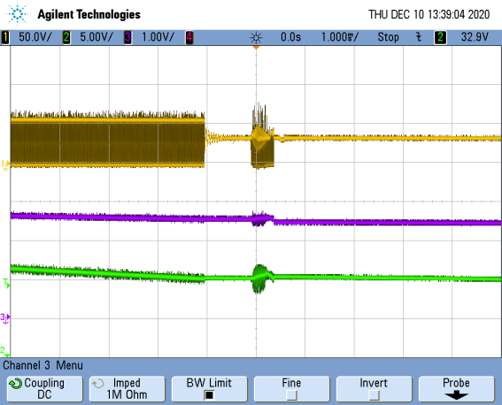
<Fig 4>
1[ms/div]
Main-SW_Vds 50[V/div]
V(UVLO) 1[V/div]
Vin 5[V/div]

