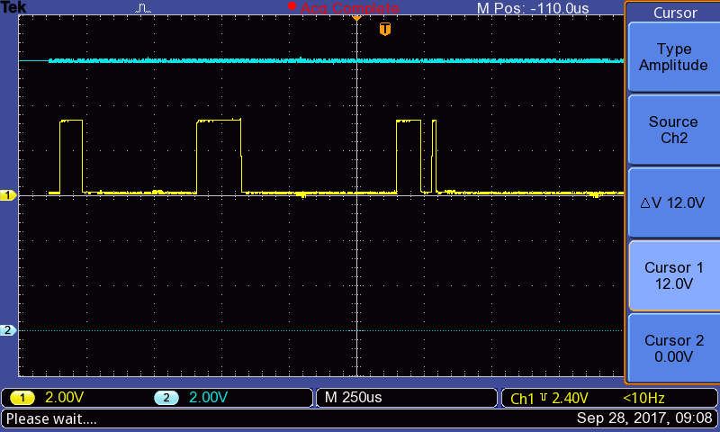

CH1=~FLT, CH2=IN

12V from a switching supply is steady with about 100 mVpp of ripple.

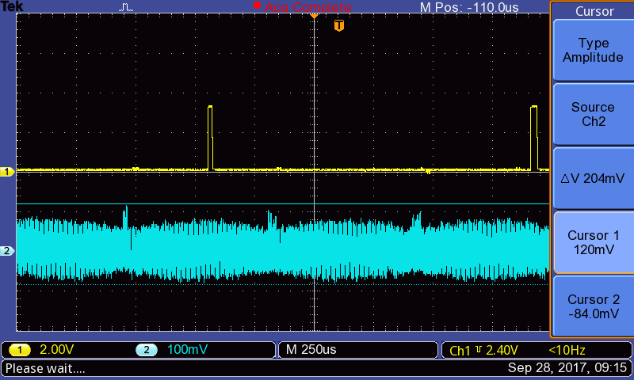

CH1=~FLT, CH2=IN

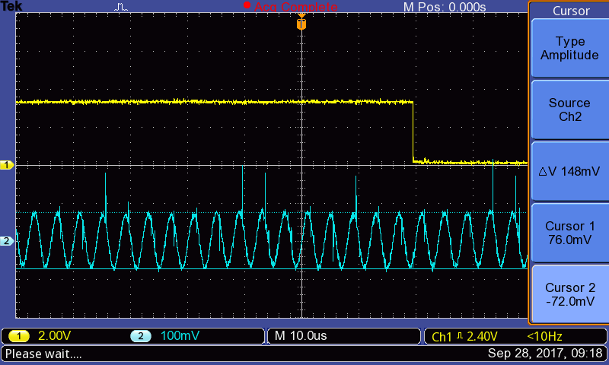

CH1=~FLT, CH2=IN

This capture shows VIN at a FLT event. Ripple is 250 KHz from switcher, approximately 148 mV / 2us = 74 KV/sec

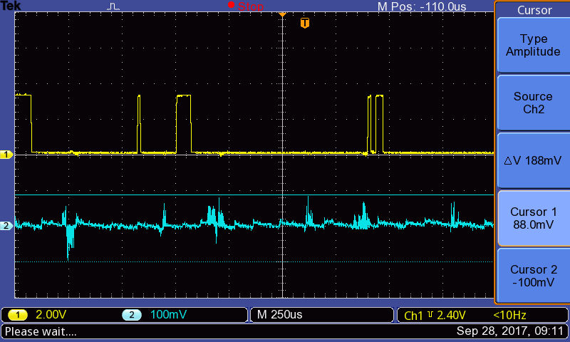

CH1=~FLT, CH2=OUT

No correlation between ~FLT and OUT