According to BQ24650 datasheet, the charge state the chip can be are:

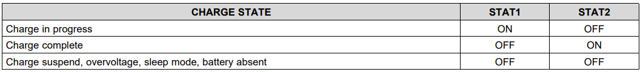

The question is, what if we get in a scenario not covered by the table above where both STAT1 and STAT2 are ON? Would that ever happen?

If the FW read that state, should it consider BQ25650 is faulty?

I also would like to double check two other things:

* “Charge suspend”: that has to do with the thermistor sense thresholds, right? (figure below)

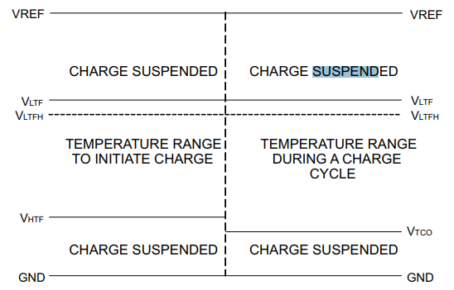

* Sleep mode: During the night, when the input voltage is lower than the battery voltage, the chip goes to sleep mode. Is that right?