Thanks for the following files:

PWR578A.PcbDoc

PWR578A.SchDoc

but, the following files are also needed:

PWR578A.PrjPcb

PWR578A.PrjPcbStructure

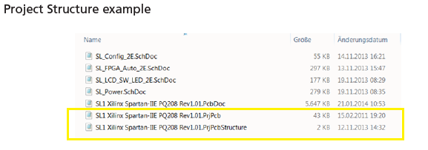

Here is the Migration Guide:

<https://www.orcad.com/sites/orcad/files/resources/files/OrCAD_Altium_Migration_Guide.pdf>

Below is the Orcad ERROR when using either PWR578A.SchDoc or PWR578A.PcbDoc

