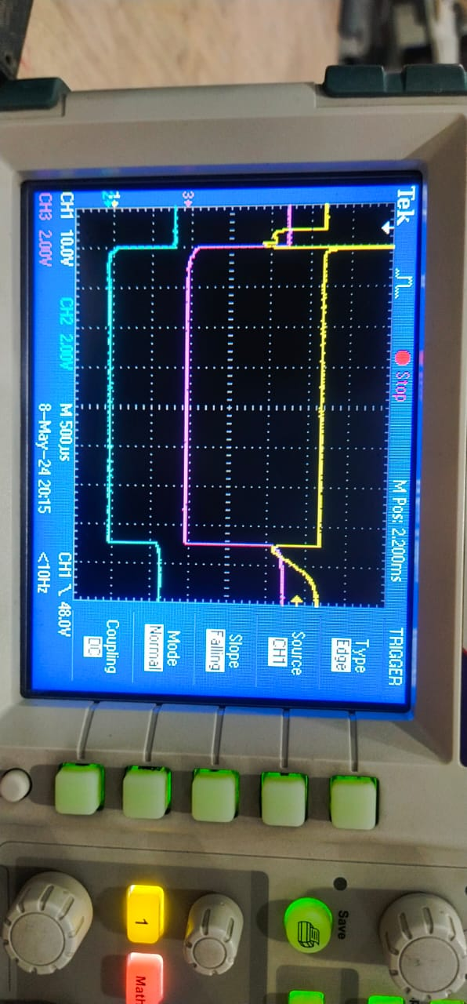**BMU SHORT CIRCUIT TEST**

**I BATT OCD**

**LO SW EN**

**Pack Delay**

**CRO Channel Connection**:

1st Channel – Battery Voltage Vs GND.

2nd Channel – AFE DDSG Vs GND.

3rd Channel –Driver DFET signal Vs R148 GND.

* **Observations:**

Step1. When we are capacitive Short Circuit at that you can see afe is detecting Short circuit due to which AFE DDSG pin becomes Low and also Driver DFET Signal also becomes low

Step2. Capacitive Short Circuit Still connected and as per the logic DFET will be ON after 5 Sec but we are seeing after 4millisec AFE DDSG Pin becomes high and when AFE DDSG Becomes High at that time we have seen variation in the temperature sensor.(All the AFE Temperature becomes -128C)