Our Cell in BQ24715 is set to 3Cell, and Vin is measured below 14.4V.

The ACDET is 4.187 (which is higher than the 2.4V threshold that ACDET identified as Adapter in).

ACOK and the output voltage will be abnormal as the accessory waveform (3Cell is an abnormal waveform, 3Cell_2 is a normal waveform), and the circuit diagram is as follows.

The questions as below:

1. What is the correspondence between the Vout and Vin of the BQ24715 in different Cell settings?

2. Suppose that in the case of 3Cell, if each Cell is fully charged at 4.2V, does Vin need a higher value than the output (Ex: 12.6V)?? How much voltage does Vin need to output higher than?

How much voltage should I add if needed? Is there a relationship??

3 cells

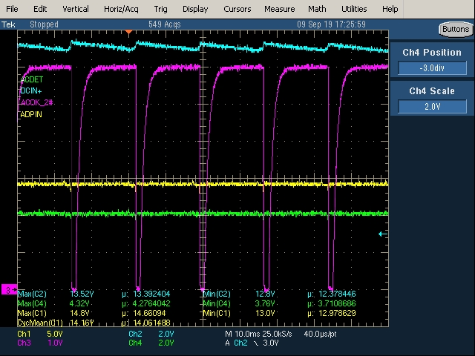

3 cell2

