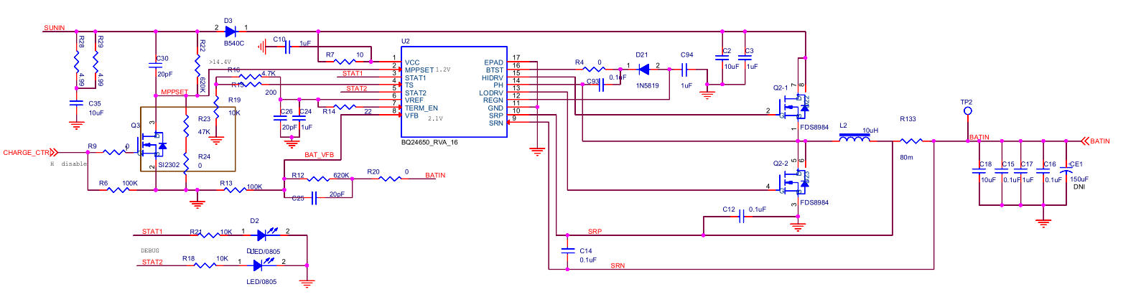
Output Current of Solar Panel is 1A,and Output Voltage of Solar Panel is 18V.
BATIN network is 14.4V, when BQ24650 is connected to solar panels.
Then, connect the lithium batteries to the BATIN network. The voltage of the BATIN network is 13.3V. After removing the lithium batteries, the BATIN network is 0.8V. The Vref is 3.3V.

Shield the sun's rays to the solar panels(Without batteries), and then remove the shield. The output of the solar panels is 19V, but the BATIN network is 0.8V.

