Issue Description:

The latest version BatteryManagementStudio-1.3.86\_Build6-windows-installer.exe couldn’t download the firmware and couldn’t be programed, even with the latest ROM file from TI website: bq28z610R1\_v1\_01\_build\_29.srec.cid:__aliyun_9AD2191D03AF05D75DAD8F024D17555B

Operation Steps:

1. Install latest version of BatteryManagementStudio-1.3.86\_Build6-windows-installer.exe;
2. Download latest 2610\_1\_01-bq28z610R1.bqz;
3. The BatteryManagementStudio could identify BQ28Z610-R1 also could modify the parameters via the software;

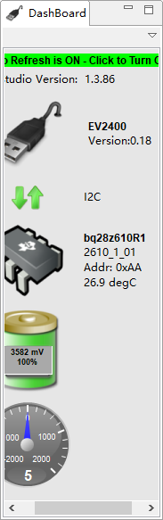

1. The Golden Image can be backup;

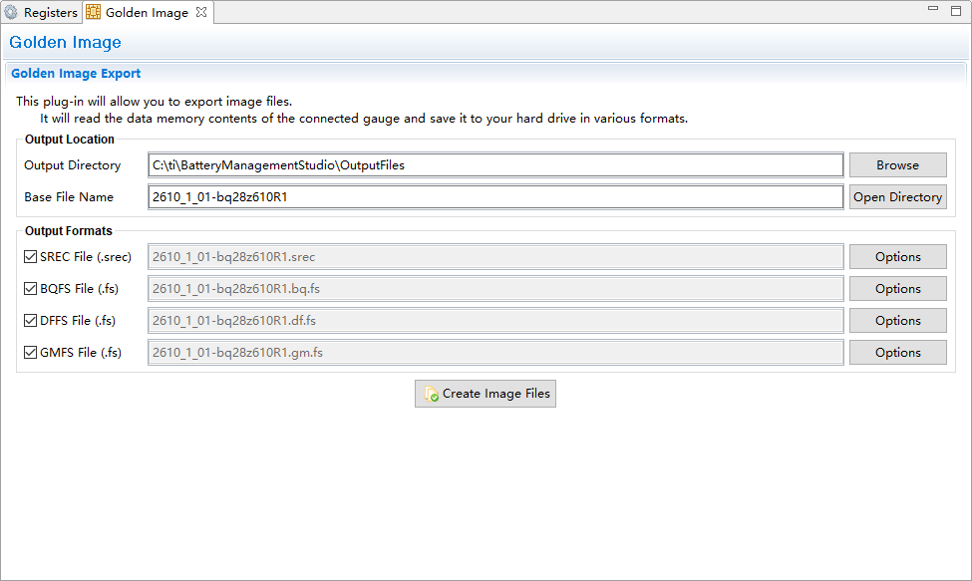

1. Failed for firmware operation in both “Programming” & “Firmware”

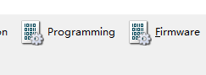

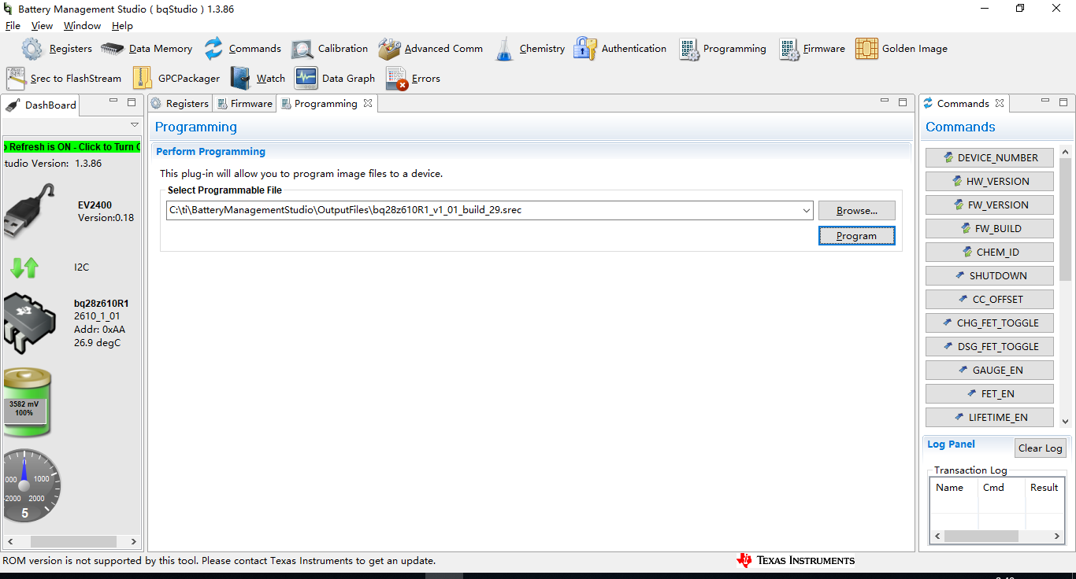

cid:__aliyun_311133AC9CA2C56F6CDC633E146FF487

