**Schematics:**

The SMART battery Clock, data and GND signals are connected at J21.5, J21.6 and J21.7

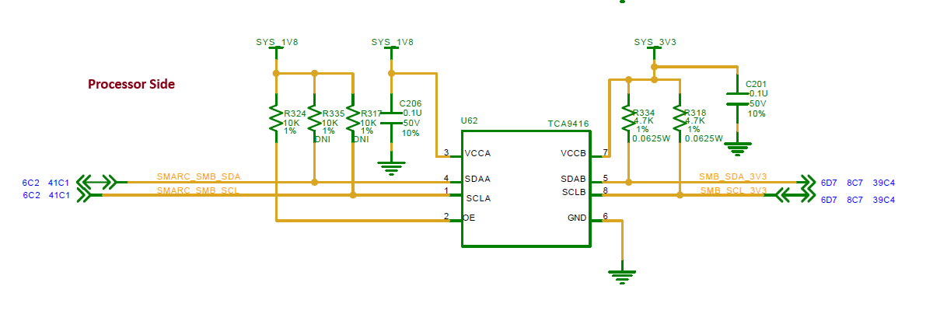

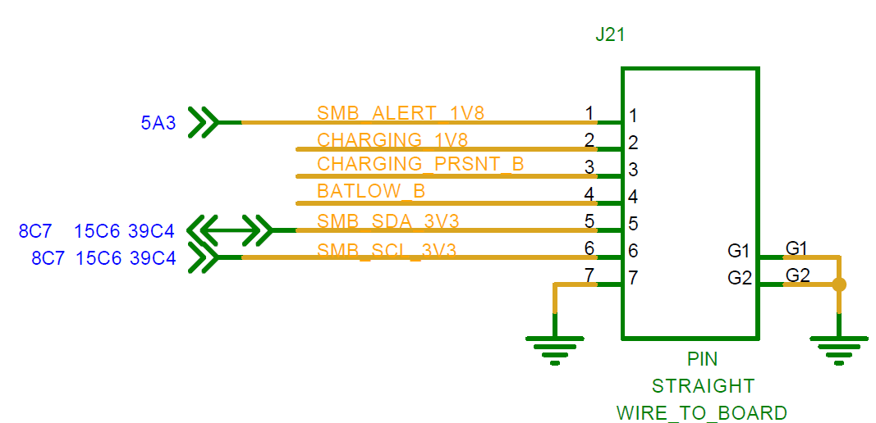

**Linux command:**

